To ask the Minister for Further and Higher Education; Research; Innovation and Science the number of students that applied for a SUSI grant in each of the years 2015 to 2024; the number of students that were granted and refused a grant in each year, in tabular form; and if he will make a statement on the matter.
- Peadar Tóibín.
* For WRITTEN answer on 26/06/2024
Ref No: 27350/24

Reply

Minister for Further and Higher Education, Research, Innovation and Science (Patrick O'Donovan)

The Student Grant Scheme is the principal support for students in financial terms by my Department. It provides grant assistance to eligible students attending approved full-time courses in approved further or higher educational institutions who meet the prescribed eligibility criteria of the relevant scheme.
The Scheme is administered on behalf of my Department by the national student grant awarding authority SUSI (Student Universal Support Ireland), a business unit of CDETB. Under the terms of the Student Grant Scheme, grant assistance is awarded to eligible students attending an approved course in an approved institution who meet the prescribed conditions of funding including those relating to nationality, residency, previous academic attainment and means.
The following table outlines the number of applications that were received, awarded, refused and cancelled from 2015/2016 to 2024/2025 on 24th June 2024.
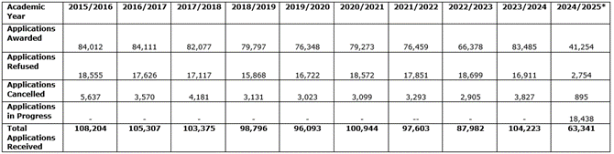
* Current year’s figures (2024/25) are subject to change as processing is ongoing.

