Enhanced Delta Smelt Monitoring
  - 2024 Phase 2 Preliminary Analysis
  - U.S. Fish and Wildlife Service
  - July 2, 2024
DRAFT

Overview
The Enhanced Delta Smelt Monitoring (EDSM) program started its 2024 Phase 2 sampling program for postlarval and juvenile Delta Smelt on April 1, 2024. Sampling effort is focused on geographic areas where Delta Smelt are likely to be present based on historical data. Sampling locations are generated using a generalized random-tessellation stratified (GRTS) design (Stevens 2004) with stratification and equal probability sampling. Trawling gear similar to that used in the California Department of Fish and Wildlife’s 20mm Survey (https://wildlife.ca.gov/Conservation/Delta/20mm-Survey) is used to conduct two tows per site.
Everything presented here is preliminary and subject to correction, revision, and improvement. The following points should be taken into consideration when interpreting the results:
- An oblique tow method was used during Phase 2 in 2017, 2018, and 2019. A surface tow method has been used for Phase 2 since 2020. In an attempt to standardize abundance indices based on surface tows with indices from previous years based on oblique tows we have used an adjustment factor when calculating postlarval/juvenile indices (see next point). A derivation of the adjustment factor is included at the end of this document.
- Separate abundance index tables are presented for postlarval/juvenile Delta Smelt, which hatched in spring 2024, and adult Delta Smelt, which hatched in the previous year. This distinction is based on fish size; see Appendix A of Mitchell et al. (2019). A design-based estimation method (Polansky et al. 2019) is used for both life stage groups, but different habitat volume estimates are applied to the two groups (see Table 4). As in Polansky et al. (2019), size-based retention probabilities are used in the estimation method.
- Delta Smelt captured outside of the live box or cod end of the net could not be assigned to a specific tow and were excluded from this analysis. These fish are included in the daily catch summary and are indicated by a Gear Condition Code of 9. Delta Smelt captured in highly impaired samples, e.g., samples with large net blockages of debris or vegetation, were also excluded from this analysis. These fish are included in the daily catch summary and are indicated by a Gear Condition Code of 3.
- Current sampling is limited to areas of the Bay-Delta that can be safely navigated by the boats, which means areas with a minimum depth of approximately 8 feet. The abundance index calculation method used here assumes that the density of fish in unsampled areas (i.e., those with depth less than 8 feet) is the same as in sampled areas (i.e., those with depth greater than or equal to 8 feet).
- Initial identifications of larval fish may change once the full QA/QC process is completed.
- 2024 Phase 2 Delta Smelt data and abundance indices should be viewed as tentative until species identifications are confirmed by subsequent genotyping results. GTseq-based genotyping of all larval Delta Smelt and a subsample of Wakasagi captured in 2024 is planned for summer 2025.

Results
Table 1: Postlarval/juvenile Delta Smelt catch summary and abundance indices by week. Lower Bound and Upper Bound represent a 95% confidence interval on the point estimate. An asterisk (*) is used to emphasize weeks when no Delta Smelt were caught and NA is used to indicate that sampling did not occur or that a quantity could not be calculated. In order to avoid confusion, weekly totals are only calculated when sampling has occurred in every stratum. Sample volumes are in cubic meters. See Table 3 for the dates corresponding to each week number.
Week | Stratum | Number of Sites | Number of Tows | Total Number Caught | Total Sample Volume | Abundance Index | Lower Bound | Upper Bound
1 | Suisun Bay | 5 | 10 | 0 | 10,575 | 0* | NA | NA
1 | Suisun Marsh | 5 | 10 | 1 | 10,605 | 378,283 | 28,010 | 1,703,608
1 | Lower Sacramento | 5 | 10 | 0 | 11,233 | 0* | NA | NA
1 | Cache Slough/LI | 5 | 10 | 0 | 11,284 | 0* | NA | NA
1 | Sac DW Ship Channel | 5 | 10 | 43 | 10,892 | 2,074,956 | 492,915 | 5,861,389
1 | Lower San Joaquin | 10 | 20 | 0 | 20,474 | 0* | NA | NA
1 | All Strata | 35 | 70 | 44 | 75,063 | 2,453,239 | 667,028 | 6,453,026
2 | Suisun Bay | 10 | 20 | 20 | 20,412 | 19,271,081 | 6,946,951 | 43,050,495
2 | Suisun Marsh | 5 | 10 | 1 | 10,650 | 165,448 | 12,397 | 742,414
2 | Lower Sacramento | 10 | 20 | 1 | 21,038 | 306,485 | 22,804 | 1,378,224
2 | Cache Slough/LI | 5 | 10 | 0 | 10,667 | 0* | NA | NA
2 | Sac DW Ship Channel | 5 | 10 | 50 | 10,307 | 2,686,912 | 1,021,424 | 5,806,864
2 | Lower San Joaquin | 5 | 10 | 0 | 10,493 | 0* | NA | NA
2 | All Strata | 40 | 80 | 72 | 83,565 | 22,429,926 | 9,255,290 | 45,986,059
3 | Suisun Bay | 5 | 10 | 1 | 10,588 | 1,887,625 | 140,401 | 8,489,306
3 | Suisun Marsh | 10 | 20 | 1 | 20,520 | 195,505 | 14,596 | 878,264
3 | Lower Sacramento | 5 | 10 | 1 | 10,103 | 213,341 | 16,132 | 954,656
3 | Cache Slough/LI | 10 | 20 | 0 | 21,256 | 0* | NA | NA
3 | Sac DW Ship Channel | 4 | 8 | 5 | 8,423 | 1,274,351 | 235,050 | 4,069,962
3 | Lower San Joaquin | 5 | 10 | 0 | 10,436 | 0* | NA | NA
3 | All Strata | 39 | 78 | 8 | 81,326 | 3,570,822 | 688,436 | 11,172,908
4 | Suisun Bay | 5 | 10 | 5 | 10,187 | 9,809,473 | 1,891,178 | 30,693,597
4 | Suisun Marsh | 5 | 10 | 3 | 10,543 | 449,223 | 45,733 | 1,823,063
4 | Lower Sacramento | 10 | 20 | 1 | 20,678 | 200,943 | 15,019 | 902,376
4 | Cache Slough/LI | 10 | 20 | 0 | 21,027 | 0* | NA | NA
4 | Sac DW Ship Channel | 5 | 10 | 6 | 11,044 | 1,012,412 | 238,805 | 2,870,279
4 | Lower San Joaquin | 5 | 10 | 0 | 10,146 | 0* | NA | NA
4 | All Strata | 40 | 80 | 15 | 83,625 | 11,472,051 | 2,735,267 | 32,345,533
5 | Suisun Bay | 5 | 10 | 0 | 10,005 | 0* | NA | NA
5 | Suisun Marsh | 5 | 10 | 0 | 9,868 | 0* | NA | NA
5 | Lower Sacramento | 5 | 10 | 5 | 10,718 | 2,863,388 | 761,300 | 7,623,766
5 | Cache Slough/LI | 5 | 10 | 0 | 10,789 | 0* | NA | NA
5 | Sac DW Ship Channel | 10 | 20 | 15 | 21,407 | 1,131,189 | 284,466 | 3,102,342
5 | Lower San Joaquin | 10 | 20 | 0 | 19,983 | 0* | NA | NA
5 | All Strata | 40 | 80 | 20 | 82,770 | 3,994,577 | 1,421,070 | 8,996,466
6 | Suisun Bay | 10 | 20 | 0 | 19,824 | 0* | NA | NA
6 | Suisun Marsh | 10 | 20 | 1 | 20,121 | 59,775 | 4,534 | 267,227
6 | Lower Sacramento | 5 | 10 | 4 | 10,599 | 2,139,862 | 549,866 | 5,802,158
6 | Cache Slough/LI | 5 | 10 | 2 | 9,936 | 58,878 | 5,817 | 241,458
6 | Sac DW Ship Channel | 5 | 10 | 14 | 10,497 | 1,299,586 | 368,064 | 3,342,767
6 | Lower San Joaquin | 5 | 10 | 0 | 10,607 | 0* | NA | NA
6 | All Strata | 40 | 80 | 21 | 81,584 | 3,558,101 | 1,380,606 | 7,590,408
7 | Suisun Bay | 5 | 10 | 0 | 9,999 | 0* | NA | NA
7 | Suisun Marsh | 10 | 20 | 5 | 20,939 | 599,515 | 109,760 | 1,921,229
7 | Lower Sacramento | 3 | 6 | 0 | 6,211 | 0* | NA | NA
7 | Cache Slough/LI | 5 | 10 | 6 | 10,370 | 155,915 | 18,113 | 603,178
7 | Sac DW Ship Channel | 5 | 10 | 25 | 10,067 | 3,235,459 | 1,147,640 | 7,299,912
7 | Lower San Joaquin | 5 | 10 | 0 | 10,250 | 0* | NA | NA
7 | All Strata | 33 | 66 | 36 | 67,836 | 3,990,889 | 1,647,921 | 8,178,403

Table 2: Adult Delta Smelt catch summary and abundance indices by week. Lower Bound and Upper Bound represent a 95% confidence interval on the point estimate. An asterisk (*) is used to emphasize weeks when no Delta Smelt were caught and NA is used to indicate that sampling did not occur or that a quantity could not be calculated. In order to avoid confusion, weekly totals are only calculated when sampling has occurred in every stratum. Sample volumes are in cubic meters. See Table 3 for the dates corresponding to each week number.
Week | Stratum | Number of Sites | Number of Tows | Total Number Caught | Total Sample Volume | Abundance Index | Lower Bound | Upper Bound | Number Marked
1 | Suisun Bay | 5 | 10 | 0 | 10,575 | 0* | NA | NA | 0
1 | Suisun Marsh | 5 | 10 | 0 | 10,605 | 0* | NA | NA | 0
1 | Lower Sacramento | 5 | 10 | 0 | 11,233 | 0* | NA | NA | 0
1 | Cache Slough/LI | 5 | 10 | 0 | 11,284 | 0* | NA | NA | 0
1 | Sac DW Ship Channel | 5 | 10 | 0 | 10,892 | 0* | NA | NA | 0
1 | Lower San Joaquin | 10 | 20 | 0 | 20,474 | 0* | NA | NA | 0
1 | All Strata | 35 | 70 | 0 | 75,063 | 0* | NA | NA | 0
2 | Suisun Bay | 10 | 20 | 0 | 20,412 | 0* | NA | NA | 0
2 | Suisun Marsh | 5 | 10 | 0 | 10,650 | 0* | NA | NA | 0
2 | Lower Sacramento | 10 | 20 | 0 | 21,038 | 0* | NA | NA | 0
2 | Cache Slough/LI | 5 | 10 | 0 | 10,667 | 0* | NA | NA | 0
2 | Sac DW Ship Channel | 5 | 10 | 0 | 10,307 | 0* | NA | NA | 0
2 | Lower San Joaquin | 5 | 10 | 0 | 10,493 | 0* | NA | NA | 0
2 | All Strata | 40 | 80 | 0 | 83,565 | 0* | NA | NA | 0
3 | Suisun Bay | 5 | 10 | 0 | 10,588 | 0* | NA | NA | 0
3 | Suisun Marsh | 10 | 20 | 0 | 20,520 | 0* | NA | NA | 0
3 | Lower Sacramento | 5 | 10 | 0 | 10,103 | 0* | NA | NA | 0
3 | Cache Slough/LI | 10 | 20 | 0 | 21,256 | 0* | NA | NA | 0
3 | Sac DW Ship Channel | 4 | 8 | 0 | 8,423 | 0* | NA | NA | 0
3 | Lower San Joaquin | 5 | 10 | 0 | 10,436 | 0* | NA | NA | 0
3 | All Strata | 39 | 78 | 0 | 81,326 | 0* | NA | NA | 0
4 | Suisun Bay | 5 | 10 | 0 | 10,187 | 0* | NA | NA | 0
4 | Suisun Marsh | 5 | 10 | 0 | 10,543 | 0* | NA | NA | 0
4 | Lower Sacramento | 10 | 20 | 0 | 20,678 | 0* | NA | NA | 0
4 | Cache Slough/LI | 10 | 20 | 0 | 21,027 | 0* | NA | NA | 0
4 | Sac DW Ship Channel | 5 | 10 | 0 | 11,044 | 0* | NA | NA | 0
4 | Lower San Joaquin | 5 | 10 | 0 | 10,146 | 0* | NA | NA | 0
4 | All Strata | 40 | 80 | 0 | 83,625 | 0* | NA | NA | 0
5 | Suisun Bay | 5 | 10 | 0 | 10,005 | 0* | NA | NA | 0
5 | Suisun Marsh | 5 | 10 | 0 | 9,868 | 0* | NA | NA | 0
5 | Lower Sacramento | 5 | 10 | 0 | 10,718 | 0* | NA | NA | 0
5 | Cache Slough/LI | 5 | 10 | 0 | 10,789 | 0* | NA | NA | 0
5 | Sac DW Ship Channel | 10 | 20 | 0 | 21,407 | 0* | NA | NA | 0
5 | Lower San Joaquin | 10 | 20 | 0 | 19,983 | 0* | NA | NA | 0
5 | All Strata | 40 | 80 | 0 | 82,770 | 0* | NA | NA | 0
6 | Suisun Bay | 10 | 20 | 0 | 19,824 | 0* | NA | NA | 0
6 | Suisun Marsh | 10 | 20 | 0 | 20,121 | 0* | NA | NA | 0
6 | Lower Sacramento | 5 | 10 | 0 | 10,599 | 0* | NA | NA | 0
6 | Cache Slough/LI | 5 | 10 | 0 | 9,936 | 0* | NA | NA | 0
6 | Sac DW Ship Channel | 5 | 10 | 0 | 10,497 | 0* | NA | NA | 0
6 | Lower San Joaquin | 5 | 10 | 0 | 10,607 | 0* | NA | NA | 0
6 | All Strata | 40 | 80 | 0 | 81,584 | 0* | NA | NA | 0
7 | Suisun Bay | 5 | 10 | 0 | 9,999 | 0* | NA | NA | 0
7 | Suisun Marsh | 10 | 20 | 0 | 20,939 | 0* | NA | NA | 0
7 | Lower Sacramento | 3 | 6 | 0 | 6,211 | 0* | NA | NA | 0
7 | Cache Slough/LI | 5 | 10 | 0 | 10,370 | 0* | NA | NA | 0
7 | Sac DW Ship Channel | 5 | 10 | 0 | 10,067 | 0* | NA | NA | 0
7 | Lower San Joaquin | 5 | 10 | 0 | 10,250 | 0* | NA | NA | 0
7 | All Strata | 33 | 66 | 0 | 67,836 | 0* | NA | NA | 0

Table 3: Week numbers and corresponding dates used in Tables 1 and 2.
Week | Dates
1 | April 1 - 5, 2024
2 | April 8 - 12, 2024
3 | April 15 - 19, 2024
4 | April 22 - 26, 2024
5 | April 29 - May 3, 2024
6 | May 6 - 10, 2024
7 | May 13 - 17, 2024

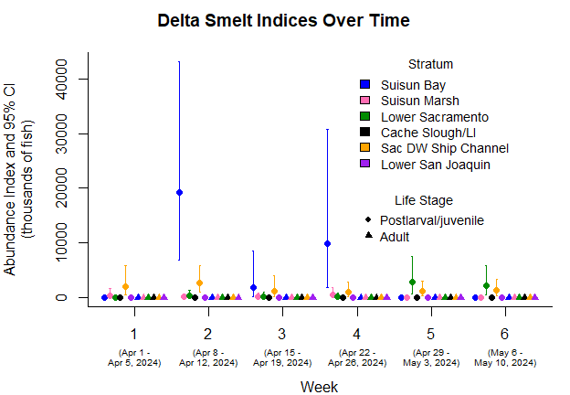
Figure 1: Delta Smelt indices estimates and 95% confidence intervals by week number and stratum for weeks 1 through 6.
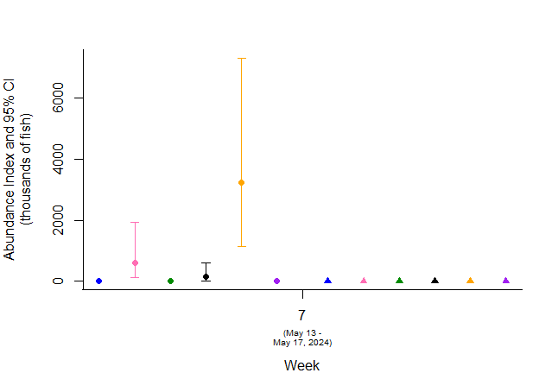
Figure 2: Delta Smelt indices estimates and 95% confidence intervals by week number and stratum for week 7.
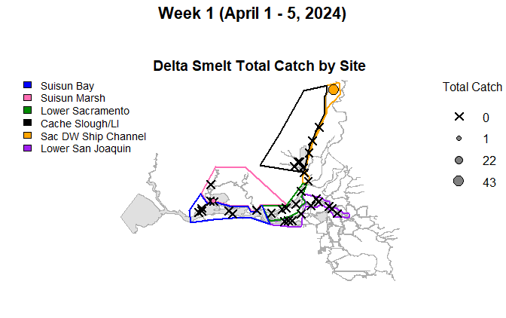
Figure 3: Map of total Delta Smelt catch by site in Week 1.
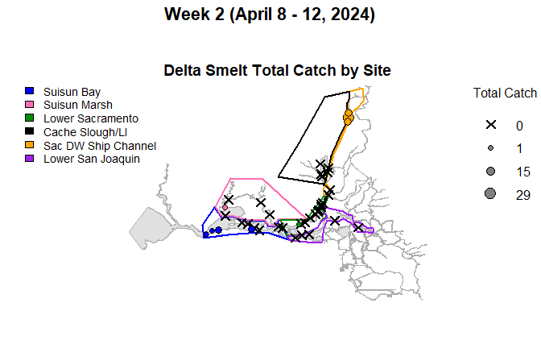
Figure 4: Map of total Delta Smelt catch by site in Week 2.
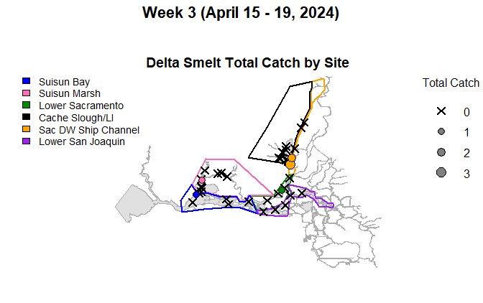
Figure 5: Map of total Delta Smelt catch by site in Week 3.
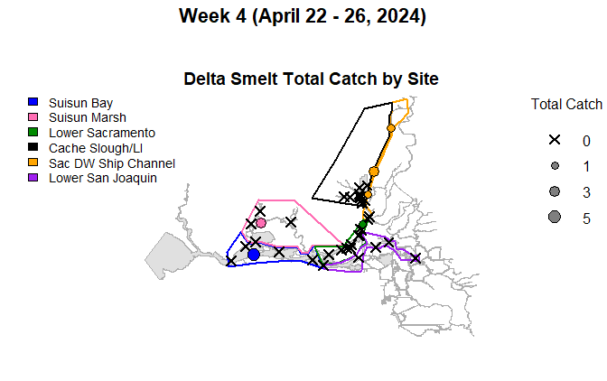
Figure 6: Map of total Delta Smelt catch by site in Week 4.
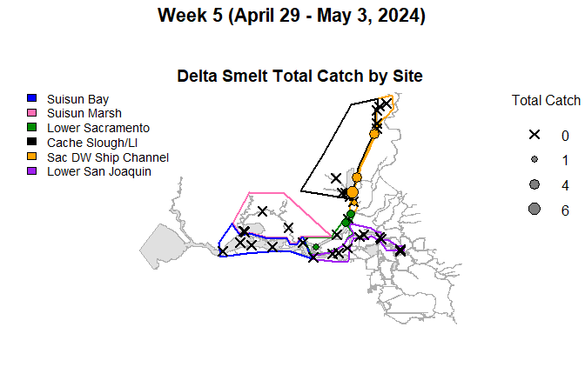
Figure 7: Map of total Delta Smelt catch by site in Week 5.
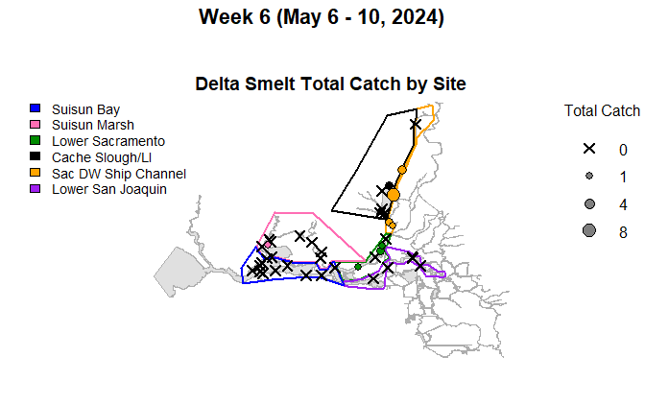
Figure 8: Map of total Delta Smelt catch by site in Week 6.
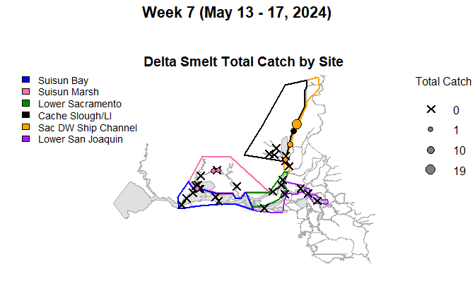
Figure 9: Map of total Delta Smelt catch by site in Week 7.

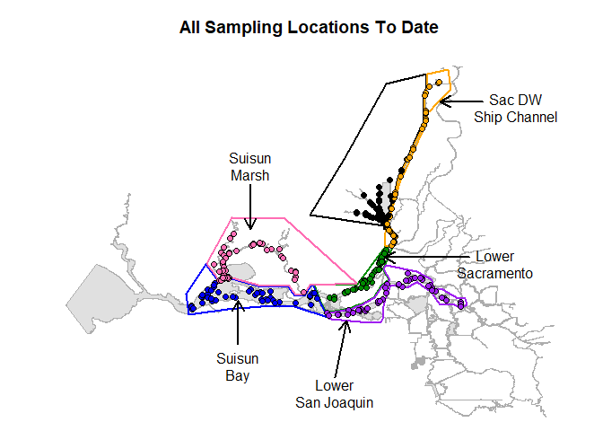
Figure 10: Map of all sampling sites in this phase.

Habitat Volume Estimates
Postlarval/juvenile and adult abundance indices are based on estimates of habitat water volume between 0 and 10-m depth, and between 0.5-m and 4.5-m depth, respectively (Table 4).
Table 4: Estimates of water volume (cubic meters) between 0 and 10-m depth (Volume 1) and between 0.5-m and 4.5-m depth (Volume 2), by stratum.
Stratum | Volume 1 | Volume 2
Cache Slough/LI | 52,180,503 | 33,420,492
Lower Sacramento | 171,562,419 | 88,162,170
Lower San Joaquin | 232,126,861 | 122,096,565
Sac DW Ship Channel | 64,336,104 | 30,411,491
Suisun Bay | 531,809,657 | 285,840,678
Suisun Marsh | 106,744,669 | 76,278,718

References
L. Mitchell, K. Newman, and R. Baxter. Estimating the size selectivity of fishing trawls for a short-lived fish species. San Francisco Estuary and Watershed Science, 17(1), 2019. http://dx.doi.org/10.15447/sfews.2019v17iss1art5.
L. Polansky, L. Mitchell, and K. B. Newman. Using multistage design-based methods to construct abundance indices and uncertainty measures for Delta Smelt. Transactions of the American Fisheries Society, 148(4):710–724, 2019. https://doi.org/10.1002/tafs.10166.
D. L. Stevens and A. R. Olsen. Spatially balanced sampling of natural resources. Journal of the American Statistical Association, 99(465):262 – 278, 2004.
Derivation of a density gradient adjustment factor to standardize Delta Smelt density estimates based on 20 mm surface tows:

During experimental larval sampling by EDSM staff in spring 2018 and spring 2019, surface tows with a 20 mm trawl generally produced higher catch-per-unit-effort (CPUE) of Delta Smelt than oblique or midwater tows. These differences in CPUE are likely caused by fish densities being higher at the surface than at depth, though other alternative or complementary explanations are possible. For example, it may be easier for post-larval and juvenile Delta Smelt to passively or actively evade the net during midwater and oblique tows than during surface tows.

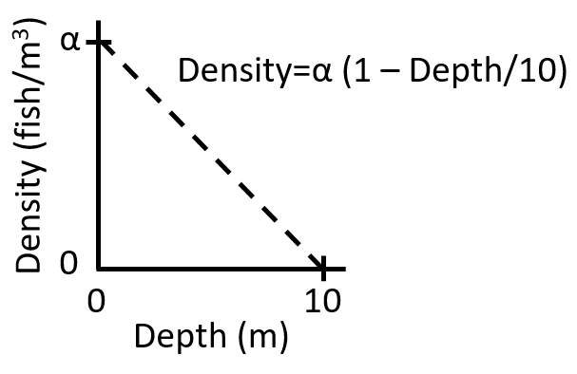
Figure A1. Fish density as a function of depth in the water column.
Starting in 2020, Phase 2 switched from using oblique tows to using surface tows in an effort to increase its overall ability to detect early life stage Delta Smelt. Here we assume that (1) post-larval and juvenile Delta Smelt caught from April through June are located between the surface and 10 m depth, and (2) the density of post-larval and juvenile Delta Smelt has a positive value $α$ at the water surface and decreases linearly to 0 at 10 m depth (Figure A1). The first assumption has been used previously in EDSM Phase 2 reports from 2017–2019 and by Polansky et al. (2019), all of which used data collected with oblique tows. The second assumption has not been explicitly used before, but does not affect density estimates based on oblique tows, as explained below.

The true average density in the vertical stratum between 0 and 10 m can be calculated as:
$${\overline{δ}}_{true}=\frac{1}{10}\int_{0}^{10}{α\left(1-\frac{x}{10}\right)dx}=\frac{α}{2}.$$ | (1)
Using the 20 mm trawl’s maximum net mouth height of 1.18 m and assuming, for simplicity, that the net mouth is rectangular (it is actually D-shaped), the average density as calculated from surface tows that sample the top 1.18 m of the water column is:
$${\overline{δ}}_{surface tow}=\frac{1}{1.18}\int_{0}^{1.18}{α\left(1-\frac{x}{10}\right)dx}=0.941 × α=\frac{α}{2}×1.882={\overline{δ}}_{true}×1.882.$$ | (2)
Then the true average density can be calculated from the surface tow average density as:
$${\overline{δ}}_{true}=\frac{1}{1.882}×{\overline{δ}}_{surface tow}=0.5313×{\overline{δ}}_{surface tow},$$ | (3)
and the density gradient adjustment factor is therefore 1/1.882 or approximately 0.5313. The density gradient adjustment factor is a function of the deeper stratum boundary, which in this case is 10 m. Because the San Francisco Estuary has variable water depths, this adjustment factor changes depending on sample location and environmental conditions that affect water depth. For simplicity, however, we have applied the single value 1/1.882 throughout the analysis. Note that no adjustment factor is needed for oblique tows because oblique tows sample from roughly the entire vertical cross-section of the stratum containing fish, in which case the integrals in Equations (1) and (2) are identical and the adjustment factor becomes one.

