PQRef: 35164/24
Deputy Holly Cairns
Question:
'To ask the Minister for Further and Higher Education; Research; Innovation and Science the total level of funding provided by Taighde Éireann; the breakdown of the level of funding provided to different categories of research for example, basic and applied; and the institution associated with each research project in receipt of funding, in tabular form.'

Total level of funding provided by SFI in 2023: €225,780,000

Level of funding provided to different categories of research:

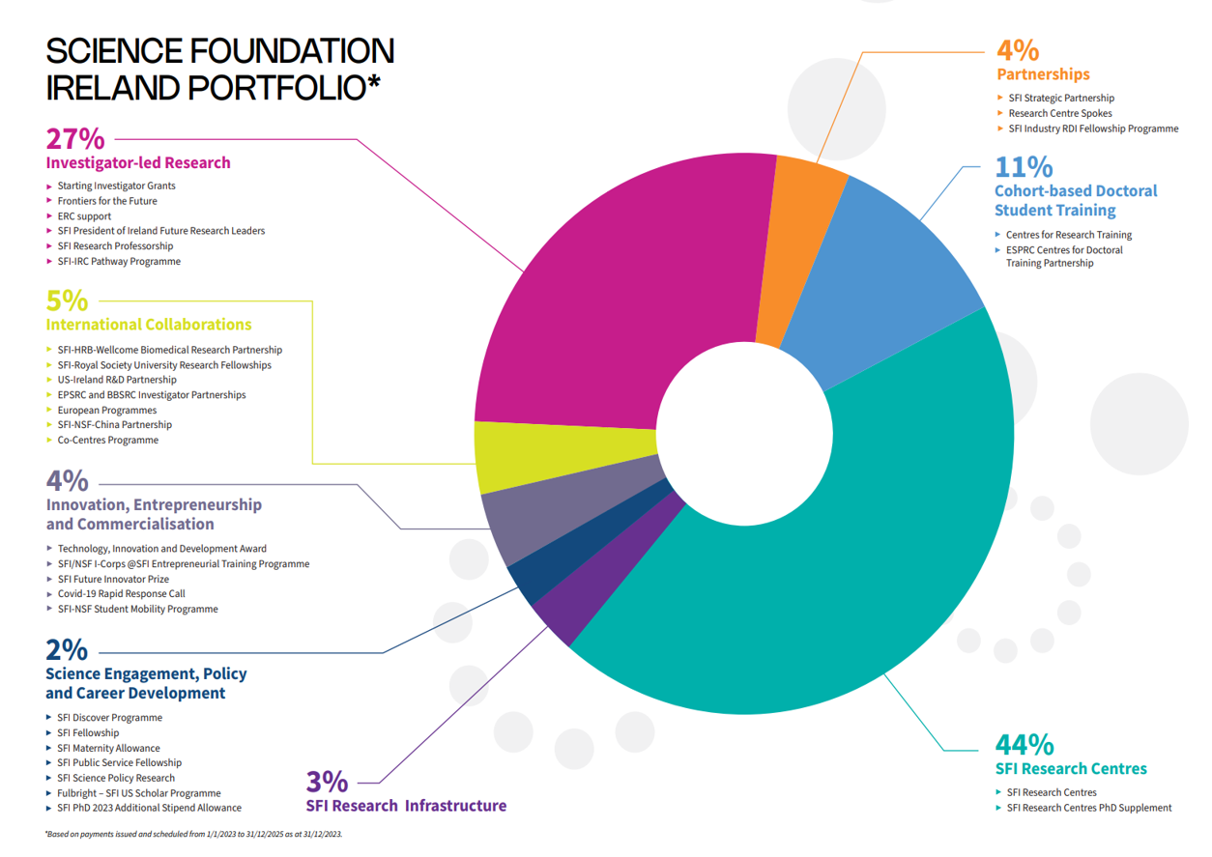
*Above graph based on payments issued and scheduled from 1/1/2023 to 31/12/2026 as at 31/12/2023

Level of funding provided to basic research by SFI in 2023: €129,144,000
Level of funding provided to applied research by SFI in 2023: €67,576,236.91

Notes / caveats
- The above figures are estimates only; there is no hard line between basic and applied research. As such, it is impossible to definitively classify an individual award as solely basic or applied.
- All SFI programmes fund aspects of both basic and applied research.
- Classifying research appropriately is particularly difficult for large scale awards such as the SFI Research Centres. These Centres, by design, combine basic research and applied research.
- As per its legislation, SFI funds oriented basic research and applied research; this response is to be read in that context.
- Some SFI programmes don’t directly fund research (e.g. Research Infrastructure, Education and Public Engagement). For example, Research Infrastructure awards facilitate and enable other research awards. These “support awards” are neither basic nor applied. As a result, the basic and applied levels stated above do not sum to the total.

2023 Payments by Institution | €000's
Trinity College Dublin | €46,067
University College Dublin | €37,709
University College Cork | €33,157
University of Galway | €26,098
University of Limerick | €22,817
Tyndall National Institute | €21,879
Maynooth University | €6,967
Dublin City University | €6,930
The Royal Society | €5,119
RCSI University of Medicine and Health Science | €4,922
Technological University Dublin | €4,448
Teagasc | €4,015
Munster Technological University | €2,225
Dublin Institute for Advanced Studies | €1,768
Atlantic Technological University | €1,615
The National Institute for Bioprocessing Research and Training | €495
Technological University of the Shannon | €464
Dundalk Institute of Technology | €426
Kinia | €307
RTÉ | €302
South East Technological University | €270
National College of Ireland | €255
Junior Achievement Ireland Ltd. | €239
Marine Institute | €236
Cosmos Education Ltd. t/a Blackrock Castle Observatory | €171
Mary Immaculate College | €163
Cork City Council t/a Lifetime Lab | €148
The Institution of Engineering and Technology | €146
The Rediscovery Centre | €126
Royal Dublin Society | €122
National Youth Council of Ireland | €90
Other | €705
Reimbursements from co-funding partners | -€4,621
Grand Total | €225,780
Table note:
- The ‘Other’ category represents smaller payments made to 31 other institutions.

