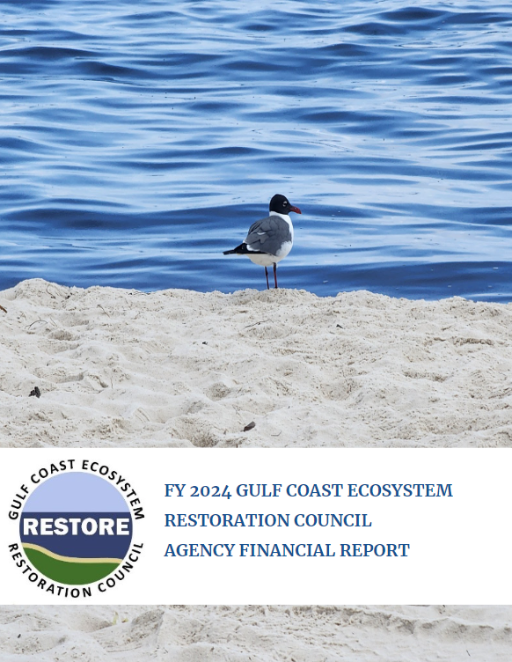

GULF COAST ECOSYSTEM RESTORATION COUNCIL
AGENCY FINANCIAL REPORT
FISCAL YEAR 2024

This Agency Financial Report for fiscal year 2024 provides the financial and performance information for the Gulf Coast Ecosystem Restoration Council (RESTORE Council or Council), enabling the President, Congress, and the American people to assess the RESTORE Council’s performance as provided by the requirements of the:
♦ Antideficiency Act;
♦ Federal Managers’ Financial Integrity Act (FMFIA) of 1982;
♦ Chief Financial Officers (CFO) Act of 1990;
♦ Government Performance and Results Act (GPRA) of 1993 as amended by the Government Performance and Results Act Modernization Act (GPRAMA) of 2010;
♦ Government Management Reform Act of 1994;
♦ Debt Collection Improvement Act of 1996;
♦ Federal Financial Management Improvement Act of 1996;
♦ Reports Consolidation Act of 2000;
♦ Accountability of Tax Dollars Act (ATDA) of 2002;
♦ Digital Accountability and Transparency Act of 2014 (DATA Act);
♦ Federal Information Security Modernization Act of 2014 (FISMA);
♦ Payment Integrity Information Act of 2019 (PIIA); and
♦ Grant Reporting Efficiency and Agreements Transparency Act of 2019 (GREAT Act).

This report is available on the internet at https://www.restorethegulf.gov/reports/performance-and-accountability-reports.
TABLE OF CONTENTS
MESSAGE FROM THE EXECUTIVE DIRECTOR 4
SECTION I: MANAGEMENT’S DISCUSSION AND ANALYSIS (MD&A) 7
I. Mission and Organization Structure 7
A. Council-Selected Restoration Component 8
B. Spill Impact Component 10
C. Fiscal Year 2024 Significant Council Actions 10
D. RESTORE Council Goals 12
E. RESTORE Council Objectives 13
F. RESTORE Council Planning Framework Priority Approaches 14
G. Performance Goals and Indicators for Fiscal Year 2024 15
H. Assessment of the Council’s Progress 16
I. Summary of Performance in Terms of Historical Trends 24
J. Summary of Strategies and Resources Used to Achieve Goals 26
K. Summary of Significant Underlying Factors that Affected the Performance (including factors outside of the Council’s control as well as those the Council could control) 27
L. Identification of Anticipated and Unanticipated Risks 28
M. Summary of Plans to Improve Performance 30
N. Summary of Procedures Management Designed and Followed to Provide Reasonable Assurance that Performance Information is Reliable and Relevant 31
O. Risks to the Agency’s Achievement of its Goals and Objectives 32
II. ANALYSIS OF FINANCIAL STATEMENTS 32
III. ANALYSIS OF SYSTEMS, CONTROLS, AND LEGAL COMPLIANCE 43
IV. FORWARD-LOOKING INFORMATION 45
SECTION II: FINANCIAL SECTION 46
MESSAGE FROM THE CHIEF FINANCIAL OFFICER 46
Inspector General’s Transmittal Letter 47
Independent Auditor’s Report 49
FINANCIAL STATEMENTS 51
BALANCE SHEETS 52
STATEMENTS OF NET COST 53
STATEMENTS OF CHANGES IN NET POSITION 54
STATEMENTS OF BUDGETARY RESOURCES 55
NOTES TO THE FINANCIAL STATEMENTS 56
SECTION III: OTHER INFORMATION (UNAUDITED) 65
I. SUMMARY OF FINANCIAL STATEMENT AUDIT AND MANAGEMENT ASSURANCE 65
II. REVENUE FOREGONE 66
III. MANAGEMENT PERFORMANCE CHALLENGES 66
IV. PAYMENT INTEGRITY INFORMATION ACT 76
V. BIENNIAL REVIEW OF USER FEES 76
VI. GRANTS PROGRAM 76

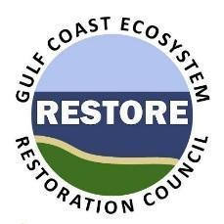
Gulf Coast Ecosystem Restoration Council
New Orleans, LA 70130

MESSAGE FROM THE EXECUTIVE DIRECTOR

November 13, 2024
I am pleased to submit the Agency Financial Report (AFR) for the Gulf Coast Ecosystem Restoration Council (Council) for fiscal year 2024 (FY 2024). The AFR provides an assessment of the Council’s financial management and program performance and outlines the Council’s accomplishments in implementing the Resources and Ecosystems Sustainability, Tourist Opportunities, and Revived Economies of the Gulf Coast States Act of 2012 (RESTORE Act).
The RESTORE Act dedicated 80% of all Clean Water Act (CWA) administrative and civil penalties arising from the Deepwater Horizon (DWH) oil spill to the Gulf Coast Restoration Trust Fund (Trust Fund) and established the Council as an independent entity within the Federal government. The Council was formally established in 2012 with the mission of implementing a long-term, comprehensive plan for the ecological and economic recovery of the Gulf Coast region. The Council, consisting of the five Gulf Coast states directly impacted by the DWH oil spill as well as six Federal agencies, is committed to working with Gulf communities and partners to invest in actions, projects, and programs that will ensure the long-term environmental health and economic prosperity of the Gulf Coast region. The Council approves projects and programs for funding under the Council-Selected Restoration Component of the RESTORE Act as set forth in Funded Priorities Lists (FPLs), as well as projects and programs under the Spill Impact Component of the RESTORE Act as set forth in State Expenditure Plans. The Council develops FPLs through collaboration among its members and with feedback from stakeholders across the Gulf; State Expenditure Plans are developed by individual Council state members.
In early FY 2024, the Council approved additional funding for the Comprehensive Plan Commitment and Planning Support FPL which provided an additional $350,000 per year per member for the next 5 years for the support of existing and future collaboration, coordination, public engagement and use of best available science in developing and selecting restoration projects. Council also initiated our fourth FPL process. In preparation for this new FPL, the Council updated the 2019 Planning Framework. The Planning Framework serves as a “bridge” between the Council’s overarching goals and objectives identified in the Comprehensive Plan and the specific restoration projects and programs approved in future FPLs.
Furthermore, throughout FY 2024, the Council awarded $260,366,661 through the completion of 131 grant actions, including 10 new awards and 19 monetary amendments, 32 non-monetary awards, and 55 Administrative Adjustments to carry out projects and programs under the RESTORE Act, as well as 15 award closeouts. These awards now bring the total amount awarded by the Council to $1.15B, crossing a major threshold in funding for restoration activities across the Gulf Coast region using funds from the Deepwater Horizon oil spill settlement: These awarded funds include: $470.42M under the Council-Selected Restoration Component, and $679.17M under the Spill Impact Component.
.
The Council also worked diligently during FY 2024 to improve its grants management processes and efficiencies through the evaluation of strategies that reduce the time it takes to review and make financial awards while maintaining high-performance standards. A significant effort in FY 2024 towards supporting this goal involved conducting a series of cross-functional, focused meetings to drive systematic changes to improve efficiencies, increase productivity, reduce grant recipient burden, reduce risk, and ensure compliance. This focused effort will be completed in early FY 2025 with implementation of improvements to follow.
As the Council continues to work towards achieving the goals and objectives of the Comprehensive Plan in order to advance its vision of a “healthy and productive Gulf ecosystem achieved through collaboration on strategic restoration projects and programs,” it emphasizes sound management of its funding and resources. This is evidenced by the Financial Statement Audit completed on November 13, 2024, that resulted in an unmodified opinion with no material weaknesses or significant deficiencies and a finding that the financial statements presented the financial position of the Council fairly, in all material respects for the tenth year in a row. Further, the Council had a successful FY 2024 audit outcome for its information security program and practices under the Federal Information Security Modernization Act of 2014 (FISMA)., Under the latest evaluation, the Council responded to the core and supplemental metrics from the Office of Management and Budget’s (OMB) FY 2024 Inspector General FISMA Metrics Evaluator’s Guide ver. 4.0 April 30, 2024. The Council takes great pride in implementing internal controls over the effectiveness and efficiency of operations, reliable financial reporting, and compliance with applicable laws and regulations to ensure operational effectiveness is operating effectively at the highest federal standards.
The Council looks forward to serving the people of the Gulf Coast through its continuing efforts in carrying out comprehensive ecosystem restoration in order to preserve and enhance the long-term environmental health and economic prosperity of the Gulf Coast region.

/S/ Original Signed
Mary S. Walker
Executive Director

SECTION I: MANAGEMENT’S DISCUSSION AND ANALYSIS (MD&A)
(UNAUDITED)

Mission and Organization Structure
The Gulf Coast environment was significantly damaged by the 2010 Deepwater Horizon (DWH) oil spill disaster. In an effort to advance environmental and economic recovery from the spill, Congress enacted the RESTORE Act (33 U.S.C §1321(t) and note) in July 2012, which amended the CWA and created the Council as well as the Trust Fund. Pursuant to the Act, the Trust Fund receives 80 percent of the civil and administrative penalties assessed under the CWA resulting from the 2010 DWH oil spill. The Council is composed of the Governors of Alabama, Florida, Louisiana, Mississippi, and Texas, the Secretaries of the U.S. Departments of Agriculture, the Interior, the Army, Commerce, and Homeland Security, and the Administrator of the U.S. Environmental Protection Agency (Administrator). The Administrator is the current Council Chairperson.

U.S. Environmental Protection Agency (Chair)
Michael Regan
Administrator

State of Alabama  Kay Ivey  Governor | U.S. Department of Agriculture  Tom Vilsack  Secretary
State of Florida  Ron DeSantis  Governor | U.S. Department of the Army  Michael L. Conner  Assistant Secretary of the Army for Civil Works
State of Louisiana  Jeff Landry  Governor | U.S. Department of Commerce  Gina Raimondo  Secretary
State of Mississippi  Tate Reeves  Governor | U.S. Department of Homeland Security  Alejandro Mayorkas  Secretary
State of Texas  Greg Abbott  Governor | U.S. Department of the Interior  Deb Haaland  Secretary

The Council administers the expenditure of 60% of the funds deposited in the Trust Fund (Figure 1). The majority of the Trust Fund’s receipts are from BP Exploration & Production Inc. (“BP”) over a 15-year period ending in 2031, pursuant to a 2016 settlement among the United States, the five Gulf states and BP. Funding for RESTORE projects is limited to amounts available in the Trust Fund. A history of the civil penalties can be found in previous AFRs on the Council’s website and the Comprehensive Plan.
Under the Council-Selected Restoration Component of the Act, 30% of available funding is administered for Gulfwide ecosystem restoration and protection through Funded Priority Lists (FPL) developed in collaboration among the members of the Council. The Council-Selected Restoration Component funding decisions are guided by criteria set forth in the RESTORE Act, the Council’s Comprehensive Plan and other policies, including the Council’s Planning Framework. The remaining 30% is allocated to the states under the Spill Impact Component of the Act, according to a formula and regulation approved by the Council in December 2015. Spill Impact Component funds are spent according to individual State Expenditure Plans (SEPs), developed by each state Council member, that contribute to the overall economic and ecological recovery of the Gulf. The SEPs must adhere to criteria set forth in the Act and are subject to approval by the Council chair in accordance with those criteria. By US District Court Order in June 2024, the remaining funds from the Halliburton Energy Services, Inc (HESI)/Transocean punitive damages settlement in the amount of $27.8 M were made available to the five Gulf States distributed as follows: Louisiana, 32%; and Alabama, Florida, Mississippi, and Texas 17% each.
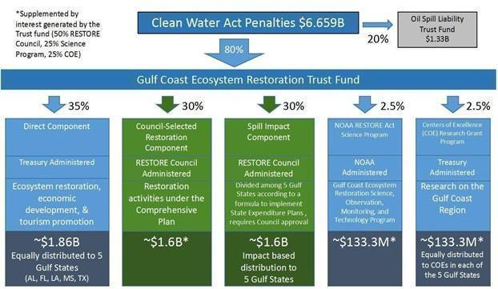
Figure 1. Allocation of the Gulf Coast Restoration Trust Fund based on settlements with BP, Transocean and Anadarko; RESTORE Council oversight components are highlighted in green.

Council-Selected Restoration Component
Under the Council-Selected Restoration Component of the Act, only Council members are eligible to submit proposals for funding. Council approval of funding requires the affirmative vote of at least three state members and the Chair. The other five federal members do not formally vote on Council funding. The Council uses FPLs that set forth approved projects and programs. The Council develops FPLs through collaboration among its members and with feedback from stakeholders across the Gulf.
Funds for approved FPL projects are disbursed to Council members via grants to state members and interagency agreements (IAAs) with federal members. As part of the grant and IAA process, all activities for which funding is sought are carefully reviewed to ensure consistency with the approved FPL and compliance with the RESTORE Act and all other applicable requirements, including compliance with all applicable federal environmental laws and the application of best available science criteria (BAS) as required by the Act and further defined by the Council.
In selecting projects and programs under the Council-Selected Restoration Component, the RESTORE Act requires that the Council give the highest priority to activities that address one or more of the following criteria:
- Projects that are projected to make the greatest contribution to restoring and protecting the natural resources, ecosystems, fisheries, marine and wildlife habitats, beaches, and coastal wetlands of the Gulf Coast region, without regard to geographic location within the Gulf Coast region.
- Large-scale projects and programs that are projected to substantially contribute to restoring and protecting the natural resources, ecosystems, fisheries, marine and wildlife habitats, beaches, and coastal wetlands of the Gulf Coast ecosystem.
- Projects contained in existing Gulf Coast state comprehensive plans for the restoration and protection of natural resources, ecosystems, fisheries, marine and wildlife habitats, beaches, and coastal wetlands of the Gulf Coast region.
- Projects that restore long-term resiliency of the natural resources, ecosystems, fisheries, marine and wildlife habitats, beaches, and coastal wetlands most impacted by the DWH oil spill.
In the Comprehensive Plan, the Council describes its progress toward its commitments thus far and builds upon these commitments by highlighting the importance of efficient, effective, and transparent environmental compliance.
The Council’s commitments are:
- Taking a regional ecosystem-based approach to restoration;
- Leveraging resources and partnerships;
- Maintaining and enhancing public engagement, inclusion, and transparency;
- Providing efficient, effective, and transparent environmental compliance;
- Applying science-based decision-making; and
- Delivering results and measuring impacts.
The Council’s vision for restoration is as follows:
A healthy and productive Gulf ecosystem achieved through collaboration on strategic restoration projects and programs.
The Council continues to believe that its vision statement for the Funding Strategy should include reference to both the desired environmental outcomes and the processes used to accomplish them. In these processes the Council will build upon the tremendous restoration experience, scientific expertise, and other capabilities of its diverse membership of state and federal agencies.

Spill Impact Component
Under the Spill Impact Component of the Act the remaining 30% of amounts in the Trust Fund administered by the Council is allocated to the state Council members (except for Florida, where funds are allocated to a consortium of 23 affected Florida counties (“Consortium”). On December 9, 2015, the RESTORE Council voted to approve a final rule for allocation of the Spill Impact Component funds and disbursed to each state. The rule became effective on April 4, 2015, when the Federal court in Louisiana approved and entered the Consent Decree. Using the information set forth in the rule, the allocation of funds among the five states is:
- Alabama – 20.40%;
- Florida – 18.36%;
- Louisiana – 34.59%;
- Mississippi – 19.07%; and
- Texas – 7.58%.
Spill Impact Component funds are spent according to individual SEPs developed by each state member that set forth programs contributing to the overall economic and ecological recovery of the Gulf. In 2016 the Council updated the Guidelines that describe required SEP elements, the process for submitting SEPs, and the criteria set forth in the Act under which the Council Chair must approve or disapprove SEPs.
Funds for projects in approved SEPs are disbursed to the state Council members (in Florida, to the Consortium) via grants when the requisite funds become available in the Trust Fund. As with the Council-Selected Restoration Component, all activities for which Spill Impact component funding is sought are carefully reviewed to ensure consistency with the applicable SEP and compliance with the RESTORE Act and all other applicable requirements, including the use of BAS and compliance with all applicable federal environmental laws.

Fiscal Year 2024 Significant Council Actions
In FY 2024, the Council crossed a major threshold. As of June of 2024, the Council has awarded over $1.15 Billion in funding for restoration activities across the Gulf Coast using funds from the Deepwater Horizon oil spill settlement. Furthermore, throughout FY 2024, the Council was able to complete several significant Council actions. The RESTORE Act (33 U.S.C. § 1321(t) and note) requires a Council vote for the following types of actions (referred to as “Significant Actions”) (33 U.S.C § 1321(t)(2)(C)(vi)):
- Approval of the Comprehensive Plan and revisions and updates thereto;
- Approval of State Expenditure Plans (SEPs) and revisions and updates thereto;
- Approval of reports to Congress required by the Act;
- Approval of transfers pursuant to 33 U.S.C. § 1321(t)(2)(E)(ii)(II); and
- Other Significant Actions as determined by the Council (e.g., approval of the Council regulation establishing the formula required under 33 U.S.C. § 1321(t)(3)).
- All Significant Actions of the Council, except approval of SEPs, require the affirmative vote of the Chairperson and three State members to be effective. Approval of a SEP or a SEP revision requires only the affirmative vote of the Chairperson together with certification that the SEP satisfies all applicable requirements of the RESTORE Act by the submitting State member. Following is a list of the Council’s Significant Actions for FY 2024:

    - Council-Selected Restoration Component FY 2024 Accomplishments
      - In October of 2023, the Council approved an update to the Comprehensive Plan Commitment and Planning Support FPL (CPS FPL) to add $350,000 a year per member for 5 years in additional funding, or a total of $1.75M per member. This action also updated the reporting schedule from semi-annual to annual.
      - Also in October 2023, the Council initiated the development of the fourth FPL (FPL 4). The Council revised and approved the FPL proposal submission guidelines, the planning framework, and agreed upon the development timeline. Through extensive coordination and collaboration between members, the Council developed and submitted twenty proposals for consideration for FPL 4. The draft FPL 4 document is expected in FY 25, with the goal of final approval in April of 2026.
      - On September 25, 2024, the Council approved amendments to FPL 3b that included
        - $7,500,000 in implementation funds for the Norton Creek Sanitary Sewer Inflow and Infiltration Rehabilitation project, a component of the FPL 3b Coastal Alabama Regional Water Quality Program.
        - $1,000,000 in implementation funds for the Highway 297a Retrofit Pond project, a component of the FPL 3b Florida Water Quality Improvement Program.
        - Expansion of the geographic boundary for the FPL 3b Tribal Youth Coastal Restoration Program to include the possibility of working with the Alabama-Coushatta Tribe of Texas on land owned by the National Park Service within the Big Thicket National Preserve, Texas.
        - Reallocation of $37,660 in previously approved FPL 1 funding from the Plug Abandoned Oil and Gas Wells project in Texas to the Jean Lafitte Canal Backfilling project in Louisiana.
    - Spill Impact Component FY 2024 Accomplishments
      - On January 17, 2024, the Council Chair, the U.S. Environmental Protection Agency, approved the Texas SEP Amendment #2. The Council also voted to amend its 2021 Funded Priorities List 3b (FPL 3b) to approve $2,123,000 in implementation funding for the City of Loxley Corn Creek Tributary Restoration project, a component of the FPL 3b Coastal Alabama Regional Water Quality Program and $6,400,000 in implementation funding for the Carpenter Creek Bayou Texar Watershed Outfalls project, a component of the FPL 3b Florida Water Quality Improvement Program.
      - On March 18, 2024, the Council Chair, approved the Florida SEP Amendment #6. This amendment modified scopes and/or reallocated funds among a subset of previously-approved projects to adjust to cost increases, changing priorities, and other factors. The amendment also added a new project in Charlotte County to improve wastewater treatment capacity, replacing the County’s previously planned septic-sewer project.
      - On May 31, 2024, the Council Chair approved the Mississippi State Expenditure Plan (SEP) 2023 Amendment. The amendment increased funding for existing SEP activities including restoration planning, a working waterfront in support of commercial seafood, and a coastal science program for high schools. The amendment also provided funding for new activities including invasive species detection and treatment, a Pascagoula River scenic trail, an artificial reef project, an interactive aquarium exhibit, and educational facilities at a Center for Marine Education and Research. The total funding that would be approved for both the new and existing SEP activities is $17,100,000.

RESTORE Council Goals
Restoring an area as large and complex as the Gulf Coast region is a costly, multi-generational undertaking. To provide the overarching framework for an integrated and coordinated approach for region-wide Gulf Coast restoration and to help guide the collective actions at the local, state, tribal, and federal levels, the Council has adopted five goals.
- Restore and Conserve Habitat – Restore and conserve the health, diversity, and resilience of key coastal, estuarine, and marine habitats.
- Restore Water Quality and Quantity – Restore and protect the water quality and quantity of the Gulf Coast region’s fresh, estuarine, and marine waters.
- Replenish and Protect Living Coastal and Marine Resources – Restore and protect healthy, diverse, and sustainable living coastal and marine resources.
- Enhance Community Resilience – Build upon and sustain communities with the capacity to adapt to short- and long-term changes.
- Restore and Revitalize the Gulf Economy – Enhance the sustainability and resiliency of the Gulf economy.
The fifth goal focuses on reviving and supporting a sustainable Gulf economy. This goal pertains to expenditures by the Gulf Coast states authorized in the RESTORE Act under the Direct Component (administered by the Department of the Treasury) and the Spill Impact Component and ensures that these investments can be considered in the context of comprehensive restoration. This goal does not apply to the Council-Selected Restoration Component.
To achieve all five goals, the Council supports ecosystem restoration that can enhance local communities by giving people desirable places to live, work, and play, while creating opportunities for new and existing businesses of all sizes, especially those dependent on natural resources. In addition, the Council supports ecosystem restoration that builds local workforce capacity.
The Council coordinates restoration activities under the Council-Selected Restoration Component and the Spill Impact Component to further the goals. While the Council does not have direct involvement in the activities undertaken by the States or local governments through the Direct Component, the Council will strive, as appropriate, to coordinate its work with those activities. In addition, the Council actively coordinates with the Gulf Coast Ecosystem Restoration Science Program (administered by the National Oceanic and Atmospheric Administration) and the Centers of Excellence Research Grants Program (administered by the Treasury Department).

RESTORE Council Objectives
The Council selects and funds projects and programs that restore and protect the natural resources, water quality, fisheries, marine and wildlife habitats, and ecosystems, including beaches and coastal wetlands of the Gulf Coast region. Projects and programs that are not aligned with the scope of the following objectives for ecosystem restoration will not be funded under the Council-Selected Restoration Component.
- Restore, Enhance, and Protect Habitats – Restore, enhance, and protect the extent, functionality, resiliency, and sustainability of coastal, freshwater, estuarine, wildlife, and marine habitats.
- Restore, Improve, and Protect Water Resources – Restore, improve, and protect the Gulf Coast region’s fresh, estuarine, and marine water resources by reducing or treating nutrient and pollutant loading; and improving the management of freshwater flows, discharges to and withdrawals from critical systems.
- Protect and Restore Living Coastal and Marine Resources – Restore and protect healthy, diverse, and sustainable living coastal and marine resources including finfish, shellfish, birds, mammals, reptiles, coral, and deep benthic communities.
- Restore and Enhance Natural Processes and Shorelines – Restore and enhance ecosystem resilience, sustainability, and natural defenses through the restoration of natural coastal, estuarine, and riverine processes, and/or the restoration of natural shorelines.
- Promote Community Resilience – Build and sustain Gulf Coast communities’ capacity to adapt to short‐ and long‐term natural and man‐made hazards, particularly increased flood risks associated with sea-level rise and environmental stressors. Promote ecosystem restoration that enhances community resilience through the re-establishment of non-structural, natural buffers against storms and flooding.
- Promote Natural Resource Stewardship and Environmental Education – Promote and enhance natural resource stewardship through environmental education efforts that include formal and informal educational opportunities, professional development and training, communication, and actions for all ages.
- Improve Science-Based Decision-Making Processes – Improve science-based decision-making processes used by the Council.

RESTORE Council Planning Framework Priority Approaches
The Council’s Planning Framework strategically links past and future restoration funding decisions to the overarching goals and objectives outlined in the Comprehensive Plan Update. The Planning Framework indicates priorities designed to continue building on previous investments, link past and future restoration funding decisions, and place decisions within the context of the Comprehensive Plan goals and objectives (Figure 2). A full description of the Planning Framework is provided in the Comprehensive Plan and previous Annual Reports to Congress found on the Council Website.
The Planning Framework outlines several priority approaches and potential techniques that support those approaches for restoration activities under the Council goals and objectives (Figure 2). The primary approaches differ from Council goals and objectives by providing a general category of methodologies being utilized across projects and programs to achieve overall restoration goals and objectives. For example, a program goal could be to improve estuarine water quality (Goal 2), but the primary approach employed to accomplish this goal could be to protect upstream forest habitat from development.
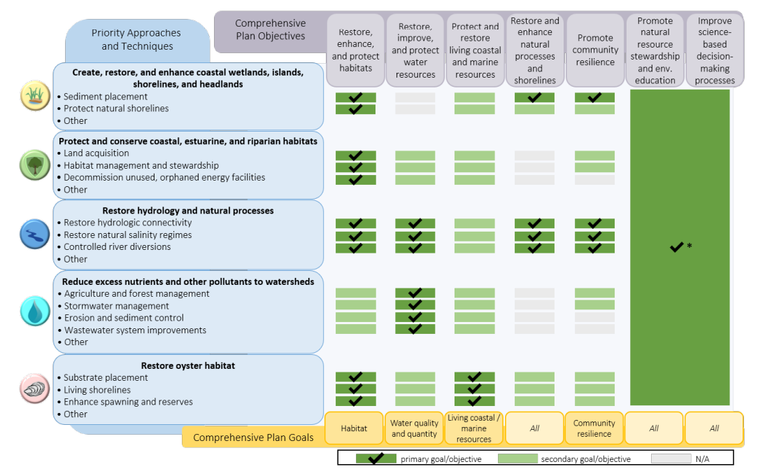
Figure 2. Example from the Planning Framework outlining how ecosystem restoration priority approaches support goals (in yellow) and objectives (in purple).
The Priority Approaches outlined in the Planning Framework include:
- Create, restore, and enhance coastal wetlands, islands, shorelines, and headlands
- Protect and conserve coastal, estuarine, and riparian habitats
- Restore hydrology and natural processes
- Reduce excess nutrients and other pollutants to watersheds
- Restore oyster habitat
- Improve science-based decision-making processes
- Promote natural resource stewardship and environmental education
- Restore and revitalize the Gulf economy

Performance Goals and Indicators for Fiscal Year 2024
The Annual Performance Plan for FY 2024 identified the following performance goals:
- Mission Performance Goals
The Mission Performance goals include the core functions and activities of Federal agencies that are reflected in statutory requirements or leadership priorities and which serve to drive their efforts in addressing pressing and relevant national problems, needs, and challenges (OMB A-11, Section 240).
- Performance Goal 1: Promote a Gulf-wide Comprehensive Approach to Restoration-Effective and efficient advancement of the Council’s vision for “A healthy and productive Gulf ecosystem achieved through collaboration on strategic restoration projects and programs.”
- Performance Goal 2: Council-Selected Restoration Program Performance Excellence-Effective and efficient implementation and administration of the Council-Selected Restoration Program to achieve the goals of the Act.
- Performance Goal 3: Spill Impact Program Performance Excellence - Effective and efficient implementation and administration of the Spill Impact Program achieve the goals of the Act.
- Stewardship Goals
The Stewardship goals respond to the responsibilities of Federal agencies to provide appropriate safeguards in executing mission and service-related activities effectively and efficiently, including minimizing instances of waste, fraud, and abuse (OMB A-11, Section 240).
- Performance Goal 4: Operational Excellence- An administrative infrastructure that supports team work, collaboration, synergy between functional areas and overall operational excellence to provide excellent services, programs and outcomes to the Gulf Coast region is maintained.
- Performance Goal 5: Management Excellence - Council staff will provide exceptional service to the Council members and their accompanying state and federal agencies, as well to the many stakeholders associated with restoration of the Gulf of Mexico ecosystem by meeting programmatic, administrative and customer service objectives.
- Service Goals
The Service goals speak to the activities that reflect the interaction(s) between individual citizens or businesses and Federal agencies in providing a direct service on behalf of the Federal Government, and which is core to the mission of the agency (OMB A-11, Section 240).
- Performance Goal 6: Public Engagement Through Inclusion and Transparency - The Council staff will provide public engagement opportunities that reflect the richness and diversity of the Gulf Coast communities to ensure ongoing public participation in the Council’s restoration efforts.

Assessment of the Council’s Progress
As of FY 2024, the Council has awarded over $1.15 Billion in funding for restoration activities across the Gulf Coast using funds from the Deepwater Horizon oil spill settlement. Over the nine-year period of FY 2016 to FY 2024, a total of $470.42M has been awarded through the Council-Selected Restoration Component through grants, Interagency Agreements (IAA) and amendments, including Commitment Planning Support (CPS) funds through the second FPL. Over the nine-year period of FY 2016 to FY 2024, a total of $679.17M has been awarded through the Spill Impact Component through grants and amendments.
- Progress by Council Goals
Most of the Council investment includes Council-Selected Restoration and Spill Impact Component funding for two of the five goals: Restore and Conserve Habitat (64.1% of investment) and Restore Water Quality and Quantity (24.3% of investment), totaling 88.4% of total investment to date (Figure 3).
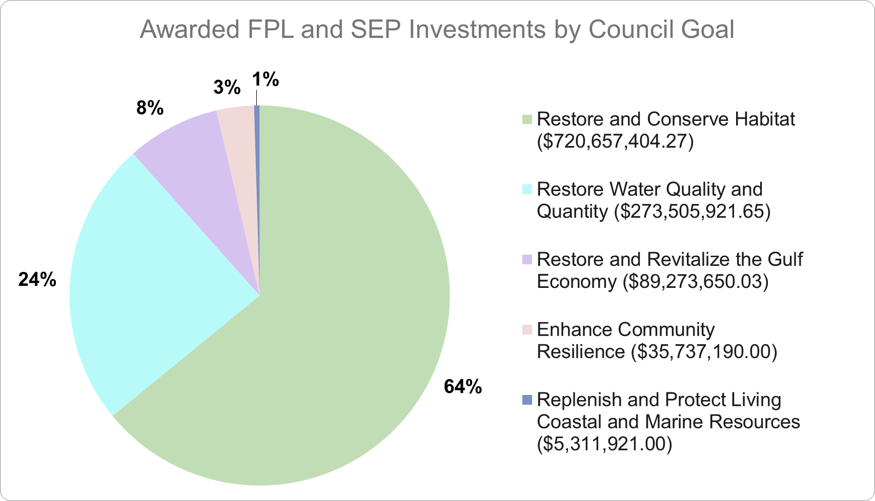
Figure 3. Funding distribution for investments to date, categorized by Council primary goal. Planning support funds, including Commitment Planning Support (FPL2) and planning SEP awards, are excluded.
In addition to identifying the primary Council goal and objective, recipients are required to monitor the performance of restoration projects funded by the Council, primarily through the selection of metrics. The Council’s Observational Data Plan (ODP) Guidelines provides guidance to the Council’s grant and IAA recipients on the selection of metrics, parameters and monitoring methodologies for Council funded activities. The Council has identified 61 metrics that are organized by the Planning Framework restoration approaches and techniques being implemented by a project or program. Funding recipients select from these metrics to identify targets, track annual award performance, and ultimately evaluate the efficacy of projects and programs in meeting the mission goals and objectives of the Council. Based on the FPL Submission Guidelines and ODP Guidelines, metrics should be:
- Objective;
- Quantifiable;
- Accompanied by targets (success criteria);
- Consistent across program activities;
- Identified in proposals with details provided in application ODPs; and
- Able to support the goals and objectives of the program or project.
The following subsections highlight some of the target values of frequently reported metrics associated with the Council’s Comprehensive Plan goals. “Target” values are grant recipient-defined values for the metrics a restoration activity aims to accomplish by award closeout. Target values are not changed after being identified. Therefore, progress on award metrics can exceed the originally defined target, or due to unforeseen circumstances, a target value may not be achieved by a grant recipient as the restoration work unfolds. Progress on achieving metric targets are reported by grant recipients annually. The target values for restoration metrics are aggregated across awards categorized by primary goal.
  - Goal 1: Restore and Conserve Habitat
This goal covers restoration and conservation activities to support the health, diversity, and resilience of key coastal, estuarine, and marine habitats in the Gulf Coast region. To date, the RESTORE Council has awarded 74 awards in support of this goal (Figure 4a).
  - Goal 2: Restore Water Quality and Quantity
This goal includes activities that reduce risks to downstream water bodies in order to restore and protect the water quality and quantity of the Gulf Coast region’s fresh, estuarine, and marine waters. To date, the RESTORE Council has awarded 51 awards in support of this goal (Figure 4b).

  - Remaining Goals
The remaining goals that comprise ~11.6% of total investment include (Figure 4c):
- Goal 3: Replenish and Protect Living Coastal and Marine Resources
- Goal 4: Enhance Community Resilience
- Goal 5: Restore and Revitalize the Gulf Economy, which is only applicable to Spill Impact Component funding through SEPs.

Across these remaining goals there are 3 awards supporting the Living Coastal and Marine Resources Goal, 9 awards supporting the Community Resilience Goal, and 26 awards supporting the Economic Revitalization Goal. Popular metrics across all awards supporting the remaining goals include:
- Number of improvements to recreational resources (13 awards)
- Number of research studies used to inform management (9 awards)
- Number of residential, commercial, and public facilities benefiting (4 awards)

a) b) c)

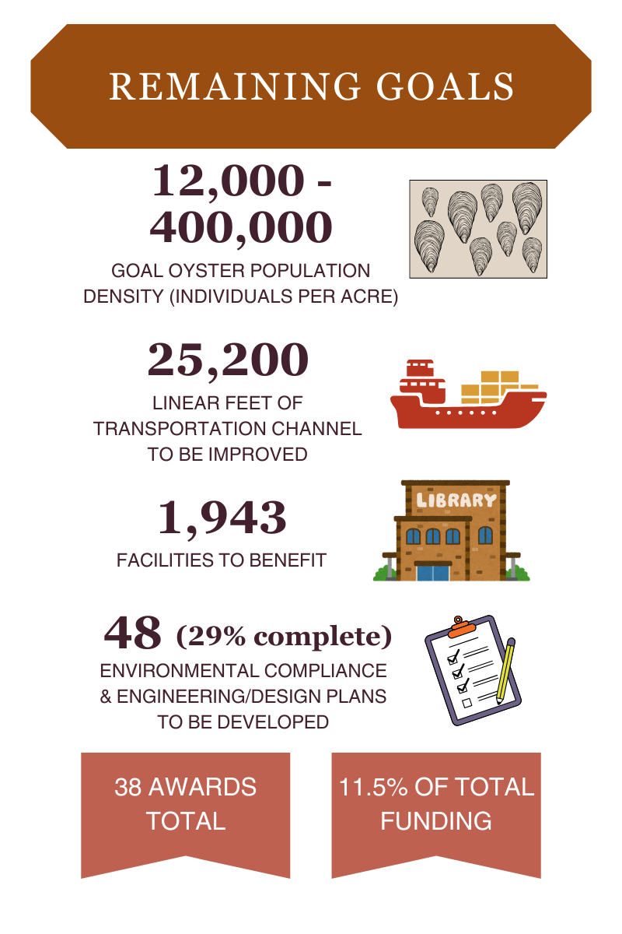
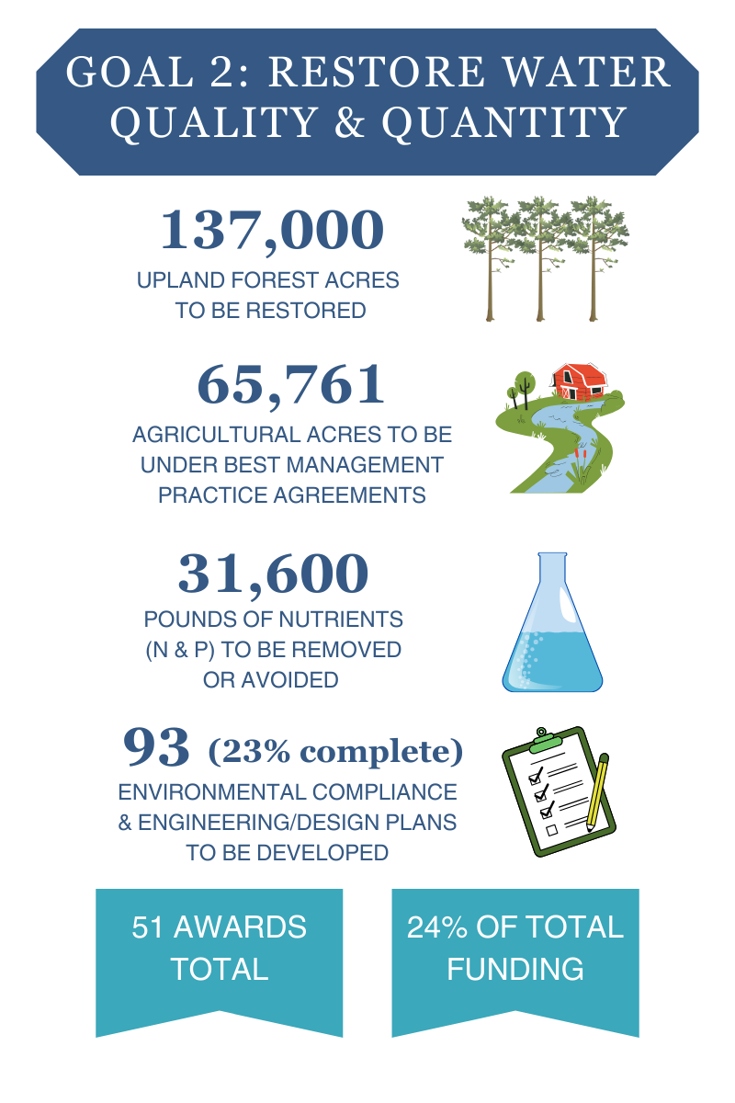
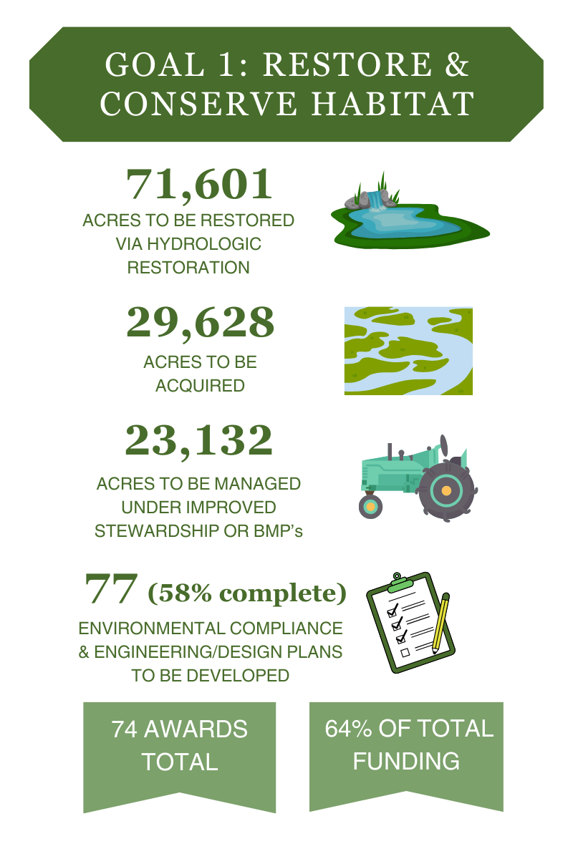

Figure 4. Infographics showing selected metric target values for Council goals: Restore & Conserve Habitat (a), Restore Water Quality & Quantity (b), and remaining goals (c).
- Progress by Council Objectives
Council objectives build on the goals by adding additional objectives that support communities and processes for restoration decision making. The majority of Council investment to date across FPLs and SEPs include funding for the following objectives: Restore, Enhance and Protect Habitats (45.3%); Restore, Improve, and Protect Water Resources (21.1%); and Restore and Enhance Natural Processes and Shorelines (11.4%), together totaling 77.8% of investment (Figure 5).
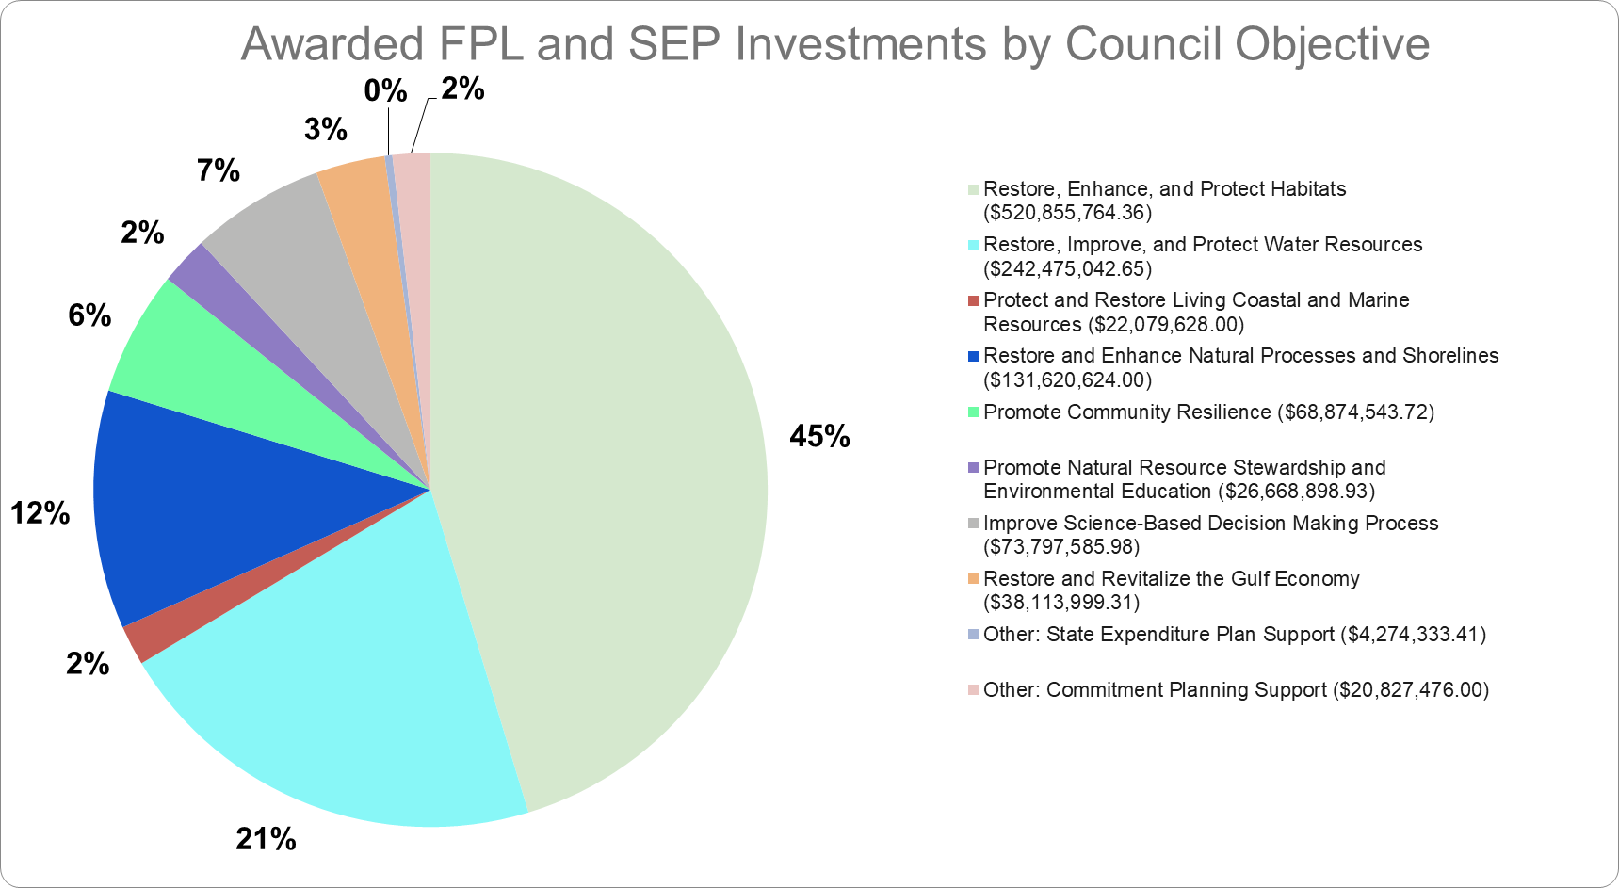
Figure 5. Funding proportions for state and federal members in support of the Council’s Comprehensive objectives through September 18, 2024. Both Council-Selected Restoration Component (FPL) and Spill Impact Component (SEP) awards are included. Planning support grants (Commitment Planning Support and planning SEPs) are also included.
Under the Council-Selected Restoration Component (FPL; Figure 6) the Restore and Enhance Natural Processes and Shorelines objective accounts for more than 25% of investment to date, whereas under the Spill Impact Component (SEP; Figure 7) the objectives to Promote Community Resilience (9.3%) and Improve Science-Based Decision Making Processes (9%) are proportionally higher. Objectives under SEPs reflect state-specific priorities, such as Restore and Revitalize the Gulf Economy (5.6%) and Protect and Restore Living Coastal and Marine Resources (3.3%).
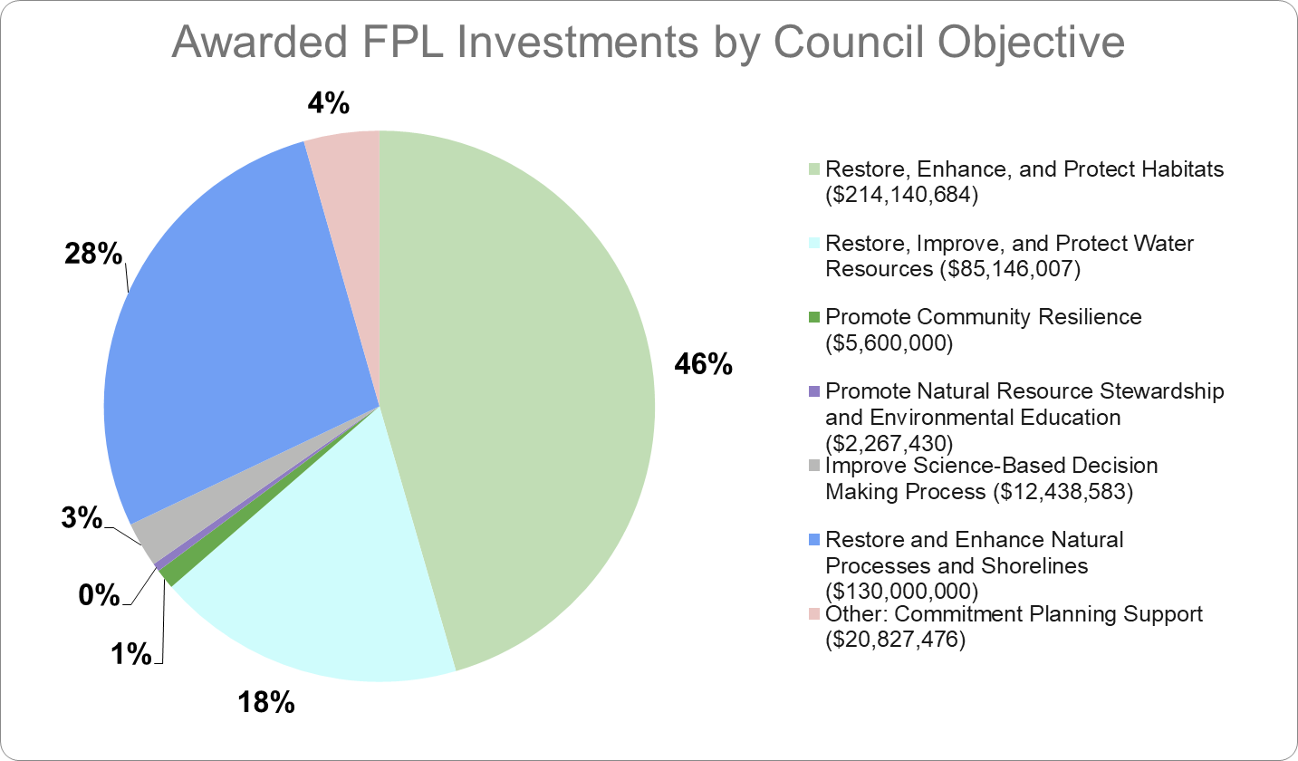

Figure 6: 2015 Initial FPL, 2017 CPS FPL, 2020/2021 FPL 3 funds by Comprehensive Plan objective, awarded as of September 18, 2024. Note: The “Improve science-based decision-making processes” objective is cross-cutting and is sometimes used as an approach to support other objectives. For example, in the 2015 Initial FPL, some monitoring activities were funded to primarily benefit the “Restore, enhance, and protect habitats” objective.
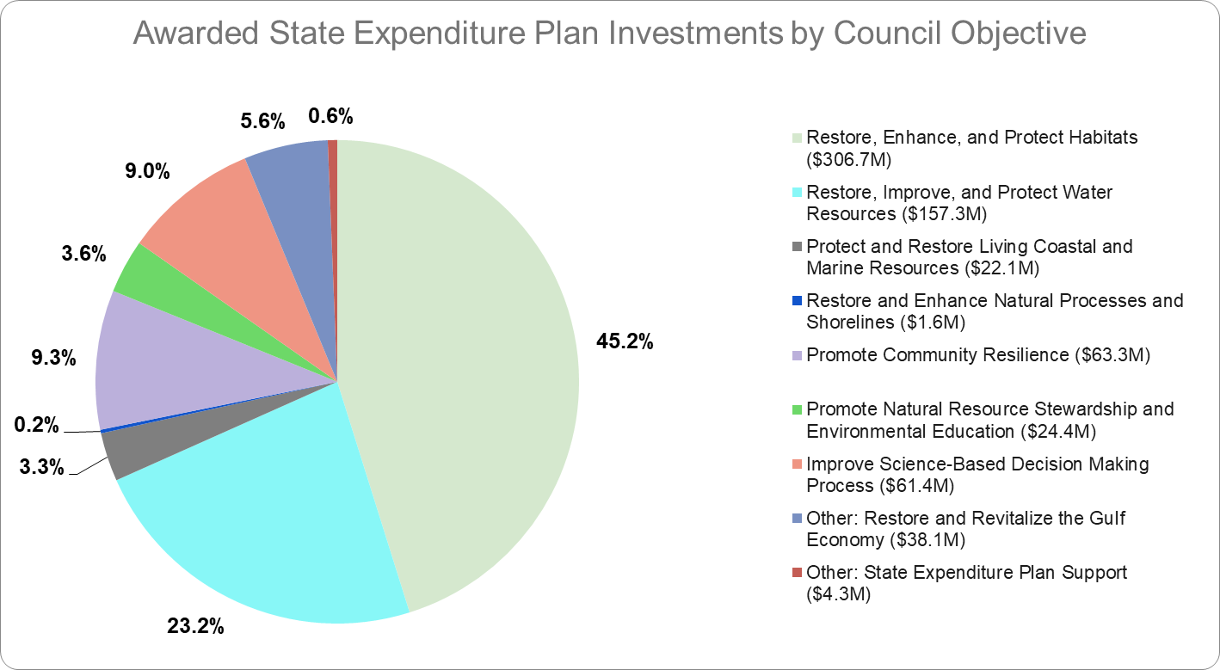
Figure 7. State Expenditure Plans awarded funds by Comprehensive Plan objectives, awarded to all five states as of September 18, 2024. Note: The “Improve science-based decision-making processes” objective is cross-cutting and is sometimes used as an approach to support other objectives. For example, in the 2015 Initial FPL, some monitoring activities were funded to primarily benefit the “Restore, enhance, and protect habitats” objective.

- Progress by Planning Framework Approaches
The Planning Framework provides a mechanism to view the primary approaches to ecosystem restoration of the Gulf being utilized by the members through the Council-Selected Restoration Component FPLs (Table 1) and the Spill Impact Component SEPs (Table 2).
Table 1. 2015 Initial FPL, 2017 CPS FPL, 2020/2021 FPL 3 funds by primary approach, awarded as of September 18, 2024 Note: The “Improve science-based decision-making process” approach is sometimes used to support awards with other primary objectives. For example, in the 2015 Initial FPL, some monitoring activities were funded to primarily benefit the “Restore, enhance, and protect habitats” objective.
Council Selected Restoration Component - Primary Approach |  | Funding Amount (percentage)
Restore Hydrology and Natural Processes |  | $179,154,056 (38.1%)
Protect and Conserve Coastal, Estuarine, and Riparian habitats |  | $113,705,028 (24.2%)
Reduce Excess Nutrients and Other Pollutants to Watersheds |  | $66,309,629 (14.1%)
Improve Science-based Decision-making Processes |  | $35,779,883 (7.6%)
Promote Natural Resource Stewardship and Environmental Education |  | $28,238,680 (6.0%)
Create, Restore and Enhance Coastal Wetlands, Islands, Shorelines, and Headlands |  | $21,740,446 (4.6%)
Restore Oyster Habitat |  | $4,679,878 (1.0%)
Other: Commitment Planning Support |  | $20,827,476 (4.4%)

The Planning Framework also provides a mechanism to view the primary approaches to ecosystem restoration of the Gulf being utilized by the members through the State Expenditure Plans (Table 2).
Table 2. State Expenditure Plan award funding by primary approach, awarded as of September 18, 2024 Note: The “Improve science-based decision-making process” approach is sometimes used to support awards with other primary objectives. For example, in the 2015 Initial FPL, some monitoring activities were funded to primarily benefit the “Restore, enhance, and protect habitats” objective.
Spill Impact Component - Primary Approach |  | Funding Amount (percentage)
Restore Hydrology and Natural processes |  | $211,946,373.00 (31.2%)
Reduce Excess Nutrients and Other Pollutants to Watersheds |  | $199,815,908.91 (29.4%)
Restore and Revitalize the Gulf Economy |  | $80,454,119.70 (11.8%)
Create, Restore and Enhance Coastal Wetlands, Islands, Shorelines, and Headlands |  | $76,571,746.00 (11.3%)
Improve Science-based Decision-making Processes |  | $70,391,128.00 (10.4%)
Restore Oyster Habitat |  | $17,517,697.00 (2.6%)
Protect and Conserve Coastal, Estuarine, and Riparian habitats |  | $11,770,933.00 (1.7%)
Promote Natural Resource Stewardship and Environmental Education |  | $6,425,477.00 (0.9%)
Other: State Expenditure Plan Support |  | $4,274,333.41 (0.6%)

Summary of Performance in Terms of Historical Trends
Over the nine fiscal years of 2016 through 2024, a total of 180 awards were made (Table 3) with 10 new awards made during FY 2024. To date, a total of 55 awards have now been made under FPL 1, 10 awards under the CPS FPL, 16 through FPL 3, and 99 SEP awards. As of the end of FY 2024, the Council has approved over $476.51M for Council-Selected Restoration Component activities, either through approval of, or amendments to, FPLs 1, 2 and 3; $697.62M has been awarded under the Spill Impact Component. Table 3 shows the breakdown of these funds for each approved FPL, as well for those awarded through the Spill Impact Component. A detailed description of the full awarding process for the Council-Selected Component and subsequent Funded Priority Lists are found in the 2022 Updated Comprehensive Plan and previous Annual Reports to Congress found on the Council Website.

Table 3: Number of grants to state members by program and fiscal year (2016 to 2024).

Fiscal Year | FPL 1 | CPS (FPL2) | FPL 3 | SEP | Total
2016 | 2 |  |  | 2 | 4
2017 | 21 |  |  | 2 | 23
2018 | 15 | 9 |  | 4 | 28
2019 | 8 | 1 |  | 5 | 14
2020 | 3 |  |  | 39 | 42
2021 | 3 |  | 1 | 16 | 20
2022 |  |  | 8 | 15 | 23
2023 | 3 |  | 4 | 9 | 16
2024 |  |  | 3 | 7 | 10
Total Number Awards | 55 | 10 | 16 | 99 | 180
Total Funding Approved (M USD) | $176.11 | $20.83 | $279.57 | $697.62 | $1,174.13

The number of awards and funding levels provides only a partial view of the grant-related workload. Many of the members have requested no-cost extensions and other non-monetary changes to their awards which require significant staff time. As shown in Table 4, the number of non-monetary grant actions has increased significantly. Further, with the costs of projects increasing due to delays from the pandemic and other significant cost increases, many members have now requested monetary amendments to their original award to cover these increased activity-level costs. In FY 2024, a total of 131 grant actions were completed with 10 new awards, 55 Administrative adjustments and 66 amendments (32 non-monetary, 19 monetary and 15 closeouts of awards).

Table 4: Number of grant-related actions by fiscal year (2016 to 2024), including a number of new awards, non-monetary and monetary amendments, and closeout of financial awards. Administrative adjustments are not included in this table.

Fiscal Year | New Awards | Non-Monetary Amendment | Monetary Amendment | Closeouts | Total  Grant Actions
2016 | 4 | 2 |  |  | 6
2017 | 23 | 4 |  |  | 27
2018 | 28 | 11 |  |  | 39
2019 | 14 | 14 |  |  | 28
2020 | 42 | 32 | 2 |  | 76
2021 | 20 | 25 |  | 1 | 46
2022 | 23 | 34 | 9 |  | 66
2023 | 16 | 42 | 26 | 12 | 96
2024 | 10 | 32 | 19 | 15 | 76
Total Number Awards | 180 | 196 | 56 | 28 | 460

Funding trends over the past nine fiscal years have cumulatively resulted in more than $1.17 billion investment in restoration regionally (Figure 8).

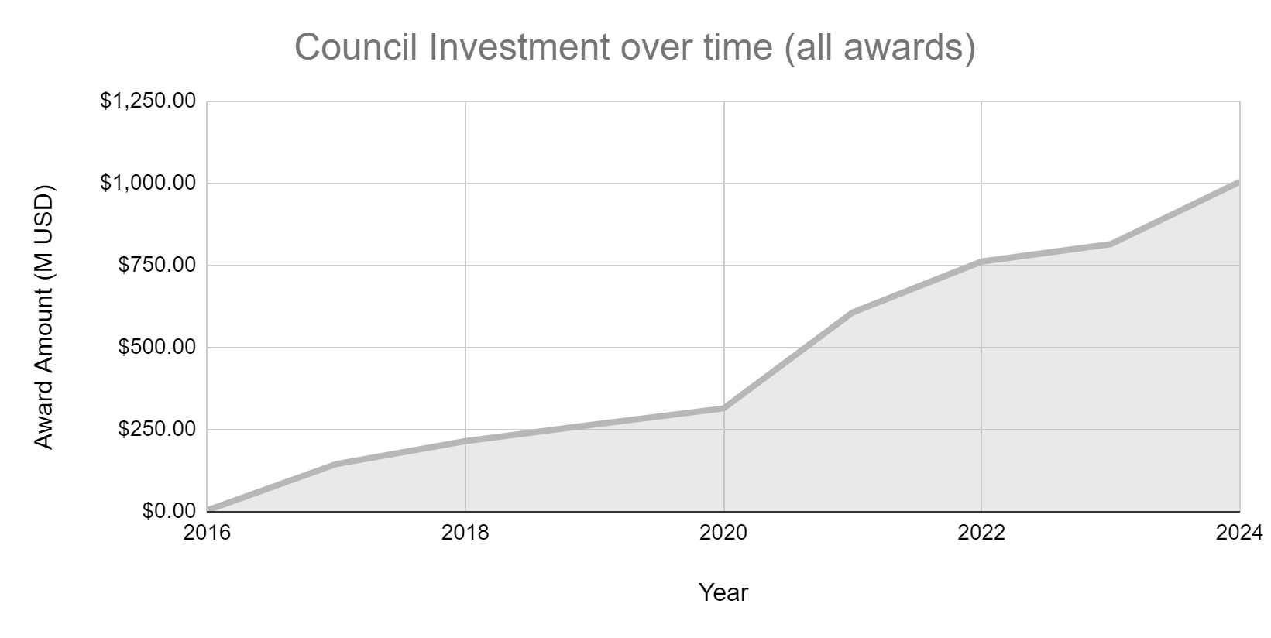

Figure 8: Cumulative investment in restoration has increased over time, for grants awarded as of September 18, 2024. Planning support grants, including CPS and planning SEP grants are not included in this graph.

Summary of Strategies and Resources Used to Achieve Goals
Building on the strong foundation established in the Gulf Coast Ecosystem Restoration Task Force, Gulf of Mexico Regional Ecosystem Restoration Strategy and other local, regional, state, and federal plans, the Council is taking an integrated and coordinated approach to Gulf Coast restoration. As the Council recognizes that ecosystem restoration investments may also improve prosperity and quality of life, this approach strives to both restore the Gulf Coast region’s environment and simultaneously revitalize the region’s economy. In addition, this approach acknowledges that coordinated action with other partners is crucial to successfully restore and sustain the health of the Gulf Coast region.
- Regional Ecosystem-based Approaches to Restoration
The use of a watershed/estuary-based approach for comprehensive ecological restoration is a fundamental component of the Comprehensive Plan. A focus on watersheds, in concert with foundational Gulf-wide activities, is one approach to ensuring that funds are spent in a way that contributes to comprehensive Gulf restoration. With this approach, the Council engages stakeholders and strategically addresses priority goals. The Council makes funding decisions that leverage limited restoration resources for maximum effectiveness, while also supporting planning, science, and other activities that maximize the potential for success.
Geographic areas described in the Planning Framework are a step toward identifying priority watersheds/estuaries for investment to meet Comprehensive Plan goals and objectives. These geographic areas vary in size from specific watersheds/estuaries to coverage of the entire coastal area of one or more states. To some degree, this range reflects the extent to which individual projects have been identified within the broader programs. In addition, these geographic areas reflect the anticipated collaboration — among members, among funding partners, and across states — needed to address broader environmental stressors.
- Coordinating, Collaborating, and Connecting Gulf Restoration Strategic Activities beyond the RESTORE Council
Consistent with its Comprehensive Plan commitment, the RESTORE Council is using collaborative and coordination processes to help ensure that Council-Selected Restoration component funded projects and programs complement restoration being accomplished through other funding streams. The funding available through the Council, as well as the other DWH-related funding sources (including other components of the RESTORE Act, Natural Resource and Damage Assessment (DWH NRDA), and National Fish and Wildlife Foundation Gulf Environmental Benefit Fund (NFWF GEBF)), presents an unprecedented opportunity to improve Gulf ecosystem conditions and function, representing one of the most substantial investments in landscape-level restoration in U.S. history.
The Gulf of Mexico region faces multiple stressors, ranging from man-made sources like the DWH oil spill disaster, water quality/quantity issues and the annual offshore hypoxic zone, as well as naturally-occurring impacts including hurricanes. By working collaboratively among the Council members and with other DWH-related funding sources, as well as working with other federal, state, and philanthropic funds, great progress can be made to increase the resiliency of the Gulf of Mexico ecosystem against these stressors.
A major challenge to Gulfwide ecosystem restoration is coordinating efforts within each state, among Council members, stakeholders, and across the Gulf restoration efforts to support personnel, travel, and logistics necessary for more effective collaboration and planning. In 2018, funding was approved in a second FPL “Funded Priorities List: Comprehensive Plan Commitment and Planning Support” (2017 CPS FPL) to address this challenge (Table 5). Each of the eleven Council members were able to apply for up to $2.1M over a five-year period beginning in 2018 through 2024. Specifically, the funding provided funds necessary for members to:
- Strengthen ecosystem restoration proposals for future FPL(s) under the Council-Selected Restoration Component;
- Enhance the efficiency of future FPL development processes; and
- Facilitate long-term planning and leveraging efforts across funding streams.
A summary of the use of CPS funds can be found in the Comprehensive Plan and in the Annual Report to Congress.
Table 5. Funding for the Commitments and Planning Support activities
Annual per member (maximum) | Annual Total Council Cap | CPS FPL | Total 5-Year Investment Maximum based on Annual Cap | Max Percentage of Total  Bucket 2 Funds*
$500K for 3 Years | $5.5M/year for 3 years | 2017 CPS FPL | $23.1M | 1.44%
$300k for 2 Years | $3.3M/year for 2 years | 2017 CPS FPL
$350k for 5 years | $3.85M/year for 5 years | 2023 CPS FPL | $19.25M | 1.20%
 |  | TOTAL | $42.35M | 2.64%*
* Calculated based on total funds provided by BP and other responsible parties; it does not include interest. Therefore, the percentage will be less over time as interest is accrued.

Summary of Significant Underlying Factors that Affected the Performance (including factors outside of the Council’s control as well as those the Council could control)
The Council also worked diligently during FY 2024 to improve its grants processes and efficiencies through the evaluation of strategies that reduce the time it takes to review and make financial awards. This effort involved conducting a series of cross-functional, focused meetings to drive systematic changes to improve efficiencies, increase productivity, reduce grant recipient burden, reduce risk, and ensure compliance. This focused effort will be completed in early FY 2025 with implementation of improvements to follow. Further, in response to the 2024 OMB directive that all federal agencies update award terms and conditions, internal agency policies, templates and other program documents by October 1, 2024, in compliance with revisions to the Uniform Guidance (2 CFR 200). Council Consensus was reached on August 28, 2024.
During FY 2024, a total of 13 process improvement meetings were held with staff to analyze existing award processes. These meetings covered the award lifecycle from the application submission and review, post-award monitoring and oversight, to final award closeout.
Cross-functional, Focus Meeting Topics
- Application Review Process
- Application Environmental Compliance Review
- Grant Budget Narrative
- Award Data Review Process
- RESTORE Best Available Science Review Process
- Risk Assessment and Analysis
- Specific Award Conditions
- Project Interagency Agreement Process
- Monitoring and Oversight
- Amendment Process
- Reporting Review Process
- Final Closeout Review Process
- Land Acquisition Award Process

This effort included the gathering of data and documents, mapping existing processes, identifying process challenges, and identifying potential improvements. This significant work has resulted in the identification of numerous potential improvements to the grants management process that are being evaluated for implementation. These focused meetings will be completed in early-FY 2025 with the effort transitioning to implementation of the process changes commencing shortly after.

Identification of Anticipated and Unanticipated Risks
There are also inherent risks the Council will consider regarding the efficacy of individual projects and/or programs themselves ranging from impacts to performance (due to unforeseen events like impacts from a hurricane) to changes in cost beyond projected contingency plan levels, which could potentially impact the ability to complete a project or program.
The Council’s Comprehensive Plan goals and objectives are designed to encompass the types of actions needed to restore ecosystem health and sustainability across the Gulf Coast region. To meet its goals and objectives, the Council must consider a wide range of past, ongoing, and emerging threats to the environment.
There are several strategies that the Council employs to anticipate and prepare for risk with associated mitigation strategies. The Council has completed an Enterprise Risk Assessment, and developed a risk profile that identifies strategic, operational, compliance, financial and reporting risks, assesses their likelihood and impact, and determines an overall risk rating with a categorization of critical, high, medium, and low. This analysis highlighted seven critical risks (high likelihood and high impact).
One of the risks speaks to the potential for overlapping project funding for the same purpose, which could take the form of project duplication within the Council-Selected Restoration Component, or a project funded by either the Spill Impact Component, or by one of the other Deepwater Horizon funding streams, including NRDA or the NFWF GEBF. The Council is providing a portion of the financial support for the DWH Project Tracker which provides a comprehensive way to track restoration efforts from a variety of DWH funding sources. Council staff also facilitate a DWH Project Tracker Working Group that aims to increase consistency in the activity data submitted to the DWH Project Tracker by the Council’s funding partner. The emphasis and funding provided through the CPS FPL to support collaboration among the Council members and the other DWH funding streams also specifically addresses this risk.
The Council considers inherent risks to the efficacy of individual projects or programs, ranging from impacts on performance (due to unforeseen events such as hurricanes) to changes in costs which could potentially impact the ability to complete a project or program. The Council is committed to using the best available science as it makes coastal restoration funding decisions. Specifically, proposals for Council funding should discuss whether the project or program is vulnerable to climate risks such as sea level rise, changes in rainfall patterns, and/or potential increases in hurricane intensity. In particular, proposals should discuss how such risks might affect the benefits and duration of the project or program. Where applicable, proposals should also discuss how the project or program might mitigate future risks associated with sea level rise, subsidence, and/or storms. . The Council will continue to carefully consider how changing environmental conditions could influence the effectiveness, sustainability, and resilience of future restoration investments.
- Best Available Science
The RESTORE Act requires the Council to “undertake projects and programs, using the best available science (BAS) that would restore and protect the natural resources, ecosystems, fisheries, marine and wildlife habitats, beaches, coastal wetlands, and economy of the Gulf Coast.” In the Comprehensive Plan, the Council strengthened its commitment to using BAS and delivering and measuring success through the use of common standards and monitoring protocols, and the development of indicators and metrics of restoration and conservation success by project, region, and/or watershed. To address uncertainties and risk, proposed projects and programs are evaluated as described on the Council’s website and the Comprehensive Plan.

- Environmental Compliance
As a federal entity, the Council must comply with all applicable federal environmental laws and other requirements when approving funding under the Council-Selected Restoration Component. The environmental laws that apply to a proposal are a function of the specific activities being proposed, and their possible direct and indirect influence on the environment, including the National Environmental Policy Act, Endangered Species Act, Magnuson-Stevens Fishery Conservation and Management Act, National Historic Preservation Act, and the Fish and Wildlife Coordination Act. Other environmental laws and requirements may apply at the award or construction stage of a project or program. The Council does not disburse Spill Impact Component funding for activities in approved SEPs until it has confirmed that all applicable laws have been addressed.

Summary of Plans to Improve Performance
In the Comprehensive Plan, the Council committed to delivering results, measuring impacts, and implementing/improving adaptive management. Ongoing coordination around science and monitoring has already reaped tangible benefits such as: alignment of overlapping tasks across entities, shared work products, and plans for future leveraging of shared resources. The Council is also exploring opportunities to create consistency and collaborate with NRDA efforts where appropriate. For example, the intersection between the Council Monitoring and Assessment Work Group (CMAWG) efforts with the NRDA Cross-Technical Implementation Group, and Monitoring and Adaptive Management Workgroup may yield important programmatic and science efficiencies.
Another element of the Council’s commitment to measuring and ensuring success is the application of adaptive management strategies. The purpose is to support meeting the Comprehensive Plan goals and objectives, both for individual activities as well as programmatically across watersheds or other geographically defined regions. By considering new information gained from monitoring and scientific advancements, the Council intends to fulfill its commitment to utilize adaptive management processes to enhance the benefits of its work.
At the programmatic scale, the Council’s structure and cyclical process for developing and approving FPLs allows for an adaptive approach to its Council-Selected Restoration Component funding decisions. For watersheds or other geographically defined areas, the Council utilizes its programmatic documents and processes to generally follow an adaptive process that may best support realization of the Council’s vision for the Gulf Coast region.
At the level of individual activities (both projects and programs), Council members set quantitative targets for each of their Comprehensive Plan objectives and describe any adaptive management strategies they plan to implement to ensure objectives are met. As set out in the activity’s ODP, monitoring data are collected and used to determine whether projects are meeting, or are expected to meet, their targeted objectives. Monitoring data may also be used to signal the need for any corrective actions that may enhance performance, as feasible. Funding recipients also report on how the results of data collection may help to resolve critical uncertainties influencing restoration and management decisions, informing and improving the success of efforts beyond the scope of the activity.
These and other actions will continue to allow the Council to improve ecosystem restoration and protection outcome and impact measurement and reporting, and assist in the development of local and regional ecosystem models. This work will also help the Council utilize lessons learned to identify and refine priority restoration needs and critical uncertainties related to Gulf restoration and inform adaptive Council decision-making processes related to these investments over time.

Summary of Procedures Management Designed and Followed to Provide Reasonable Assurance that Performance Information is Reliable and Relevant
Over its lifetime, the Council will invest over $3B in Gulf Coast ecosystem and economic restoration activities. These investments will not only advance the Council’s vision of a healthy and productive Gulf ecosystem, but also result in diverse scientific and economic data observations that will be used to demonstrate the benefits of Council investments. The Council recognizes the importance of comprehensive planning for the collection and compilation of data that can be compared across projects. Comparable data enables reporting at multiple scales, including project- and program-specific scales, as well as potential future larger-scale assessments across the Gulf Coast region. Understanding outcomes and impacts will further help to achieve tangible results and ensure that funds are invested in a meaningful way.
As described in the Comprehensive Plan, to facilitate consistent data collection and management, RESTORE Council projects/programs are required to develop an ODP as part of the Council’s financial award process. An ODP is a tool to ensure that an activity’s observational data (e.g., monitoring data) is collected and managed in such a way that it can be used to:
- Assess if the project was constructed as designed;
- Evaluate if the project has achieved, or is on track to achieve, its specific goals and objectives;
- Understand why the project has, or has not, performed as anticipated;
- Inform potential adaptive management actions to enhance performance;
- Improve future projects;
- Conduct further analyses (e.g., by ensuring long-term accessibility of data to the Council and public.
The selected metrics must be able to support all of the goals and objectives a project has identified. For example, if a project’s objective is to restore habitat, a metric must be selected to track the restoration of that habitat. Case-by-case exceptions may be made based on factors that limit the ability or need to conduct detailed monitoring. Feasibility, resource constraints, and the availability of existing data and scientific support may influence metric selection, particularly for SEP projects, where the members have more discretion over how funds are to be used. Council staff review financial and performance reports to assess progress on all awards. In addition, staff perform financial desk reviews and on-site/virtual site visits on a subset of awards.

Risks to the Agency’s Achievement of its Goals and Objectives
The Council is taking preemptive and proactive actions to identify and mitigate risks, to a degree practicable, to ensure the goals and objectives of the RESTORE Act and Comprehensive Plan will be achieved. Procedural policies that enhance coordination among Council members and with other Deepwater Horizon funding streams will reduce duplicative funding and enable leveraging of investments across programs. Tracking of performance through metrics and regular communication will bring to light performance challenges, enabling mitigation strategies to be employed. Further, the CMAWG and Council programmatic staff will review metrics and provide recommendations to adaptively manage projects and programs as new insights are garnered from results of ecosystem restoration efforts. However, there are still unforeseen events, both natural (e.g., hurricanes) and man-made which could impact the successful completion of some projects funded by either the Council-Selected Restoration or Spill Impact components that are beyond the ability of the Council to control.

ANALYSIS OF FINANCIAL STATEMENTS

The financial statements and financial data provided are derived from the accounting records of the Gulf Coast Ecosystem Restoration Council. These statements are prepared to disclose the financial position, financial condition, and operating results, in accordance with the regulations of 31 U.S.C. § 3515(b). They also comply with the Federal generally accepted accounting principles (GAAP) and the formats prescribed by OMB. It is important to note that these statements pertain to a division of the U.S. Government.

The Council is funded in its entirety by the RESTORE Trust Fund and serves as an expenditure fund for the Trust Fund. It does not receive appropriated funds, and all funding is Category B mandatory funding. The Council’s financial statements reflect the amount of funds available to and used by the Council. Table 6 below shows the current status of the trust fund components that are managed by the Council: The Council-Selected Restoration Component, and the Oil Spill Impact Component. The Council-Selected Administrative Funds and Council-Selected Program Expense Funds are subcategories of the Council-Selected Restoration Funds and are used by the Council to carry out its operations. The apportionments received by the Council are used to develop programs, carry out operations, and fund projects.

The Department of the Treasury issued an Interim Final Rule regarding the investment and use of amounts deposited in the Gulf Coast Restoration Trust Fund. Upon issuance of this Rule, the Council was able to request apportionments for the Council-Selected Restoration Component Funds. The Spill Impact Interim Final Rule published on August 22, 2014, made available an amount of funds less than or equal to the statutory minimum allocation (5% of funds available under the Spill Impact Component) that would be available to a Gulf Coast State or eligible entity for a SEP that funds planning activities only. On December 15, 2015, the Council published the RESTORE Act Spill Impact Component Allocation Final Rule which became effective on April 4, 2016, when the United States Court for the Eastern District of Louisiana entered the Consent Decree. This Rule established the formula for the allocation of Spill Impact Component funds to the States making these funds available for apportionment.

Table 6 offers a detailed breakdown of the Council’s trust fund apportionments from fiscal years 2013 to 2024. Apportionment is an Office of Management and Budget-approved plan on how to spend resources provided by a mandatory appropriation, an annual or supplemental appropriation act, or a continuing resolution as well as other sources of funding such as a Trust Fund. An apportionment contains the amounts available for obligation and expenditure. It also specifies and limits what obligations can be done and what expenditures can be made during specified timeframes, for programs, projects, and activities, or any combination of these.

Table 6: Trust Fund Apportionments Received Summary

Trust Fund Balance (After Sequestration) | Council Selected Administrative Funds (6011) | Council Selected Projects and Programs Funds (6012) | Total Comprehensive Plan | Spill Impact 6013
TRUST FUND  DEPOSITS | $30,913,781 | $999,545,583 | $1,030,459,364 | $960,755,543
Apportionment FY13-20 | 8,953,028 | 246,632,369 | 255,585,397 | 379,536,645
Apportionment FY21 | 1,734,224 | 146,361,378 | 148,095,602 | 73,623,810
Apportionment FY22 | 1,081,530 | 8,684,446 | 9,765,976 | 274,396,619
Apportionment FY23 | 1,599,375 | 138,351,431 | 139,950,806 | 97,882,816
Apportionment FY24 | 1,649,766 | 37,614,784 | 39,264,550 | 85,176,009
Total Apportioned | 15,017,923 | 577,644,408 | 592,662,331 | 910,615,899
TRUST FUND  BALANCE | $15,895,858 | $421,901,175 | $437,797,033 | $50,139,644

In fiscal year 2024, the Total Comprehensive Plan had an apportionment balance of $39.26 million, with $1.65 million allocated to Council Selected Administrative Funds and $37.61 million to Council Selected Projects and Programs. Additionally, Spill Impact received $85.18 million.
Since fiscal year 2013, the Council has apportioned $15.02 million to Administrative Funds and $577.64 million to Projects and Programs, totaling $592.66 million. Spill Impact's total apportionment is $910.62 million. As of September 30, 2024, the Trust Fund balances are $437.80 million for the Total Comprehensive Plan and $50.14 million for Spill Impact.

Five-Year Operational Costs Summary

To best serve the communities of the Gulf Coast region, the Council strives to implement the Comprehensive Plan and accomplish the requirements of the RESTORE Act effectively and efficiently, at the minimum cost possible, to maximize the funds available for restoration projects and programs. The Council has managed its fiscal resources through a strategy of incremental growth corresponding to developing the Council-Selected Restoration Component and Spill Impact Component programs.

Table 7 shows each fiscal year's financial apportionment, revenue, obligations, operations costs, and carryforward funds from prior and current years. Council approval is required to use carryforward funds if an expense exceeds a certain threshold but has yet to be included in the approved annual operating budget. During fiscal year 2024, the Council allocated $1.93 million in carryforward funds for interagency agreements for ARC services, Axiom, NARA, BAS Appraisal Reviews, VMSI, translation services, PIPER maintenance, and augmenting the cost of Grant Solutions. Additionally, $161,710 from the $1.2 million reserved for the Unified Solution (GrantSolutions and PIPER) will be carried forward until exhausted. In fiscal year 2025, carryforward funds will be utilized for ARC services, Axiom, NARA, and VMSI. Surplus carry-forward funds from fiscal year 2024 will be used to fulfill fiscal year 2025 operational requirements in lieu of requesting new funding from the Trust Fund.

Table 7: 5-Year Revenue and Operational Cost History (in millions) *represents the first 7 years
Council Operational Cost History | Carryforward from PY | New Apportionment | Recoveries from PY Obligations | Current Year Trust Fund Revenue | Funded Obligations | Total Cost of Operations | Carry Forward
FY13 -20* | $9.07 | $27.85 | $0.73 | $37.65 | $28.96 | $28.34 | $10.38
FY21 | $2.23 | $7.64 | $0.02 | $9.89 | $7.14 | $7.71 | $1.74
FY22 | $1.74 | $7.55 | $0.08 | $9.37 | $5.94 | $7.30 | $1.96
FY23 | $1.96 | $8.16 | $0.01 | $10.13 | $7.53 | $8.60 | $1.93
FY24 | $1.93 | $8.00 | $0.17 | $10.10 | $8.36 | 8.36 | $0.73

Five-Year Operational Cost Trends

Table 8: Operating Expense (Obligations Incurred) by Cost Category (in millions)
Fiscal Year | Salaries and Benefits | Contract and IAAs | Travel | Equipment/ Grant System | Supplies Printing and Misc | Rent, Communications Utilities
2020 | $4.188 | $3.415 | $0.119 | $0.204 | $0.007 | $0.012
2021 | $4.049 | $2.866 | $0.025 | $0.131 | $0.006 | $0.061
2022 | $4.277 | $3.044 | $0.082 | $0.190 | $0.024 | $0.058
2023 | $4.519 | $3.147 | $0.163 | $0.053 | $0.004 | $0.057
2024 | $3.639 | $3.320 | $0.238 | $0.206 | $0.028 | $0.060

The Council's operations are driven by three primary cost drivers: salaries and benefits costs, travel, and contracts and agreements for services. However, the Council only requests funds for immediate operational needs, following an incremental approach. In fiscal year 2024, the Council maintained a steady number of full-time equivalents (FTE) and staff positions at 24 FTE. Nevertheless, operational costs during this period decreased mainly due to a 19.47% decrease in salaries and benefits and travel expenses experienced a significant surge of 46.01%.

Expenses for contracts and Inter-Agency Agreements (IAA) saw a 5% increase in fiscal year 2024, totaling $3.320 million. This rise can be attributed to higher contractor support costs, as well as maintenance and support from USGS and VMSI. There was also an increase of 3.37% in expenses for contracted services associated with administrative facilities and information technology. This increase can be attributed to the fact that Council employees work remotely, resulting in significantly increased expenses for IT, printing, shipping, equipment, and supplies. The Council's 288% increase in equipment costs in fiscal year 2024 is due to info technology (NOAA) agreements in support of PIPER.

Administrative Expenses

The RESTORE Act specifies that no more than 3% of the funds received by the Council-Selected Restoration Component may be used for administrative expenses. This limitation is further explained in the Treasury regulation implementing the Act at 31 CFR §34.204(b), "Limitations on administrative costs and administrative expenses."(as amended September 28, 2016). The regulation states that the 3% limit is applied to the amounts received by the Council under the Comprehensive Plan [Council-Selected Restoration] Component before the termination of the Trust Fund. It also specifies that amounts used for administrative expenses cannot exceed 3% of the total of the amounts received by the Council and the amounts in the Trust Fund that are allocated to but not yet received by the Council under § 34.103.

The Council collaborated with the Office of Management and Budget (OMB) to separate administrative expense funds through apportionment. To ensure that expenses are classified correctly, the Council refers to the definition of administrative expenses provided by the Treasury regulation implementing the Act at 34 CFR §34.2. This definition guides the Council in accurately classifying certain administrative expenses and categorizing the remaining expenses as programmatic.

The Council manages and supervises projects and programs during the post-award period. As the Council is expected to cease operations once all funds available from the Trust Fund have been spent, a long-term forecast is created for its administrative and operational expenses. This forecast is based on the projected closeout date of all grants. To ensure operational costs are fiscally responsible and well-managed throughout the program, the Council has projected its operations through 2042 based on the Consent Decree payment schedule and the projected closeout timeframe for grants awarded.

Table 9 provides information on the funds deposited as of September 30, 2024, for the Council Selected Restoration component and the funds available for administrative expenses. The amount of funds apportioned for administrative expenses is below the amount of administrative funds available in the Trust Fund and is equivalent to 3% of the total funds apportioned for the Council-Selected Restoration Component.

Of the total $1,035.6 million, including interest, deposited into the Trust Fund for the Comprehensive Plan component, $1,030.5 million was made available, and $5.2 million was withheld in fiscal year 2024 due to sequestration. Of the $30.9 million available for administrative expenses, $15.9 million remains in the Trust Fund. Overall, 15 million (49%) of the available administrative funds have been apportioned, equaling 1.5% of the total available trust funds.

Table 9: Three Percent Analysis
STATUS OF 3% ADMINISTRATIVE EXPENSE FUNDS (as of 09/30/2024)
Trust Funds-Comprehensive Plan
Amount Available | $ 1,035,648,330
Minus Sequestration for 2024 | 5,188,966
Total Amount Available | $1,030,459,364
Administrative Expense Funds Available | 30,913,781
(Total Amount Available x 3%)
Minus Total Administrative Funds Apportioned through 2024 | $ 15,017,923
Balance of Administrative Funds Remaining in the Trust Fund | $ 15,895,858

Projects and Programs

The Louisiana and Mississippi State Expenditure Plans (SEPs) were approved in fiscal year 2017, followed by the Florida SEP in fiscal year 2018, and the Texas and Alabama SEPs in fiscal year 2019. While these SEPs have been approved, it is important to note that the projects included in the plans must undergo thorough development and comply with planning and environmental regulations before receiving funding.

Each state has the autonomy to choose which projects to prioritize and request funding for and the timing of these decisions. In fiscal year 2024, the Spill Impact Component provided $90.47 million in grants. This funding was allocated through amendments and awards to the participating states. Alabama received ten amendments totaling $24.18 million in awards. The Florida Consortium received two amendments and three awards amounting to $18.97 million, while Louisiana received one amendment totaling $25.51 million. Mississippi and Texas were also granted funds through amendments and awards. Mississippi received four new awards and one amendment totaling $21.80 million. Texas had no new awards this fiscal year. However, Texas did have one amendment to decrease an award by $15.0 million, leaving a balance of $8.68 million.

Under the Council-selected Restoration Component, $169.89M in projects and programs have been funded through FY 2024. During the past fiscal year, three FPL 1 project amendments were awarded: Money Bayou Wetlands Restoration Planning ($0.85M); Bahia Grande Wetland System Restoration ($0.97M); and the Mississippi Sound Estuarine Program ($.21M). One new FPL 3a project was awarded; River Reintroduction into Maurepas Swamp (Construction) ($130.00M) and one amended; Perdido River Land Conservation and Habitat Enhancements ($16.73M). FPL 3b also had two new awards in FY 2024; Coastal Alabama Regional Water Quality Program ($16.13M) and the Apalachicola Regional Restoration Initiative ($5.00M).

In fiscal year 2017, the Council approved FPL 2’s Collaboration and Planning Support (CPS) funding. This funding allowed its members to support Comprehensive Plan commitments and identify future investments that maximize the achievement of Gulf-wide restoration goals. In fiscal year 2024, the Gulf Coast Ecosystem Restoration Council requested an additional $19.25 million in funding authority for FPL 2. The authority was received and will be used to extend FPL 2 CPS funding for five years.

Table 10 provides an annual breakdown of project and program funds awarded. Balances for FPL 1 and SEP from fiscal years 2016–2020 have been adjusted due to the final closure of grants in fiscal year 2024. Similarly, the fiscal year 2021 SEP balance was reduced as additional grants reached closure. These closures resulted in an overall decrease of $5.80 million for the specified fiscal years.

Table 10: Projects and Program Funds Awarded (in millions)
Projects and Programs | 2016-2020 | 2021 | 2022 |  | 2023 | 2024 | Total to Date
FPL 1 | $162.07 | $6.77 |  | $0.00 | $5.24 | $2.03 | $176.11
FPL 2 | 20.83 | 0 |  | 0 | 0 | 0 | $20.83
FPL 3a | 0 | 0 |  | 10.15 |  | 146.73 | $156.88
FPL 3b | 0 | 11.97 |  | 57.81 | 31.78 | 21.13 | $122.69
SEP | 213.75 | 92.4 |  | 85.19 | 215.81 | 90.47 | $697.62
TOTALS | $396.65 | $111.14 |  | $153.15 | $252.83 | $260.37 | $1,174.13

Costs Incurred

The Council's incurred costs include operational expenses such as salaries, benefits, administrative services, travel, and automated services supporting program and grant activities. These costs are realized as expenses are incurred, and contracts and agreements are liquidated. In fiscal year 2016, the initial Funded Priority List (FPL) and State Expenditure Plans (SEPs) were approved, leading to the issuance of the first four grant and interagency agreement (IAA) awards shortly thereafter. The administrative and programmatic operational expenditures have been consistent with annual obligations.

Due to the diverse and complex nature of restoration projects, the performance of these awards has taken longer, resulting in a slower expenditure rate. However, the expenditure rate has begun to increase, as shown in Table 11.

Table 11: Total Council Incurred (Actual) Costs to Date (in dollars)
Year(s) | Administrative Expense |  | Programmatic Operating  Expense |  |  | Council  Selected Projects and Programs | Spill Impact Projects  and Programs | TOTAL COST
2013-2020 |  | $9,845,961 |  | $24,608,202 | $95,509,794 |  | $53,411,641 | $183,375,598
2021 |  | 1,486,794 |  | 6,257,674 | 33,303,982 |  | 76,937,067 | 117,985,517
2022 |  | 1,362,085 |  | 5,984,249 | 54,361,529 |  | 83,534,545 | 145,242,408
2023 |  | 1,701,730 |  | 6,928,835 | (2,771,281) |  | 10,613,552 | 16,472,836
2024 |  | 1,516,992 |  | 7,857,171 | 39,740,810 |  | 198,086,787 | 247,201,760
TOTALS | $15,913,562 |  |  | $51,636,131 | $220,144,834 |  | $422,583,592 | $710,278,119

In fiscal year 2024, the Council saw an increase in operational costs, mainly due to higher expenses related to Memorandums of Understanding with organizations such as the Office of the Inspector General, the Environmental Protection Agency, and the Bureau of Fiscal Service Administrative Resource Center.

The costs were impacted by projects being awarded in FPL 1, FPL 3, and the State Expenditure Plans programs. In fiscal year 2024, there was a rise in costs for FPL 1 due to the awarding of three projects.

Variance Analyses

Below are the Council's variance analyses of its financial statements for fiscal years 2024 and 2023, respectively. The analyses measure the Council's financial and operational data between fiscal years 2024 and 2023 and provide key data on the Council's expenses, revenue, and grants.

Assets

Assets for the Council for fiscal years 2024 and 2023, respectively, are shown in Table 12 below. As of September 30, 2024, Council total assets were $1,143,486,187 an increase of $223,506,288 or 24% over fiscal year 2023.

Table 12: Council Assets
Council Assets | FY 2024 | FY 2023 | Increase/ Decrease |  | % Change
Fund Balance with Treasury | $ 397,083,782 | $275,714,094 | $121,369,688 | 44%
Expenditure Transfers Receivable | $745,998,340 | $643,772,911 | $102,225,429 | 16%
Advances and Prepayments | $26,488 | $0 | $26,488 | N/A
Property, Equipment, and Software, Net | $377,577 | $492,894 | -$115,317 | -23%
Assets | $1,143,486,187 | $919,979,899 | $223,506,288 | 24%

The Treasury's Fund balance experienced a notable 44% growth as of September 2024, compared to September 2023, amounting to $121,369,688. As various projects approach completion or enter the construction phase, the expenditure rate escalates, leading to a greater cash withdrawal from the trust fund. These withdrawals are made in anticipation of upcoming quarterly payments and are strategically planned to maintain a sufficient cushion of funds for each program, thereby mitigating the need for emergency drawdowns.

The Expenditure Transfers Receivable witnessed an incline of 16%, which is an increase of $102,225,429. This term refers to the Council's receivable from the Trust Fund. It is augmented when the Office of Management and Budget (OMB) authorizes an allotment from the Trust Fund to provide the Council with budget authority for its operations, projects, and programs under the Council-Selected and Spill Impact Components.

While funds are apportioned in their entirety for each FPL upon Council approval, the amount allocated for SEPs is based on estimates provided by the recipients regarding the timing and value of awards for their respective projects.

The balance within the Expenditure Transfers Receivable signifies the maximum cash amount that the Council can withdraw from the Trust Fund at any given time. This figure is determined by calculating the net variance between the apportioned amounts and the cash withdrawals from the Trust Fund. Although the Council can withdraw funds equivalent to the total appropriation amount, it has opted to only withdraw funds as necessary for meeting quarterly obligations and expenses

Liabilities

Liabilities for the Council for fiscal year 2024 and fiscal year 2023, respectively, are shown in Table 13. As of September 30, 2024, the Council's total liabilities were $345,595,130, an increase of $168,088,767 or 95% over fiscal year 2023.

Table 13: Total Liabilities
Council Liabilities | FY 2024 |  | FY 2023 | Increase/ Decrease | %  Change
Accounts Payable |  | $1,034,156 | $967,989 | $66,167 | 7%
Federal Employees and Veterans Benefits Payable |  | $547,462 | $647,084 | -$99,622 | -15%
Advances from Others & Deferred Revenue |  | $9,125 | $27,375 | -$18,250 | -67%
Other Liabilities |  | $24,857 | $60,781 | -$35,924 | -59%
Grants Payable |  | $343,979,530 | $175,803,134 | $168,176,396 | 96%
Liabilities |  | $345,595,130 | $177,506,363 | $168,088,767 | 95%

The Council's Total Liabilities encompass a range of outstanding invoices and accruals from both public and federal partners. Notably, there has been a significant increase of $168,088,767 in the Council’s Other Liabilities, primarily attributed to grant payables and contributions from various public and federal partners.

The Council has observed an increase in accounts payable owed to several public and federal partners. Notable entities include the Department of Health and Human Services, which handles grant management services, the United States Geological Survey, responsible for PIPER development and maintenance services, the Administrative Resource Center, which provides procurement services, the Interior Business Center, and Veterans Management Services Inc.

The Council's Employees and Veterans Benefits Payable represents the Council's outstanding obligations towards selected payroll benefits, specifically the Federal Employee Retirement System, Federal Employee Health Benefits, Flexible Spending Account, Federal

Statement of Changes in Net Position

Net Position for the Council for fiscal year 2024 and fiscal year 2023, respectively, are shown in Table 14. As of September 30, 2024, the Council’s Net Position was $797,891,057 an increase of $55,417,521, or 7%, from fiscal year 2023.

Table 14: Net Position
Net Position | FY 2024 | FY 2023 | Increase/ Decrease |  | %
Net Position | $797,891,057 | $742,473,536 | $55,417,521 | 7%

The Council Cumulative Results of Operations is the net difference between expenses and financing sources since the inception of Council activities, including apportionments (financing sources), reimbursed and non-reimbursed revenues, expenses, and imputed employee benefits for life insurance and retirement. The increase in Net Position is due to increased financing sources, e.g., apportionments from the Trust Fund for FPL and SEP projects.

Net Cost

Net Cost for the Council fiscal years 2024 and 2023, respectively, are shown in Table 15 below. As of September 30, 2024, the Council’s Net Cost was $247,201,760, an increase of $230,763,924 or 1404%, from fiscal year 2023.

Table 15: Net Cost
Council Net Cost | FY 2024 | FY 2023 |  | Increase/ Decrease | % Change
Comprehensive Plan Administrative Expense | $1,516,992 |  | $1,701,730 | -$184,738 | -11%
Comprehensive  Plan-Program Expense | $7,857,171 |  | $6,893,835 | $963,336 | 14%
Comprehensive Plan-Projects & Program (Grants) | $39,740,810 |  | -$2,771,281 | $42,512,091 | 1,534%
Spill Impact-State Expenditure Plan (Grants) | $198,086,787 |  | $10,613,552 | $187,473,235 | 1,766%
Net Cost | $247,201,760 |  | $16,437,836 | $230,763,924 | 1,404%

The Comprehensive Plan Administrative, Programmatic, Projects and Programs, and Spill Impact Program expenses, along with the Spill Impact Program expenses, have been meticulously recorded in the table above. Notably, the Council's operating costs have stabilized as the organization has reached a state of maturity in its operations.

All expenses categorized as grants and any Interagency Agreements (IAAs) are either liquidated or have accruals recorded as needed. As of September 30, 2024, the Council has successfully marked nine IAAs and six grants as “finally closed”.

Budgetary Resources Analysis

Budgetary Resources for the Council fiscal years 2024 and 2023, respectively are shown in Table 16 below. As of September 30, 2024, the Council’s Budgetary Resources were $541,469,050 a decrease of $134,848,318 or 20%, from fiscal year 2023.

Table 16: Budgetary Resources
Council Budgetary  Resources |  | FY 2024 | FY 2023 | Increase/ Decrease | % Change
Unobligated Balance Brought Forward , Oct 1 | $239,186,764 |  | $438,448,746 | -$199,262,982 | -45%
New Spending Authority (from offsetting collections, e.g., the Trust Fund) | $302,282,286 |  | $237,868,622 | $67,413,664 | 27%
Total Budgetary Resources | $541,469,050 |  | $676,317,368 | -$134,848,318 | -20%
Recoveries of Prior Year Unpaid Obligations | $21,016,613 |  | $8,188,221 | $12,828,392 | 157%
Obligations Incurred | $249,755,205 |  | $260,784,024 | -$11,028,819 | -4%
Unobligated Balance, End of Year (Total) | $291,713,845 |  | $415,533,344 | -$123,819,499 | -30%

The increase in budgetary resources is primarily attributed to a 27% increase in new spending authority and an increase in the use of non-monetary amendments to original awards to cover new costs. The FY24 obligations incurred reflect the significant decrease in the amount of new grant awards compared to last year’s obligations incurred.

ANALYSIS OF SYSTEMS, CONTROLS, AND LEGAL COMPLIANCE

The Federal Managers’ Financial Integrity Act (FMFIA) requires CFO Act agencies to establish controls that effectively protect assets from waste, loss, unauthorized use, or misappropriation. The Act also mandates that agencies keep accurate and complete records of revenues and expenditures to enable reliable financial and statistical reports while remaining accountable for assets.

To comply with FMFIA requirements, the agency head must ensure that management controls and financial systems are adequate and adhere to government standards. Furthermore, the statement should assess the agency's compliance with FMFIA objectives. The Council has issued its annual assurance statement, signed by the Executive Director and available on the next page.

COUNCIL’S FMFIA STATEMENT OF ASSURANCE
November 13, 2024

As the Executive Director of the Gulf Coast Ecosystem Restoration Council (Council), I am pleased to present this Statement of Assurance in accordance with the Federal Managers' Financial Integrity Act (FMFIA) for Fiscal Year 2024.

Over the past year, the Council has evaluated its financial and operational frameworks to identify risks, strengthen oversight, and ensure compliance with relevant legal and regulatory standards. These efforts have significantly enhanced our internal controls, particularly in financial reporting, budget management, and program execution. I am proud to report that no material weaknesses were identified in our internal control systems during this fiscal year.

Our financial reporting framework is reinforced by robust internal controls within the Bureau of Fiscal Services’ Accounting, Procurement, and General Computer Operations (ARC). A thorough assessment of ARC’s compliance with the Statement on Standards for Attestation Engagements (SSAE) No. 18 found no significant issues, affirming the integrity of our financial reporting for FY 2024. We are pleased to offer unqualified assurance for Sections 2 and 4 of the FMFIA, underscoring the reliability and effectiveness of our financial management processes.

In addition, we continue to maintain a comprehensive Information Assurance (IA) program in full compliance with the Federal Information Security Modernization Act (FISMA). Our IA program follows the National Institute of Standards and Technology (NIST) Risk Management Framework (RMF)—a leading methodology for managing information security risks. Committed to continuous improvement, we actively adapt to emerging challenges while safeguarding operational integrity.

As of September 30, 2024, I can confidently affirm that the Council’s internal controls provide reasonable assurance regarding the effectiveness of operations, the reliability of financial reporting, and compliance with applicable laws. This reflects our enduring commitment to transparency, accountability, and the responsible management of funds allocated for restoring the Gulf Coast ecosystem.

Looking ahead, the Council will continue to uphold the highest standards of financial stewardship and operational excellence, ensuring the Gulf Coast's restoration and protection are carried out with unwavering integrity and accountability.

Sincerely,

/S/ Original Signed

Mary S. Walker
Executive Director Gulf Coast Ecosystem Restoration Council

FORWARD-LOOKING INFORMATION

Going forward into FY 2025 and beyond, the Council will continue to focus on enhancing its programmatic accomplishments, along with improving operational efficiencies and effectiveness in support of achieving the Council’s vision. Work will also continue on the development of the next FPL (FPL 4) with a target completion date of April 2026 with a funding level of approximately $400 million to support Council-Selected Ecosystem Restoration projects. During FY 2025, it is anticipated that the Council will complete Best Available Science reviews of the initial FPL 4 program and project submissions by Council members. An initial draft of FPL 4 will also be written and reviewed by the Council’s Steering Committee through a series of in-person and video conferencing meetings with the objective of completing a public comment draft in early FY 2026.

Council staff have invested significant time and energy in assessing internal processes in both its grants and programmatic procedures to identify ways to improve the timeliness of the awarding and oversight processes to maximize efficiencies while minimizing risk to the degree that is practicable in compliance with all federal funding regulations. In FY 2025, staff will continue to evaluate streamlining of programmatic protocols to improve the timeliness of reviewing award and amendment applications from Council members, building on successes completed to date. Improvements in efficiency, compliance with OMB’s update of 2 CFR 200, and clarification of post-award activities will also be accomplished through in-person training and on-line opportunities to assist members in implementing recommended actions.

During FY 2025, staff will also work to modernize the Council’s website to improve navigation and update and enhance content. Council staff will also enhance our StoryMap to better communicate the Council’s significant accomplishments through metric dashboards.
Internal Council staff operations will continue to focus on providing high-quality administrative and financial support for Council members and staff, as well as implementing any new federal regulations and Executive Orders, as appropriate, that are developed during FY 2025.

SECTION II: FINANCIAL SECTION

MESSAGE FROM THE CHIEF FINANCIAL OFFICER

November 13, 2024

I am pleased to present the fiscal year 2024 financial statements of the Gulf Coast Ecosystem Restoration Council (Council). This report not only exemplifies our unwavering commitment to fiscal integrity and effective financial management but also serves as a vital tool for demonstrating our accountability to the Gulf Coast region and the American public. It underscores our dedication to stewardship and emphasizes our fiduciary responsibilities in managing the resources entrusted to us.

In FY 2024, the Council's financial management operations successfully managed a cumulative total of $1.99 billion in Trust Fund deposits and $1.45 billion in Council outlays, underscoring our commitment to fiscal responsibility and strategic resource allocation. This careful oversight is essential to ensuring that funds are utilized efficiently and effectively in support of our mission to restore and protect the Gulf Coast ecosystem.

Our financial statements have been meticulously prepared to provide a comprehensive overview of our financial position, net costs, changes in net position, and budgetary resources. We adhere to Generally Accepted Accounting Principles (GAAP) applicable to federal entities, following the specific formats prescribed by the Office of Management and Budget (OMB).

We are particularly proud to announce that the Council has received an unmodified opinion on its financial statements from our external auditors for the tenth consecutive year. This accolade reaffirms the integrity and accuracy of our financial data, serving as a testament to our rigorous internal controls and financial processes.

This financial report reflects our steadfast commitment to transparency, accountability, and responsible financial management. It highlights our proactive measures to meet the needs of our constituents and underscores our dedication to maintaining the highest levels of trust and confidence from the American public. As we move forward, we remain resolute in our mission to restore and protect the Gulf Coast, ensuring that we utilize our resources wisely and effectively for the benefit of current and future generations.

Sincerely,
/S/ Original signed
Vanessa Taylor
Chief Financial Officer
Gulf Coast Ecosystem Restoration Council

Inspector General’s Transmittal Letter


DEPARTMENT OF THE TREASURY
WASHINGTON, D. C. 20220
November 14, 2024
OFFICE OF
INSPECTOR GENERAL
The Honorable Michael Regan
Administrator, Environmental Protection Agency
Chairperson, Gulf Coast Ecosystem Restoration Council
1200 Pennsylvania Ave, NW
Washington, DC 20460-0003
Dear Chairperson Regan:
Under a contract monitored by our office, RMA Associates, LLC (RMA), a certified independent public accounting firm, audited the financial statements of the Gulf Coast Ecosystem Restoration Council (Council) as of September 30, 2024 and 2023, and for the years then ended. The contract required that the audit be performed in accordance with government auditing standards and Office of Management and Budget (OMB) Bulletin No. 24-02, Audit Requirements for Federal Financial Statements.
The audit of the Gulf Coast Ecosystem Restoration Council’s financial statements is required by the Chief Financial Officer’s Act, as amended by the Accountability of Tax Dollars Act of 2002. This audit was performed as part of our authority under Section 1608 of the Resources and Ecosystems Sustainability, Tourist Opportunities, and Revived Economies of the Gulf Coast States Act of 2012.
In its audit of the Council, RMA found:
- the financial statements were fairly presented, in all material respects, in accordance with accounting principles generally accepted in the United States of America;
- no deficiencies in internal control over financial reporting that are considered material weaknesses; and
- no instances of reportable noncompliance with laws, regulations, contracts, and grant agreements tested.
In connection with the contract, we reviewed RMA’s reports and related documentation and inquired of its representatives. Our review, as differentiated from an audit performed in accordance with U.S. generally accepted government auditing standards, was not intended to enable us to express, and we do not express an opinion on the Council’s financial statements or conclusions about the effectiveness of internal control or compliance with laws and regulations. RMA is responsible for the attached auditors’ report dated November 13, 2024, and the conclusions expressed in the report. However, our review disclosed no instances where RMA did not comply, in all material respects, with U.S. generally accepted government auditing standards and OMB Bulletin No. 24-02.
I appreciate the courtesy and cooperation extended to RMA and my staff during the audit. If you wish to discuss this report, please contact me at (202) 528-8997, or a member of your staff may contact Deborah Harker, Assistant Inspector General for Audit, at (202) 486-1420.
Sincerely,
/s/
Richard K. Delmar
Acting Inspector General, Department of the Treasury
Enclosure
cc: Mary Walker, Executive Director

Independent Auditor’s Report
Acting Inspector General
Department of the Treasury
Administrator, U.S. Environmental Protection Agency and
Chairperson, Gulf Coast Ecosystem Restoration Council
Report on the Audit of the Financial Statements
Opinion
We have audited the accompanying financial statements of the Gulf Coast Ecosystem Restoration Council (Council), which comprise the balance sheets as of September 30, 2024 and 2023, and the related statements of net cost, changes in net position, and budgetary resources for the years then ended, and the related notes to the financial statements.
In our opinion, the accompanying financial statements present fairly, in all material respects, the financial position of the Council as of September 30, 2024 and 2023, and its net costs, changes in net position, and budgetary resources for the years then ended, in accordance with accounting principles generally accepted in the United States of America.
Basis for Opinion
We conducted our audit in accordance with auditing standards generally accepted in the United States of America (GAAS) and the standards applicable to financial audits contained in Government Auditing Standards issued by the Comptroller General of the United States (Government Auditing Standards), and the Office of Management and Budget (OMB) Bulletin No. 24-02, Audit Requirements for the Federal Financial Statements. Our responsibilities under those standards are further described in the Auditor’s Responsibilities for the Audit of the Financial Statements section of our report. We are required to be independent of the Council and to meet our other ethical responsibilities, in accordance with the relevant ethical requirements relating to our audit. We believe that the audit evidence we have obtained is sufficient and appropriate to provide a basis for our audit opinion.
Responsibilities of Management for the Financial Statements
Management is responsible for the preparation and fair presentation of the financial statements in accordance with accounting principles generally accepted in the United States of America, and for the design, implementation, and maintenance of internal control relevant to the preparation and fair presentation of financial statements that are free from material misstatement, whether due to fraud or error.
Auditor’s Responsibilities for the Audit of the Financial Statements
Our objectives are to obtain reasonable assurance about whether the financial statements as a whole are free from material misstatement, whether due to fraud or error, and to issue an auditor’s report that includes our opinion. Reasonable assurance is a high level of assurance but is not absolute assurance and therefore is not a guarantee that an audit conducted in accordance with GAAS, Government Auditing Standards, and OMB Bulletin No. 24-02 will always detect a material misstatement when it exists. The risk of not detecting a material misstatement resulting from fraud is higher than for one resulting from error, as fraud may involve collusion, forgery, intentional omissions, misrepresentations, or the override of internal control. Misstatements are considered material if there is a substantial likelihood that, individually or in the aggregate, they would influence the judgment made by a reasonable user based on the financial statements.
In performing an audit in accordance with GAAS, Government Auditing Standards, and OMB Bulletin No. 24-02 we:
- Exercise professional judgment and maintain professional skepticism throughout the audit.
- Identify and assess the risks of material misstatement of the financial statements, whether due to fraud or error, and design and perform audit procedures responsive to those risks. Such procedures include examining, on a test basis, evidence regarding the amounts and disclosures in the financial statements.
- Obtain an understanding of internal control relevant to the audit in order to design audit procedures that are appropriate in the circumstances, but not for the purpose of expressing an opinion on the effectiveness of the Council’s internal control. Accordingly, no such opinion is expressed.
- Evaluate the appropriateness of accounting policies used and the reasonableness of significant accounting estimates made by management, as well as evaluate the overall presentation of the financial statements.
We are required to communicate with those charged with governance regarding, among other matters, the planned scope and timing of the audit, significant audit findings, and certain internal control-related matters that we identified during the audit.
Required Supplementary Information
Accounting principles generally accepted in the United States of America require management’s discussion and analysis be presented to supplement the basic financial statements. Such information is the responsibility of management and, although not a part of the basic financial statements, is required by the Federal Accounting Standards Advisory Board who considers it to be an essential part of financial reporting for placing the basic financial statements in an appropriate operational, economic, or historical context.
We have applied certain limited procedures to the required supplementary information in accordance with GAAS, which consisted of inquiries of management about the methods of preparing the information and comparing the information for consistency with management’s responses to our inquiries, the basic financial statements, and other knowledge we obtained during our audit of the basic financial statements. We do not express an opinion or provide any assurance on the information because the limited procedures do not provide us with sufficient evidence to express an opinion or provide any assurance.
Other Information
Management is responsible for the other information included in the Agency Financial Report. The Message from the Executive Director and the Other Information are presented for purposes of additional analysis and are not a required part of the basic financial statements. Our opinion on the basic financial statements does not cover the other information, and we do not express an opinion or any form of assurance thereon.
In connection with our audit of the basic financial statements, our responsibility is to read the other information and consider whether a material inconsistency exists between the other information and the financial statements, or the other information otherwise appears to be materially misstated. If based on the work performed, we conclude that an uncorrected material misstatement of the other information exists, we are required to describe it in our report.
Report on Internal Control Over Financial Reporting
In planning and performing our audit of the financial statements, we considered the Council’s internal control over financial reporting (internal control) as a basis for designing audit procedures that are appropriate in the circumstances for the purpose of expressing our opinion on the financial statements, but not for the purpose of expressing an opinion on the effectiveness of the Council’s internal control. Accordingly, we do not express an opinion on the effectiveness of the Council’s internal control.
A deficiency in internal control exists when the design or operation of a control does not allow management or employees, in the normal course of performing their assigned functions, to prevent, or detect and correct, misstatements on a timely basis. A material weakness is a deficiency, or a combination of deficiencies, in internal control, such that there is a reasonable possibility that a material misstatement of the entity’s financial statements will not be prevented, or detected and corrected, on a timely basis. A significant deficiency is a deficiency, or a combination of deficiencies, in internal control that is less severe than a material weakness, yet important enough to merit attention by those charged with governance.
Our consideration of internal control was for the limited purpose described in the first paragraph of this section and was not designed to identify all deficiencies in internal control that might be material weaknesses or significant deficiencies and therefore, material weaknesses or significant deficiencies may exist that were not identified. Given these limitations, during our audit, we did not identify any deficiencies in internal control that we consider to be material weaknesses. However, material weaknesses or significant deficiencies may exist that were not identified.
Report on Compliance and Other Matters
As part of obtaining reasonable assurance about whether the Council’s financial statements are free from material misstatement, we performed tests of its compliance with certain provisions of laws, regulations, contracts, and grant agreements, noncompliance with which could have a direct and material effect on the financial statements. However, providing an opinion on compliance with those provisions was not an objective of our audit, and accordingly, we do not express such an opinion. The results of our tests disclosed no instances of non-compliance or other matters that are required to be reported under Government Auditing Standards or OMB Bulletin No. 24-02.
The purpose of the communication described in the Report on Internal Control Over Financial Reporting and the Report on Compliance and Other Matters sections is solely to describe the scope of our testing of internal control and compliance and the results of that testing, and not to provide an opinion on the effectiveness of the Council’s internal control or compliance. This section is an integral part of an audit performed in accordance with Government Auditing Standards in considering the Council’s internal control and compliance. Accordingly, this communication is not suitable for any other purpose.
Arlington, VA
November 13, 2024

GULF COAST ECOSYSTEM RESTORATION COUNCIL

FINANCIAL STATEMENTS
FOR THE FISCAL YEARS ENDED SEPTEMBER 30, 2024, AND 2023

TABLE OF CONTENTS

BALANCE SHEET…………………………………………………………..……52

STATEMENT OF NET COST……………………………………..……………..53

STATEMENT OF CHANGES IN NET POSITION………………………..…….54

STATEMENT OF BUDGETARY RESOURCES………………………..………55

NOTES TO THE FINANCIAL STATEMENTS……………………………....….56

GULF COAST ECOSYSTEM RESTORATION COUNCIL

BALANCE SHEETS
AS OF SEPTEMBER 30, 2024 AND 2023
(In Dollars)

 | 2024 | 2023

Assets
Intragovernmental Assets | - | -
Fund Balance with Treasury (Note 2) | $ 397,083,782 | $ 275,714,094
Accounts Receivable, Net (Note 3) | 745,997,969 | 643,772,711
Advances and Prepayments | 26,488 | -
Total Intragovernmental Assets | 1,143,108,239 | 919,486,805
 | - | -
Other than Intragovernmental Assets | - | -
Accounts Receivable, Net (Note 3) | 371 | 200
Property, Plant, and Equipment, Net (Note 4) | 377,577 | 492,894
Total Other than Intragovernmental Assets | 377,948 | 493,094
Total Assets | $ 1,143,486,187 | $ 919,979,899
 | - | -
Liabilities  Intragovernmental Liabilities | 12,671,997.00 | 8,019,704.00
Accounts Payable | $ 455,442 | $ 470,665
Advances from Others and Deferred Revenue | 9,125 | 27,375
Other Liabilities (Note 5) | 12,207,430 | 7,521,664
Total Intragovernmental Liabilities | 12,671,997 | 8,019,704
 | - | -
Other than Intragovernmental Liabilities | - | -
Accounts Payable | 578,714 | 497,324
Federal Employee Salary, Leave, and Benefits Payable | 547,462 | 9,022
Other Liabilities (Note 5) | 331,796,957 | 168,980,313
Total Other than Intragovernmental Liabilities | 332,923,132 | 169,486,659
Total Liabilities | $ 345,595,130 | $ 177,506,363
 | - | -
Net Position  Unexpended Appropriations | - | -
 | - | -
Cumulative Results of Operations | - | -
Funds From Dedicated Collections | 797,891,057 | 742,473,536
Total Cumulative Results of Operations (Consolidated) | 797,891,057 | 742,473,536
Total Net Position | $ 797,891,057 | $ 742,473,536
 | - | -
Total Liabilities and Net Position | $ 1,143,486,187 | $ 919,979,899

The accompanying notes are an integral part of these financial statements.

GCC SNC Summary

GULF COAST ECOSYSTEM RESTORATION COUNCIL

STATEMENTS OF NET COST
FOR THE FISCAL YEARS ENDED SEPTEMBER 30, 2024 AND 2023
(In Dollars)

 | 2024 | 2023

Program Costs: | 247,201,760.00 | 16,437,836.00
Comprehensive Plan - Administrative Expenses: | 1,516,992.00 | 1,701,730.00
Gross Costs | $ 1,516,992 | $ 1,701,730
Net Comprehensive Plan - Administration Expenses | $ 1,516,992 | $ 1,701,730
 | - | -
Comprehensive Plan - Programmatic Expense: | 7,857,171.00 | 6,893,835.00
Gross Costs | $ 7,910,421 | $ 6,928,835
Less: Earned Revenue | (53,250) | (35,000)
Total Comprehensive Plan - Programmatic Expenses | $ 7,857,171 | $ 6,893,835
 | - | -
Comprehensive Plan - Projects & Programs (Grants): | 39,740,810.00 | -2,771,281.00
Gross Costs | $ 39,740,810 | $ (2,771,281)
Total Comprehensive Plan - Projects and Programs (Grants) | $ 39,740,810 | $ (2,771,281)
Net Comprehensive Plan - Programmatic Expense Costs | $ 47,597,981 | $ 4,122,554
 | - | -
Spill Impact - State Expenditure Plan (Grants): | 198,086,787.00 | 10,613,552.00
Gross Costs | $ 198,086,787 | $ 10,613,552
Net Spill Impact Costs (Grants) | $ 198,086,787 | $ 10,613,552
 | - | -
Net Cost of Operations | $ 247,201,760 | $ 16,437,836

The accompanying notes are an integral part of these financial statements.

'

GULF COAST ECOSYSTEM RESTORATION COUNCIL

STATEMENTS OF CHANGES IN NET POSITION
FOR THE FISCAL YEARS ENDED SEPTEMBER 30, 2024 AND 2023
(In Dollars)

 | 2024 | 2023

Unexpended Appropriations | 0.00 | -
Beginning Balance | $ - | $ -
Beginning Balance, as Adjusted | $ - | $ -
 | - | -
Total Unexpended Appropriations | $ - | $ -
 | - | -
Cumulative Results of Operations | 797,891,057.00 | 742,473,536.00
Beginning Balance | $ 742,473,536 | $ 698,626,589
Beginning Balance, as Adjusted | $ 742,473,536 | $ 698,626,589
 | - | -
Transfers-In/(Out) without Reimbursement | 302,247,286 | 59,991,895
Imputed Financing (Note 7) | 371,995 | 292,888
Net Cost of Operations | (247,201,760) | (16,437,836)
Net Change in Cumulative Results of Operations | 55,417,521 | 43,846,947
Total Cumulative Results of Operations | $ 797,891,057 | $ 742,473,536
Net Position | $ 797,891,057 | $ 742,473,536

The accompanying notes are an integral part of these financial statements.

'

GULF COAST ECOSYSTEM RESTORATION COUNCIL

STATEMENTS OF BUDGETARY RESOURCES
FOR THE FISCAL YEARS ENDED SEPTEMBER 30, 2024 AND 2023
(In Dollars)

 | 2024 | 2023

Budgetary Resources | 541,468,850.00 | 676,317,368.00
Unobligated Balance From Prior Year Budget Authority, Net | $ 239,186,764 | $ 438,448,746
Spending Authority from Offsetting Collections | 302,282,286 | 237,868,622
Total Budgetary Resources | $ 541,469,050 | $ 676,317,368
 | - | -
Status of Budgetary Resources | 541,468,850.00 | 676,317,368.00
New Obligations and Upward Adjustments (Total) | $ 249,755,205 | $ 260,784,024
Unobligated Balance, End of Year | 291,713,845.00 | 415,533,344.00
Apportioned, Unexpired Accounts | 270,697,232 | 407,345,123
Unapportioned, Unexpired Accounts | 21,016,613 | 8,188,221
Unexpired Unobligated Balance, End of Year | 291,713,845 | 415,533,344
Unobligated Balance, End of Year (Total) | 291,713,845 | 415,533,344
Total Budgetary Resources | $ 541,469,050 | $ 676,317,368
 | - | -
Outlays, Net and Disbursements, Net | -1,369,688.00 | -6,821,337.00
Outlays, Net (Total) | $ (121,369,688) | $ (6,821,336)
Agency Outlays, Net | $ (121,369,688) | $ (6,821,336)

The accompanying notes are an integral part of these financial statements.

NOTES TO THE FINANCIAL STATEMENTS

NOTE 1. SUMMARY OF SIGNIFICANT ACCOUNTING POLICIES

A. Reporting Entity

The Gulf Coast Ecosystem Restoration Council (Council) was established under the Resources and Ecosystems Sustainability, Tourist Opportunities, and Revived Economies of the Gulf Coast States Act of 2012 (RESTORE Act) (title I, subtitle F of PL 112-141) and section 311 of the Federal Water Pollution Control Act (FWPCA) (33 U.S.C. 1321). The Council is comprised of governors from the five affected Gulf States (Alabama, Florida, Louisiana, Mississippi, and Texas), the Secretaries from the U.S. Departments of the Interior, Commerce, Agriculture, and Homeland Security, as well as the Secretary of the Army and the Administrator of the U.S. Environmental Protection Agency.

The Council reporting entity is comprised of a General Fund and General Miscellaneous Receipts. The Council is a party to interagency transfers with the Gulf Coast Restoration Trust Fund (Trust Fund). The interagency transfers are processed through the Intra-Governmental Payment and Collection (IPAC) System.

General Funds are accounts used to record financial transactions arising under congressional appropriations or other authorizations to spend general revenues.

B. Basis of Presentation

The financial statements have been prepared to report the financial position and results of operations of the Council. The Balance Sheet presents the financial position of the agency. The Statement of Net Cost presents the agency’s operating results; the Statement of Changes in Net Position displays the changes in the agency’s equity accounts. The Statement of Budgetary Resources presents the sources, status, and uses of the agency’s resources and follows the rules for the Budget of the United States Government.

The statements are a requirement of the Chief Financial Officers Act of 1990, the Government Management Reform Act of 1994 and the Accountability of Tax Dollars Act of 2002. They have been prepared from, and are fully supported by, the books and records of the Council in accordance with the hierarchy of accounting principles generally accepted in the United States of America, standards issued by the Federal Accounting Standards Advisory Board (FASAB), Office of Management and Budget (OMB) Circular A-136, Financial Reporting Requirements, as amended, and the Council’s accounting policies which are summarized in this note. These statements, with the exception of the Statement of Budgetary Resources, are different from financial management reports, which are also prepared pursuant to OMB directives that are used to monitor and control the Council’s use of budgetary resources. The financial statements and associated notes are presented on a comparative basis. Unless specified otherwise, all amounts are presented in dollars.

Starting in fiscal year 2024, Federal reporting entities are required to report a right-to-use lease asset and a lease liability for non-intragovernmental, non-short-term contracts or agreements, when the entity has the right to obtain and control access to economic benefits or services from an underlying property, plant, or equipment asset for a period of time in exchange for consideration under the terms of the contract or agreement.

C. Basis of Accounting

Transactions are recorded on both an accrual accounting basis and a budgetary basis. Under the accrual method, revenues are recognized when earned, and expenses are recognized when a liability is incurred, without regard to receipt or payment of cash. Budgetary accounting facilitates the control and monitoring of federal funds as well as compliance with legal requirements on the use of those funds.

D. Fund Balance with Treasury

Fund Balance with Treasury is an asset of a reporting entity and a liability of the General Fund. It is the aggregate amount of the Council’s funds with Treasury in expenditure, receipt, revolving, and deposit fund accounts. Appropriated funds recorded in expenditure accounts are available to pay current liabilities and finance authorized purchases.

The Council does not maintain bank accounts of its own, has no disbursing authority, and does not maintain cash held outside of the Treasury. When the reporting entity seeks to use Fund Balance with Treasury or investments in Government securities to liquidate budgetary obligations, Treasury will finance the disbursements in the same way it finances all other disbursements, which is to borrow from the public if there is a budget deficit (and to use current receipts if there is a budget surplus). Funds are disbursed for the agency on demand.

E. Accounts Receivable

Accounts receivable consist of amounts owed to the Council by other federal agencies and the general public. Amounts due from federal agencies are considered fully collectible. Accounts receivable from the public include reimbursements from employees. An allowance for uncollectible accounts receivable from the public is established when, based upon a review of outstanding accounts and the failure of all collection efforts, management determines that collection is unlikely to occur considering the debtor’s ability to pay.

F. Property, Equipment, and Software

Property, equipment, and software represent furniture, fixtures, equipment, and information technology hardware and software which are recorded at the original acquisition cost and are depreciated or amortized using the straight-line method over their estimated useful lives. Major alterations and renovations are capitalized, while maintenance and repair costs are expensed as incurred. The Council’s capitalization threshold is $50,000 for individual purchases and $500,000 for bulk purchases. Property, equipment, and software acquisitions that do not meet the capitalization criteria are expensed upon receipt. Applicable standard governmental guidelines regulate the disposal and convertibility of agency property, equipment, and software. The useful life classifications for capitalized assets are as follows:

Asset Class Useful Life
Equipment 5 years
Leasehold Improvements Lesser of Remaining Term or 7 Years
Software 5 Years

G. Advances and Prepaid Charges

Advance payments are generally prohibited by law. There are some exceptions, such as reimbursable agreements, subscriptions, and payments to contractors and employees. Payments made in advance of the receipt of goods and services are recorded as advances or prepaid charges at the time of prepayment and recognized as expenses when the related goods and services are received.

H. Liabilities

Liabilities represent the amount of funds likely to be paid by the Council as a result of transactions or events that have already occurred.

The Council reports its liabilities under two categories, Intragovernmental and Other than Intragovernmental. Intragovernmental liabilities represent funds owed to another government agency. Liabilities other than intragovernmental represent funds owed to any entity or person that is not a federal agency, including private sector firms and federal employees. Each of these categories may include liabilities that are covered by budgetary resources and liabilities not covered by budgetary resources.

Liabilities covered by budgetary resources are liabilities funded by a current appropriation or other funding source. These consist of accounts payable and accrued payroll and benefits. Accounts payable represent amounts owed to another entity for goods ordered and received and for services rendered except for employees. Accrued payroll and benefits represent payroll costs earned by employees during the fiscal year which are not paid until the next fiscal year.

Liabilities not covered by budgetary resources are liabilities that are not funded by any current appropriation or other funding source. These liabilities consist of accrued annual leave. Deferred rent is the difference at year-end between the sum of monthly cash disbursements paid to date for rent and the sum of the average monthly rent calculated based on the term of the lease.

I. Annual, Sick, and Other Leave

Annual leave is accrued as it is earned, and the accrual is reduced as leave is taken. The balance in the accrued leave account is adjusted to reflect current pay rates. Liabilities associated with other types of vested leave, including compensatory, restored leave, and sick leave in certain circumstances, are accrued at year-end, based on latest pay rates and unused hours of leave. Funding will be obtained from future financing sources to the extent that current or prior year appropriations are not available to fund annual and other types of vested leave earned but not taken. Nonvested leave is expensed when used. Any liability for sick leave that is accrued but not taken by a Civil Service Retirement System (CSRS)-covered employee is transferred to the Office of Personnel Management (OPM) upon the retirement of that individual. Credit is given for sick leave balances in the computation of annuities upon the retirement of Federal Employees Retirement System (FERS)-covered employees.

J. Retirement Plans

The Council’s employees participate in either the CSRS or the FERS. The employees who participate in CSRS are beneficiaries of the Council’s matching contribution, equal to seven percent of pay, distributed to their annuity account in the Civil Service Retirement and Disability Fund.

Prior to December 31, 1983, all employees were covered under the CSRS program. From January 1, 1984 through December 31, 1986, employees had the option of remaining under CSRS or joining FERS and Social Security. Employees hired as of January 1, 1987 are automatically covered by the FERS program. Both CSRS and FERS employees may participate in the federal Thrift Savings Plan (TSP). FERS employees receive an automatic agency contribution equal to one percent of pay and the Council matches any employee contribution up to an additional four percent of pay. For FERS participants, the Council also contributes the employer’s matching share of Social Security.
FERS employees and certain CSRS reinstatement employees are eligible to participate in the Social Security program after retirement. In these instances, the Council remits the employer’s share of the required contribution.

The Council recognizes the imputed cost of pension and other retirement benefits during the employees’ active years of service. OPM actuaries determine pension cost factors by calculating the value of pension benefits expected to be paid in the future and communicate these factors to the Council for current period expense reporting. OPM also provides information regarding the full cost of health and life insurance benefits. The Council recognized the offsetting revenue as imputed financing sources to the extent these expenses will be paid by OPM.

The Council does not report on its financial statements information pertaining to the retirement plans covering its employees. Reporting amounts such as plan assets, accumulated plan benefits, and related unfunded liabilities, if any, is the responsibility of the OPM, as the administrator.

K. Other Post-Employment Benefits

The Council’s employees eligible to participate in the Federal Employees' Health Benefits Plan (FEHBP) and the Federal Employees' Group Life Insurance Program (FEGLIP) may continue to participate in these programs after their retirement. The OPM has provided the Council with certain cost factors that estimate the true cost of providing the post-retirement benefit to current employees. The Council recognizes a current cost for these and Other Retirement Benefits (ORB) at the time the employee's services are rendered. The ORB expense is financed by OPM and offset by the Council through the recognition of an imputed financing source.

L. Use of Estimates

The preparation of the accompanying financial statements in accordance with generally accepted accounting principles requires management to make certain estimates and assumptions that affect the reported amounts of assets, liabilities, revenues, and expenses. Actual results could differ from those estimates.

M. Classified Activities

Accounting standards require all reporting entities to disclose that accounting standards allow certain presentations and disclosures to be modified, if needed, to prevent the disclosure of classified information.

NOTE 2. FUND BALANCE WITH TREASURY

Fund Balance with Treasury account balances as of September 30, 2024, and 2023, were as follows:

TFM FBWT Footnote

 | 2024 | 2023

Status of Fund Balance With Treasury | - | -
Unobligated Balance | - | -
Available | $ 270,697,232 | $ 407,345,122
Unavailable | 21,016,613 | (169,653,506)
Obligated Balance Not Yet Disbursed | 105,369,937 | 38,022,478
Total | $ 397,083,782 | $ 275,714,094

GCC FBWT by Program Footnote

 | 2024 | 2023

Fund Balances (General Fund): | - | -
Comprenhensive Plan - Administrative Cost | $ 580,868 | $ 325,231
Comprenhensive Plan - Program Cost | - | -
Programmatic Expense | 2,086,671 | 1,580,827
Projects and Programs (grants) | 109,345,078 | 74,269,507
Spill Impact (grants) | 285,071,165 | 199,538,529
Total | $ 397,083,782 | $ 275,714,094

No discrepancies exist between the Fund Balance reflected on the Balance Sheet and the balances in the Treasury accounts.

The available unobligated fund balances represent the current period amount available for obligation or commitment. At the start of the next fiscal year, this amount will become part of the unavailable balance as described in the following paragraph.

The unavailable unobligated fund balances represent the amount of appropriations for which the period of availability for obligation has expired. These balances are available for upward adjustments of obligations incurred only during the period for which the appropriation was available for obligation or for paying claims attributable to the appropriations.

The obligated balance not yet disbursed includes accounts payable, accrued expenses, and undelivered orders that have reduced unexpended appropriations but have not yet decreased the fund balance on hand.

NOTE 3. ACCOUNTS RECEIVABLE, NET

Accounts receivable balances as of September 30, 2024 and 2023, were as follows:

TFM AR Footnote

 | 2024 | 2023

Intragovernmental | - | -
Accounts Receivable | $ 745,997,969 | $ 643,772,711
Total Intragovernmental Accounts Receivable | $ 745,997,969 | $ 643,772,711
 | - | -
Other than Intragovernmental | - | -
Accounts Receivable | $ 371 | $ 200
Total Other than Intragovernmental Accounts Receivable | $ 371 | $ 200
Total Accounts Receivable | $ 745,998,340 | $ 643,772,911

Historical experience has indicated that the majority of the receivables are collectible. There are no material uncollectible accounts as of September 30, 2024 and 2023.

NOTE 4. PROPERTY, PLANT, AND EQUIPMENT, NET

Schedule of General Property, Plant, and Equipment, Net as of September 30, 2024 and 2023:

 | Acquisition Cost | Accumulated Depreciation and Amortization | Net Book Value

2024 | - | - | -
Major Class: | - | - | -
Software | $ 576,587 | $ 357,074 | $ 219,513
Software In Development | 158,064 | - | 158,064
Total | $ 734,651 | $ 357,074 | $ 377,577
 | 0.00 | 0.00 | 0.00
2023 | 0.00 | 0.00 | 0.00
Major Class: | - | - | -
Software | $ 576,587 | $ 241,757 | $ 334,830
Software In Development | 158,064 | - | 158,064
Total | $ 734,651 | $ 241,757 | $ 492,894

NOTE 5. OTHER LIABILITIES

Other liabilities account balances as of September 30, 2024 and 2023, were as follows:

 | 2024 | 2023

 | - | -
Intragovernmental: | - | -
Employer Contributions and Payroll Taxes Payable (without reciprocals) | $ 5,275 |  | $ 12,988
Custodial Liability (to the general fund) | 1 |  | -
Employer Contributions and Payroll Taxes Payable | 19,581 |  | 47,793
Other Liabilities w/Related Budgetary Obligations | 12,182,573 |  | 7,460,883
Total Intragovernmental | $ 12,207,430 |  | $ 7,521,664
 | 0.00 |  | 0.00
Other than Intragovernmental: | - |  | -
Accrued Funded Payroll and Leave | $ - |  | $ 638,062
Other Liabilities w/Related Budgetary Obligations | 331,796,957 |  | 168,342,251
Total Other than Intragovernmental | $ 331,796,957 |  | $ 168,980,313
Total Other Liabilities | $ 344,004,387 |  | $ 176,501,977
 | 0.00 | 0.00

NOTE 6. LEASES

The Council occupies office space under a lease agreement that is accounted for as an operating lease. The lease term begins on October 1, 2023 and expires on September 30, 2029. Lease payments are increased annually based on the adjustments for operating cost and real estate tax escalations. The total operating lease expense for fiscal years 2024 and 2023 were $52,621 and $45,255, respectively.

TFM Leases Footnote (By Class & Location)

Below is a schedule of future payments for the term of the lease:

 | Office Space | Other | Total Federal

2025 | $ 26,565 | $ 18,883 | $ 45,448
2026 | 26,565 | 18,883 | 45,448
2027 | 26,565 | 18,883 | 45,448
2028 | 26,565 | 18,883 | 45,448
2029 | 19,174 | 14,162 | 33,336
Total | $ 125,434 | $ 89,694 | $ 215,128

NOTE 7. INTER-ENTITY COSTS

Council recognizes certain inter-entity costs for goods and services that are received from other federal entities at no cost or at a cost less than the full cost. Certain costs of the providing entity that are not fully reimbursed are recognized as imputed cost and are offset by imputed revenue. Such imputed costs and revenues relate to employee benefits and claims to be settled by the Treasury Judgement Fund. Council recognizes as inter-entity costs the amount of accrued pension and post-retirement benefit expenses for current employees.

The assets and liabilities associated with such benefits are the responsibility of the administering agency, OPM. For the fiscal years ended September 30, 2024 and 2023, respectively, inter-entity costs were as follows:

TFM Inter-Entity Costs Footnote

 | 2024 | 2023

Office of Personnel Management | $ 371,995 | $ 292,888
Total Imputed Financing Sources | $ 371,995 | $ 292,888

NOTE 8. UNDELIVERED ORDERS AT THE END OF THE PERIOD

Budgetary resources obligated for undelivered orders as of September 30, 2024 and 2023 were as follows:

 | Intragovernmental | Other than Intragovernmental | Total

2024 | - | - | -
Paid Undelivered Orders | $ 26,487 | $ - | $ 26,487
Unpaid Undelivered Orders | 40,157,600 | 465,624,304 | 505,781,904
Total Undelivered Orders | $ 40,184,087 | $ 465,624,304 | $ 505,808,391
 | 0.00 | 0.00 | 0.00
2023 | 0.00 | 0.00 | 0.00
Paid Undelivered Orders | $ - | $ - | $ -
Unpaid Undelivered Orders | 45,203,845 | 459,223,364 | 504,427,209
Total Undelivered Orders | $ 45,203,845 | $ 459,223,364 | $ 504,427,209

The Budget with the Actual amounts for the current year (i.e., FY 2024) will be available at a later date at President's Budget | The White House (https//www.whitehouse.gov)

NOTE 9: RECONCILIATION OF NET OPERATING COST & NET BUDGETARY OUTLAYS

The reconciliation of net outlays, presented on a budgetary basis, and the net cost, presented on an accrual
basis, provides an explanation of the relationship between budgetary and financial accounting information.

The reconciliation of Net Cost to Net Outlays as of September 30, 2024:
TFM Standard BAR - Summary

 | Intragovern-mental | Other than Intragovern-mental | 2024 Total

Net Operating Cost (Revenue) Reported on Statement of Net Cost | $ 13,913,209 | $ 233,288,551 | $ 247,201,760
 | 0.00 | 0.00 | 0.00
Components of Net Operating Cost Not Part of the Budgetary Outlays | 97,227,458.00 | -163,551,621.00 | -66,324,163.00
Property, Plant, and Equipment Depreciation Expense | - | (115,317) | (115,317)
 | 0.00 | 0.00 | 0.00
Increase/(Decrease) in Assets Not Affecting Budgetary Outlays: | 102,251,745.00 | 170.00 | 102,251,915.00
Accounts Receivable, Net | 102,225,258 | 170 | 102,225,428
Advances and Prepayments | 26,488 | - | 26,488
 | 0.00 | 0.00 | 0.00
(Increase)/Decrease in Liabilities Not Affecting Budgetary Outlays: | -4,652,292.00 | -163,436,474.00 | -168,088,766.00
Accounts Payable | 15,223 | (81,390) | (66,167)
Federal Employee Salary, Leave, and Benefits Payable | - | (538,440) | (538,440)
Advances from Others and Deferred Revenue | 18,250 | - | 18,250
Other Liabilities | (4,685,766) | (162,816,643) | (167,502,409)
 | 0.00 | 0.00 | 0.00
Financing Sources: | -371,995.00 | - | -371,995.00
Imputed Cost | (371,995) | - | (371,995)
Total Components of Net Operating Cost Not Part of the Budgetary Outlays | $ 97,227,458 | $ (163,551,620) | $ (66,324,162)
 | 0.00 | 0.00 | 0.00
Components of the Budgetary Outlays That Are Not Part of Net Operating Cost | -302,247,286.00 | 0.00 | -302,247,286.00
 | 0.00 | 0.00 | 0.00
Financing Sources: | -302,247,286.00 | 0.00 | -302,247,286.00
Transfers Out (In) Without Reimbursements | (302,247,286) | - | (302,247,286)
Total Components of the Budgetary Outlays That Are Not Part of Net Operating Cost | $ (302,247,286) | $ - | $ (302,247,286)
 | 0.00 | 0.00 | 0.00
Misc Items | 1.00 | -1.00 | 0.00
Custodial/Non-Exchange Revenue | 1 | (1) | -
Total Other Reconciling Items | $ 1 | $ (1) | $ -
Total Net Outlays (Calculated Total) | $ (191,106,618) | $ 69,736,930 | $ (121,369,688)
Budgetary Agency Outlays, net | $ - | $ - | $ (121,369,688)

The reconciliation of Net Cost to Net Outlays as of September 30, 2023:

'

 | Intragovern-mental | Other than Intragovern-mental | 2023  Total

Net Operating Cost (Revenue) Reported on Statement of Net Cost | $ 7,943,854 | $ 8,493,982 | $ 16,437,836
 | 0.00 | 0.00 | 0.00
Components of Net Operating Cost Not Part of the Budgetary Outlays | 2,359,000.00 | 34,216,977.00 | 36,575,977.00
Property, Plant, and Equipment Depreciation Expense | - | (120,157) | (120,157)
 | 0.00 | 0.00 | 0.00
Increase/(Decrease) in Assets Not Affecting Budgetary Outlays: | -7,363,125.00 | 200.00 | -7,362,925.00
Accounts Receivable, Net | (7,363,105) | 200 | (7,362,905)
Advances and Prepayments | (20) | - | (20)
 | 0.00 | 0.00 | 0.00
(Increase)/Decrease in Liabilities Not Affecting Budgetary Outlays: | 10,015,013.00 | 34,336,934.00 | 44,351,947.00
Accounts Payable | (158,429) | (409,322) | (567,751)
Federal Employee Salary, Leave, and Benefits Payable | - | (508) | (508)
Other Liabilities | 10,173,442 | 34,746,764 | 44,920,206
 | 0.00 | 0.00 | 0.00
Financing Sources: | -292,888.00 | - | -292,888.00
Imputed Cost | (292,888) | - | (292,888)
Total Components of Net Operating Cost Not Part of the Budgetary Outlays | $ 2,359,000 | $ 34,216,977 | $ 36,575,977
 | 0.00 | 0.00 | 0.00
Components of the Budgetary Outlays That Are Not Part of Net Operating Cost | -59,835,149.00 | - | -59,835,149.00
Acquisition of Capital Assets | 156,746 | - | 156,746
 | 0.00 | 0.00 | 0.00
Financing Sources: | -59,991,895.00 | - | -59,991,895.00
Transfers Out (In) Without Reimbursements | (59,991,895) | - | (59,991,895)
Total Components of the Budgetary Outlays That Are Not Part of Net Operating Cost | $ (59,835,149) | $ - | $ (59,835,149)
 | 0.00 | 0.00 | 0.00
 | 0.00 | 0.00 | 0.00
Total Net Outlays (Calculated Total) | $ (49,532,295) | $ 42,710,959 | $ (6,821,336)
 | 0.00 | 0.00 | 0.00
Budgetary Agency Outlays, net | $ - | $ - | $ (6,821,336)

SECTION III: OTHER INFORMATION (UNAUDITED)

SUMMARY OF FINANCIAL STATEMENT AUDIT AND MANAGEMENT ASSURANCE

The following tables show that there were no material weaknesses or significant deficiencies in fiscal year 2024. This information is consistent with the Council’s FMFIA Statement of Assurance.

Table 17: Summary of Financial Statement Audit
Audit Opinion | Unmodified
Restatement | No
Material Weakness | Beginning Balance | New | Resolved |  | Consolidated |  | Ending Balance
Total Material Weaknesses | - | - |  | - |  | NA | -

 | Table 18: Summary of Management Assurances
 | Effectiveness of Internal Control over Financial Reporting (FMFIA - § 2)
 | Statement of Assurance | Unmodified
 | Material Weaknesses | Beginning Balance |  | New | Resolved | Consolidated | Reassessed | Ending Balance
 | Total Material Weaknesses | - | - |  | - | NA | NA | -
Effectiveness of Internal Control over Operations (FMFIA - § 2)
 | Statement of Assurance | Unmodified
 | Material Weaknesses | Beginning Balance |  | New | Resolved | Consolidated | Reassessed | Ending Balance
 | Total Material Weaknesses | - |  | - | NA | NA | NA | -

Conformance with Financial Management System Requirements (FMFIA - § 4)
Statement of Assurance | Conform
Non-Conformances | Beginning Balance | New | Resolved | Consolidated | Reassessed | Ending Balance
Total Non-Conformances | 0 | 0 | NA | NA | NA | 0
Compliance with Section 803(a) of the Federal Financial Management Improvement Act (FMFIA)
 | Agency |  |  | Auditor
Federal Financial Management System Requirements | No lack of compliance noted |  |  | No lack of compliance noted
Applicable Federal Accounting Standards | No lack of compliance noted |  |  | No lack of compliance noted
USSGL at Transaction Level | No lack of compliance noted |  |  | No lack of compliance noted

REVENUE FOREGONE
The Council has no revenue forgone and does not collect taxes.

MANAGEMENT PERFORMANCE CHALLENGES

The Treasury Inspector General (IG) has oversight responsibility over the Council. The 2024 Management and Performance Challenges (OIG-CA-24-001) Report and the Council’s response are as follows:

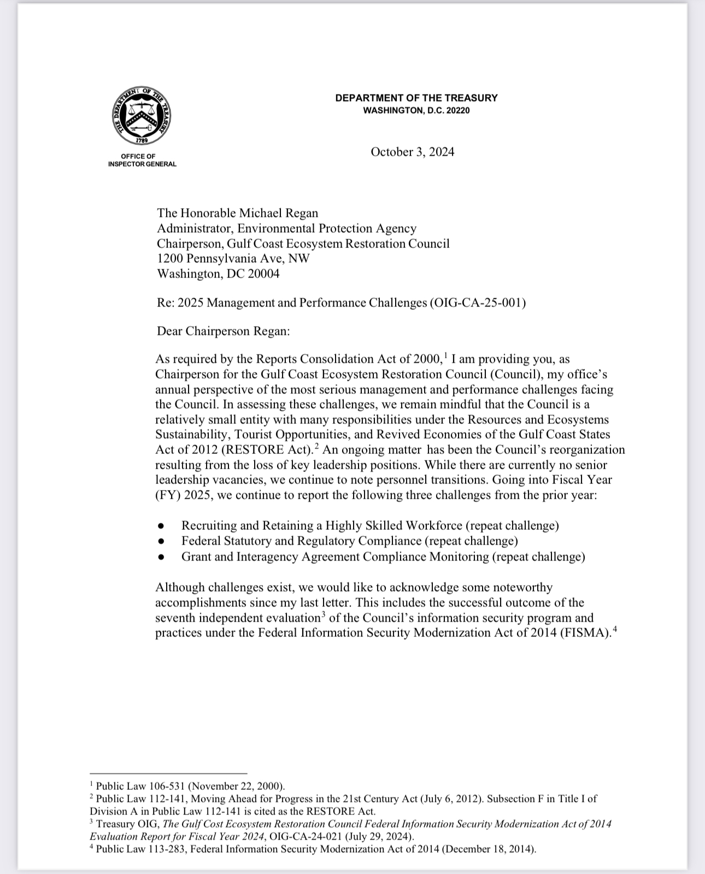
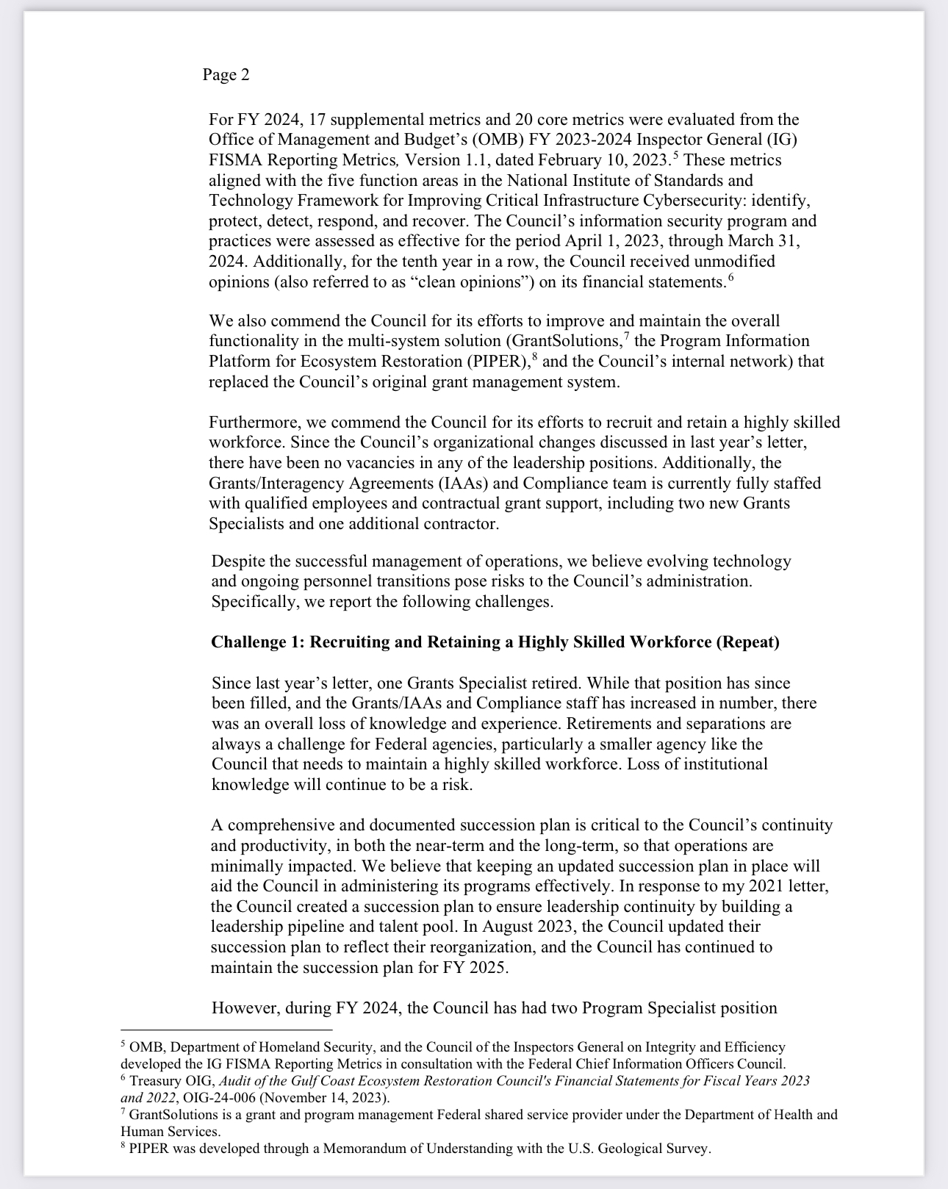

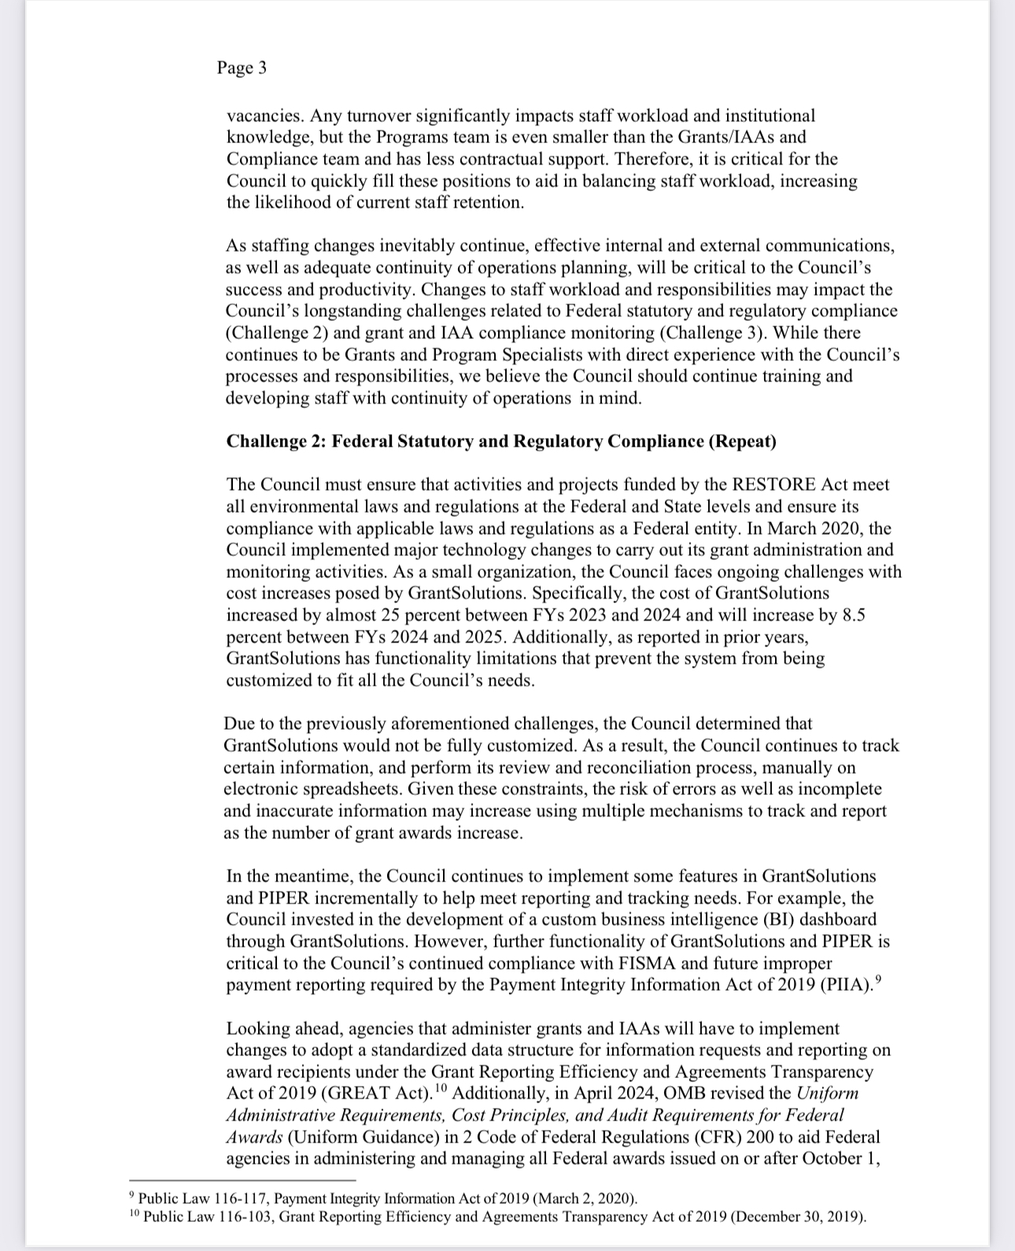
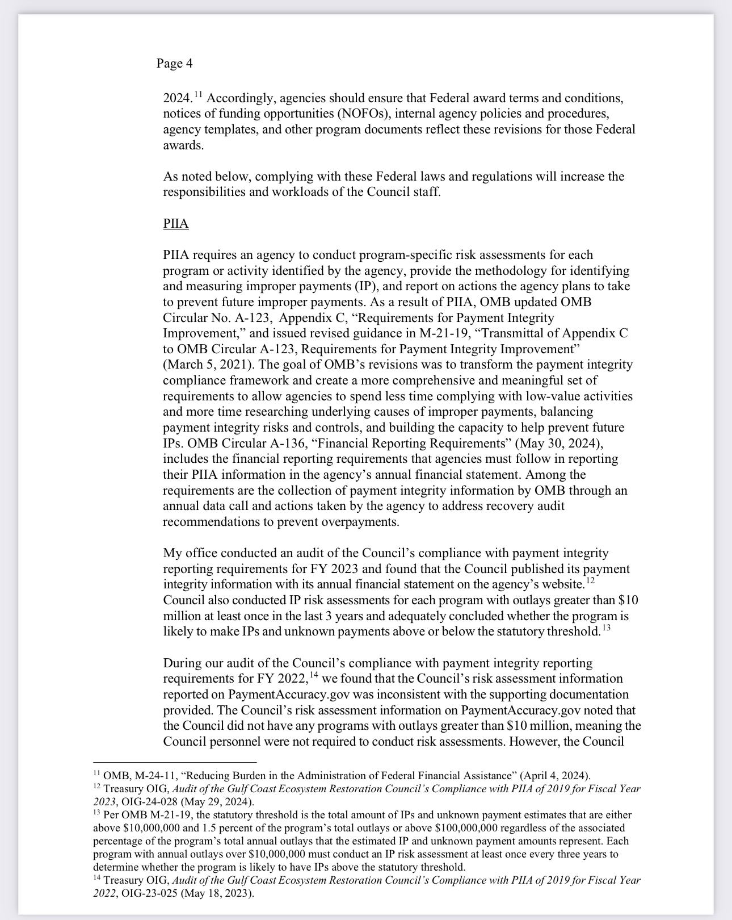

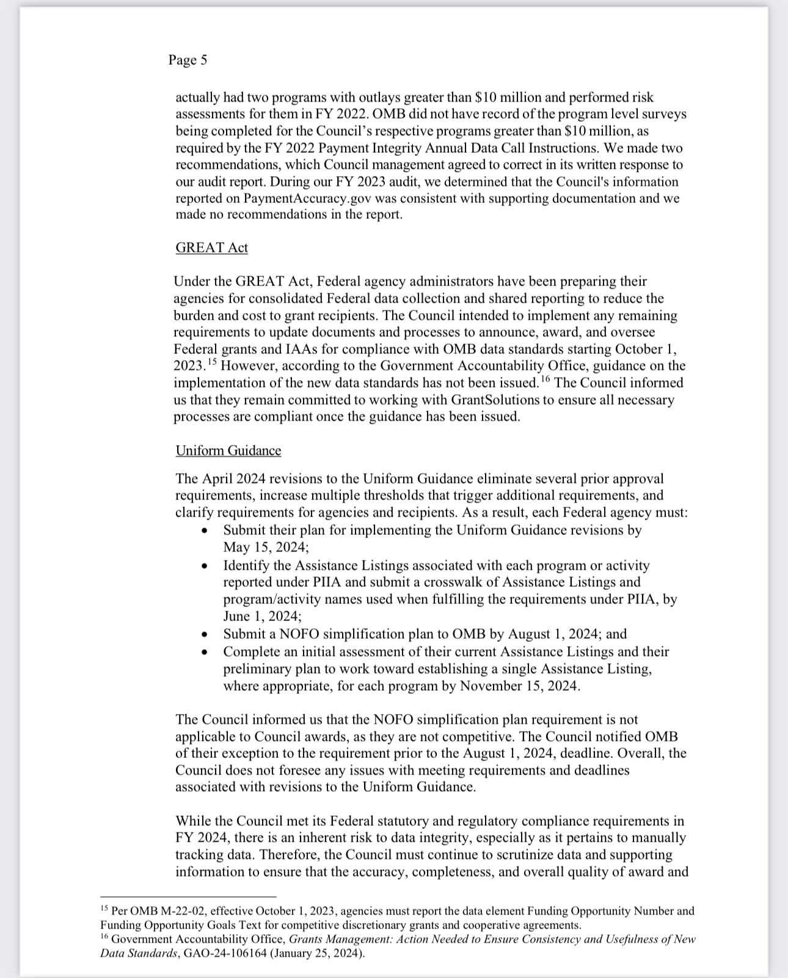

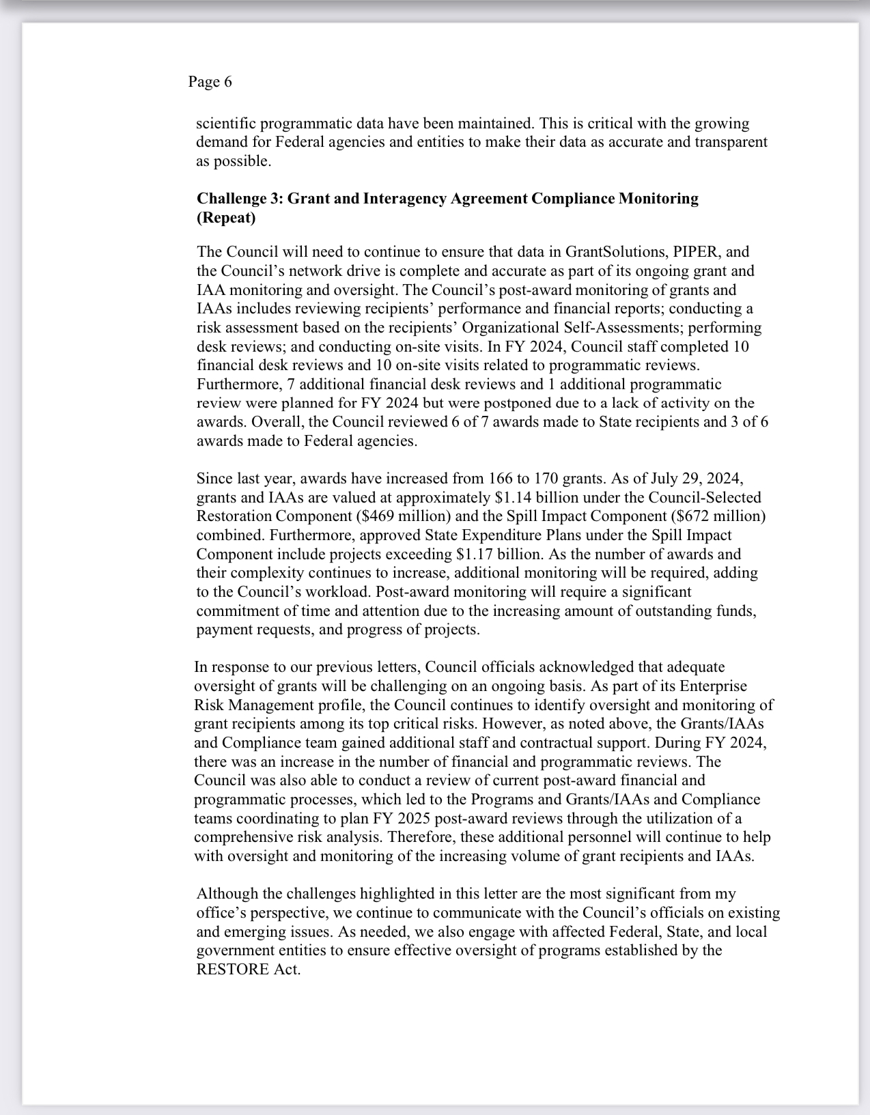

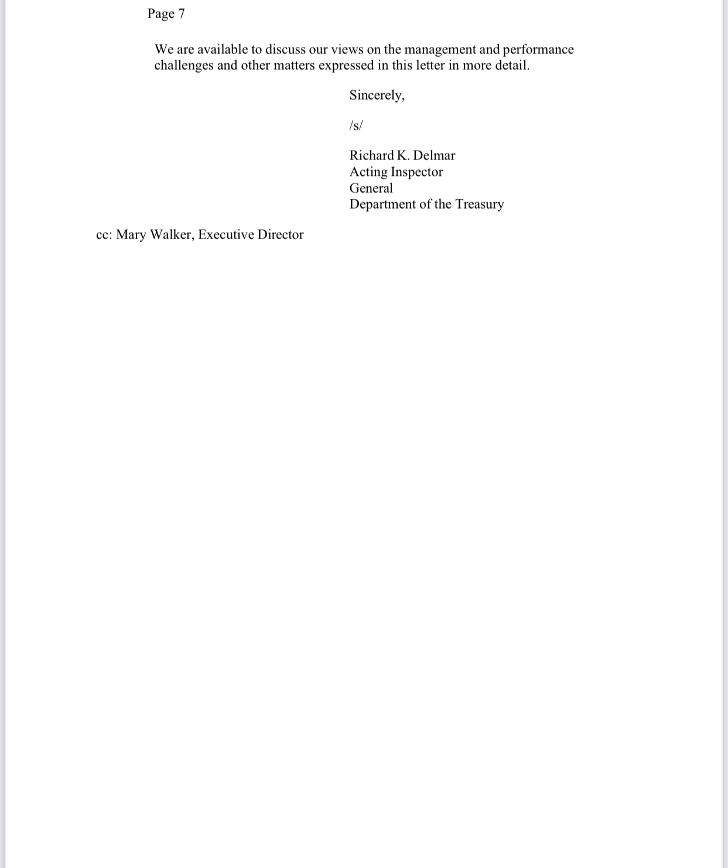

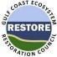

Gulf Coast Ecosystem Restoration Council

October 10, 2024

Re: Response to 2025 Management and Performance Challenges (OIG-CA-25-001)

Thank you for the opportunity to review the Office of Inspector General's (OIG) 2025 Management and Performance Challenges (OIG-CA-25-001). As you have noted, the Gulf Coast Ecosystem Restoration Council (Council) is a small agency with many responsibilities under the Resources and Ecosystems Sustainability, Tourist Opportunities, and Revived Economies of the Gulf Coast States Act of 2012 (RESTORE Act).

We appreciate your acknowledgment of the Council's accomplishments as we continue to strive to ensure an effective financial, IT, and grants management infrastructure for our agency. This includes the successful outcome of the Council’s evaluation of its information security program and practices under the Federal Information Security Modernization Act of 2014 (FISMA). The Council’s information systems security program and practices were assessed as effective for the period April 1, 2023, through March 31, 2024.
Additionally, for the tenth year in a row, the Council received unmodified opinions (also referred to as “clean opinions”) on its financial statements.

We agree with your assessment of challenges facing the Council in Fiscal Year 2025, and we provide the following comments with respect to our current status in addressing these challenges.

Challenge 1: Recruiting and Retaining a Highly Skilled Workforce (New)

The Council agrees with your assessment that recruiting and retaining a highly skilled workforce is critical to its ability to accomplish its mission. We recognize the inherent staffing challenges associated with managing routine turnover in a small agency. As a result, ongoing staff development is a key piece of our agency’s human capital management. Succession planning is and will remain a key focus for agency leadership.

Challenge 2: Federal Statutory and Regulatory Compliance (Repeat)

The Council shares your assessment that compliance with all applicable federal laws and regulations is a core responsibility and key priority. As you note in your letter, agencies that administer federal financial assistance must comply with numerous laws and regulations, including the adoption of standardized data structures under the Grants Reporting Efficiency and Agreement Transparency Act of 2019 (GREAT Act) and Payment Integrity Information Act of 2019 (PIIA).
We appreciate your acknowledgment of the Council’s continued efforts to improve the overall functionality and efficiency of our grants management systems. We recognize, as you have noted, that as a small organization, the Council faces ongoing challenges posed by GrantSolutions, including cost. The Council acknowledges that there are still some gaps in functionality as well as some level of risk associated with a two-system solution. Ensuring the integrity of award data is a high priority; therefore, internal controls, testing, and regular reconciliations between systems are in place. The Council continues to assess system needs as we work to determine which system, or method will provide the most effective solution for meeting additional requirements currently not met by our systems.

The Council adopted OMB’s revised Uniform Administrative Requirements, Cost Principles, and Audit Requirements for Federal Awards (Uniform Guidance) in 2 Code of Federal Regulations (CFR) 200 and has updated its regulations to reflect the revisions. These revisions will be applied to new awards issued after October 1, 2024.

PIIA
The Council acknowledges the discrepancy with PaymentAccuracy.gov that occurred in FY 2022. In response, Council staff have implemented the auditors’ recommendations in accordance with the FY2023 Annual Data Call requirement that all agency submissions be reviewed and approved by the Chief Financial Officer before submission. The FY2023 Payment Integrity Information Act of 2019 (PIIA) audit resulted in no findings, and we are preparing to follow the same process for the FY2024 submission.

Challenge 3: Grant and Interagency Agreement Compliance Monitoring (Repeat)

The Council agrees with your assessment that compliance monitoring is a critical function for our agency. Grant and interagency agreement compliance monitoring will remain an ongoing focus of Council staff for the duration of the Council, and we continue to invest in this area. In response to the increased award management workload, last calendar year (FY 2024) the Council brought on board two additional grants specialists to help support this work. We continue to utilize the Grants monitoring Risk Analysis and Screening Tool to target oversight, and we will benefit from increased staff resources as we focus our oversight efforts.

Again, thank you for providing us with the opportunity to review this report. In Fiscal Year 2025, the Council will use this evaluation to continue to improve its processes. We appreciate the ongoing cooperation and support that we receive from your staff, and we look forward to working with you in the year ahead.

Sincerely

/S/ Original signed

Mary S. Walker
Executive Director
Gulf Coast Ecosystem Restoration Council

PAYMENT INTEGRITY INFORMATION ACT

The U.S. Department of the Treasury, in coordination with the U.S. Department of Justice and the Office of Management and Budget, has launched the PaymentAccuracy.gov website (https://www.paymentaccuracy.gov/payment-accuracy-the-numbers/) to serve as a centralized resource for information regarding improper payments made by the U.S. government to individuals, organizations, and contractors. This platform also facilitates the reporting of suspected incidents of fraud, waste, and abuse and provides insights on (1) current and historical rates and amounts of improper payments, (2) the underlying causes of these payments, and (3) the measures agencies are implementing to mitigate and recapture improper payments.

Moreover, PaymentAccuracy.gov includes data from the Council on overpayments identified and recaptured in FY 2024, as well as relevant payment integrity and fraud-related information. This encompasses details previously reported in the Council’s Agency Financial Reports (AFR) that are not required for inclusion in this fiscal year’s payment integrity reporting.

BIENNIAL REVIEW OF USER FEES

The Council does not charge user fees for services and things of value.

GRANTS PROGRAM

The Council does not have expired, but not closed Federal grants or cooperative agreements (awards), for which the period of performance elapsed before September 30, 2022.

¹ Public Law 113-283 (December 18, 2014).
² OIG, The Gulf Coast Ecosystem Restoration Council Federal Information Security Modernization Act of 2014 Evaluation Report for Fiscal Year 2024, (OIG-CA-24-021; July 29, 2024).
³ OMB, Department of Homeland Security, and the Council of the Inspectors General on Integrity and Efficiency developed the IG FISMA Reporting Metrics in consultation with the Federal Chief Information Officers Council.

