Ref. COMM(24)02688 02/10/2024

Joint Statement
European Commission grants an additional twelve months for EUDR implementation in response to sector concerns

European primary producers and various industries welcome the European Commission’s proposal to extend the implementation period of the EU Deforestation Regulation (EUDR) by an additional 12 months. While we fully support the regulation’s objective to combat global deforestation, it is crucial to ensure that it is implemented under the right conditions to be effective and feasible.
For many months, our organisations have raised concerns about the regulation’s practical applicability and the substantial administrative burden it imposes. We therefore call the European Parliament and the Council to consider the challenges raised by EU Member States, third countries, and relevant stakeholders, and to approve the Commission’s proposal for a one-year postponement.
The focus must now shift to addressing the practical challenges associated with the EUDR’s implementation to prevent uncertainties and avoid supply chain disruptions. We will carefully review the guidance document published today and remain committed to further dialogue to ensure workable solutions for all impacted sectors.

Signatories:
CEI-Bois – European Confederation of Woodworking Industries
CEPF – Confederation of European Forest Owners
Cepi – Confederation of European Paper Industries
Copa-Cogeca – European Farmers and Agri-Cooperatives
ELO – European Landowners’ Organization
EOS – European Organisation of the Sawmill Industry
EUSTAFOR – European State Forest Association
FEFAC – Euroepan Feed Manufacturers’ Federation
UECBV - European Livestock and Meat Trading Union
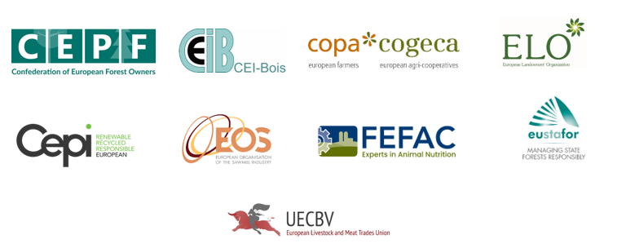

-END-
Translations will be available in DE, ES, FR, IT, PL and RO on the Copa-Cogeca website soon.
About us - Copa and Cogeca are the united voice of farmers and agri-cooperatives in the EU. Together, we ensure that EU agriculture is sustainable, innovative and competitive, while guaranteeing food security for 500 million people throughout Europe. >>> More information www.copa-cogeca.eu

For further information, please contact
Oana Neagu  Director, General Affairs  oana.neagu@copa-cogeca.eu | Jean-Baptiste Boucher  Communication Director  +32 474 84 08 36  jean-baptiste.boucher@copa-cogeca.eu

Press Release Mailing List
Unsubscribe
Subscribe

