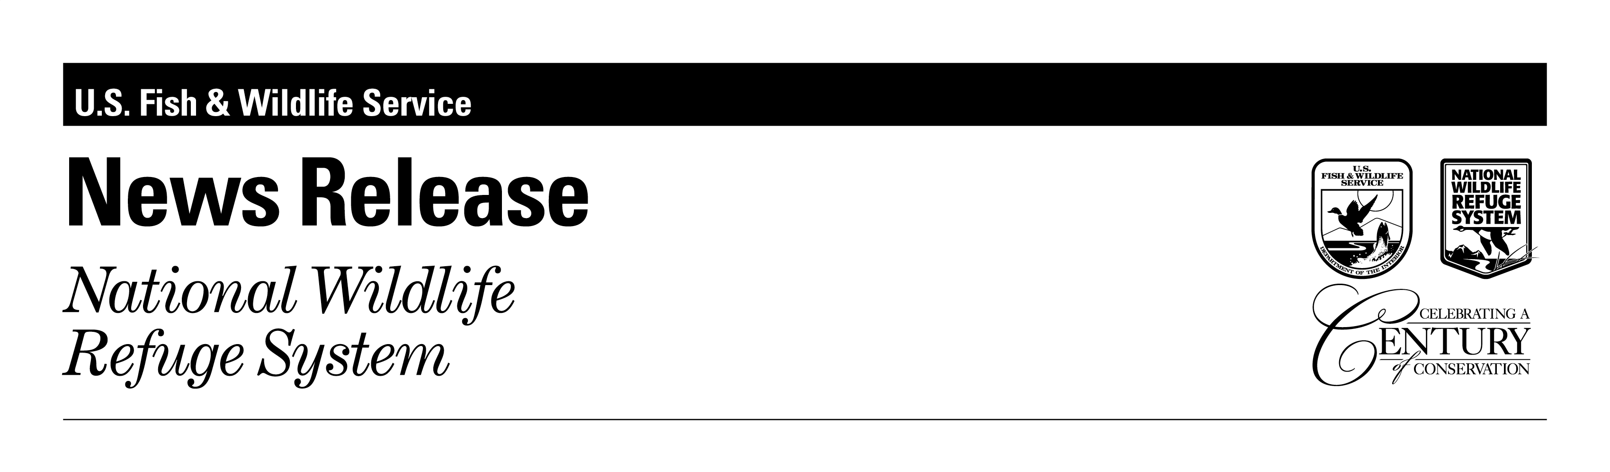

FOR IMMEDIATE RELEASE

Joshua Smith (302) 653-9345

**2024 - 2025 FALL HUNTING OPPORTUNITIES**

**AT BOMBAY HOOK AND PRIME HOOK NATIONAL WILDLIFE REFUGES**

Bombay Hook and Prime Hook will offer Deer, Waterfowl, and Upland Game/Webless Migratory Bird hunting opportunities this year. We allow hunting with archery/crossbow, shotgun, and muzzleloader. No centerfire rifles are permitted. The refuges are not open to hunting on Sundays.

In addition to all applicable State and Federal stamps and licenses, all hunters are required to obtain a hunting permit from the refuge for the specific hunt in which they are participating. (i.e. deer permit for deer hunting, waterfowl permit for waterfowl, etc.) Permits include additional information/regulations and are available at each refuge’s office or online.

**Deer:**

Both refuges will conduct a lottery for Headquarters unit deer hunts. Applications can be picked up at either refuge or printed from refuge web sites. Completed applications can be submitted in person or by mail to either refuge headquarters (addresses below). The deadline to apply is Sunday, September 15th.

**Headquarters hunt dates:**  
Bombay Hook: October 11th (Muzzleloader), November 15th (Shotgun), December 18th (Antlerless)

Prime Hook: October 15th (Muzzleloader) and November 19th (Shotgun)

Bombay Hook will offer permits in units H-1, H-2, H-3, H-4, H-5, and H-6. There will be 45 permits issued per hunt date.

Prime Hook will offer permits in the 4 headquarters units. There will be 28 permits issued per hunt date.

**Waterfowl:**

In addition to the regular duck and goose seasons both refuges will be open for resident Canada goose and September teal seasons this year. Bombay Hook hunts on Kelly Island and Mahon Tract will continue to be issued at the Little Creek hunt check station. Prime Hook hunts will be issued via hunter led daily lottery at the Prime Hook hunt check station.

**Small Game:**

Small game seasons will be open in the South Upland, Steamboat Landing, and Fischer tracts at Bombay Hook. At Prime Hook; Fowler North, Prime Hook North and Prime Hook South units are open for small game. Shotgun shooting shot is the only permitted method of take. Non-toxic shot is required at Prime Hook and highly encouraged at Bombay Hook. See brochures for season dates and closure information. The State of Delaware has closed all hunting of wild bobwhite quail for the 2024/25 season.

If you have any questions, please call Prime Hook at (302) 684-8419 or Bombay Hook at (302) 653-9345.

Bombay Hook NWR

2591 Whitehall Neck Rd

Smyrna, De 19977

https://www.fws.gov/refuge/bombay-hook

Prime Hook NWR

11978 Turkle Pond Road,

Milton, DE 19968

https://www.fws.gov/refuge/prime-hook

The mission of the U.S. Fish and Wildlife Service is working with others to conserve, protect and enhance fish, wildlife, plants and their habitats for the continuing benefit of the American people. We are both a leader and trusted partner in fish and wildlife conservation, known for our scientific excellence, stewardship of lands and natural resources, dedicated professionals and commitment to public service. For more information on our work and the people who make it happen, visit **www.fws.gov**.