To ask the Minister for Further and Higher Education; Research; Innovation and Science the number of persons who sought a SUSI grant on the grounds that they were estranged from their parents in each of the past ten years, in tabular form.
- Peadar Tóibín.
* For WRITTEN answer on 26/06/2024
Ref No: 27352/24

Reply

Minister for Further and Higher Education, Research, Innovation and Science (Patrick O'Donovan)

For student grants purposes, students are categorised according to their circumstances either as students dependent on parents or a legal guardian, or as independent mature students.
A student may be assessed as an independent mature student if he or she has attained the age of 23 on the 1st of January of the year of first entry to an approved course or of re-entry following a break in studies of at least three years and is not ordinarily resident with his/her parents from the previous October. Otherwise he or she would continue to be assessed on the basis of parental income.
Only in exceptional cases, where compelling evidence of estrangement from parents/guardians is provided, can candidates who are under 23 be assessed without reference to their parents/guardians income or address, Article 21(3) (b) of the Scheme refers.
The assessment of a case of estrangement is carefully considered to ensure there is sufficient evidence to demonstrate that the exceptional circumstances pertaining in such cases genuinely exists. Cases of genuine estrangement are relatively rare and almost always will involve exceptional circumstances unique to a particular family situation. The scheme does not stipulate precisely how an awarding authority satisfies itself that such circumstances prevail. This is to allow the awarding authority sufficient flexibility to assess the evidence of irrevocable estrangement in each individual case. The type of documentary evidence required is dependent on the applicant's individual circumstances.
Please see below for the number of applicants who applied for a SUSI grant stating estrangement from 2016/17 to 2024/25.
Please note that data from academic years prior to 2016/17 is not available.
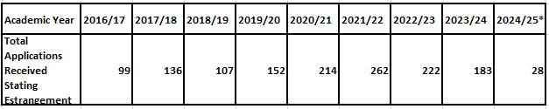
* The current year’s figures (2024/25) may change as processing is ongoing.

