CENTRAL BANK OF SEYCHELLES
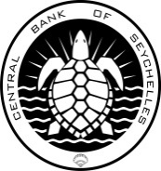

NOTICE TO THE GENERAL PUBLIC

The Central Bank of Seychelles (CBS) would like to inform the public that it will be performing a test on its standby generator on Thursday November 04, 2021, from 9.00 a.m. to 11.00 a.m.

There may be minimal interruptions to the CBS’ IT infrastructure and telephone system during the testing period. Banking platforms linked to the CBS system may also experience service interruptions during this time.

The testing of the standby generator, which is scheduled on a monthly basis, is an essential part of CBS’ Business Continuity Plan.

The CBS would like to apologise for any inconvenience caused and thank the public for their understanding.

