|  |  |
| --- | --- |
| European Parliament  2019-2024 | EP logo RGB_Mute |

<Commission>{IMCO}Committee on the Internal Market and Consumer Protection</Commission>

<Date>{23/03/2023}23.3.2023</Date>

<TitreType>MISSION REPORT</TitreType>

<Titre>following the mission to Helsinki and Tallinn from 20 to 22 February 2023</Titre>

<Commission>{IMCO}Committee on the Internal Market and Consumer Protection</Commission>

Members of the mission:

Anna Cavazzini (Verts/ALE) (Leader of the mission)

Adriana Maldonado López (S&D)

Tsvetelina Penkova (S&D)

Andrus Ansip (Renew)

Malte Gallée (Verts/ALE)

Introduction

The mission’s objective was to find out more about the two Member State’s initiatives to promote a circular economy and digital governance.

Summary account of meetings in Helsinki

Visit to the Finnish National Parliament (Eduskunta), Meeting with Ms Hanna Kosonen (Chair) and Members of the Environment Committee

The first meeting in Helsinki took the IMCO delegation to the Finnish Parliament to meet with Finnish parliamentarians from the Environment Committee. It was also one of the last working weeks of that legislature of the Eduskunta, with new elections scheduled for 2 April 2023. Members had the possibility to hear about the structure and working procedures of the Finnish Parliament, as well as exchange primarily about the recent packaging and packaging waste proposal from the Commission. It was underlined that for a successful implementation of new rules, financial incentives coupled with convenience were key to changing the public’s behaviour. Both sides expressed the wish to continue a dialogue on circular economy issues in the future.

Visit to Infinited Fiber, Company producing recycled textile fibre InfinnaTM for the clothing industry

Infinited Fiber Company is a Finnish biotech founded in 2016 to commercialize a recycling technology that can turn cellulose-rich raw materials – like cotton-rich textile waste, used cardboard, or wheat or rice straw – into high-quality textile fibers with the look and feel of cotton. The IMCO delegation met with the company’s Chief Marketing Officer who gave the Members an interesting presentation of the various production stages of the textile fibre InfinnaTM and its use by many global brands (HM, Tommy Hilfiger, and Patagonia). The reasons for choosing Finland as the production base were also explained - namely available renewable energy, IP protection (pulp cooking expertise) and feedstock availability (collected textile waste). The visit allowed Members to get a better insight for ongoing IMCO files, in particular on the EU strategy for sustainable and circular textiles (2022/2171(INI)).

Meeting with Finnwatch, NGO promoting responsible business conduct

Finnwatch is an NGO monitoring the human rights impact of Finnish companies and the meeting with the IMCO delegation allowed both sides to exchange on the current and upcoming IMCO proposals with a focus on responsible business conduct. Particular attention was paid to the files such as the CSDD (Corporate Sustainability Due Diligence), proposal on the prohibition of forced labour, the upcoming customs files and the green claims proposal, where Finnwatch colleagues explained the concerns they had and if/how these could still be alleviated. Members took note of the problems raised and inquired further about the cases Finnwatch had investigated about Finnish companies.

Meeting with Mr Jussi-Pekka Teini, Adviser on Engineering Sustainability, TEK (Tekniikan Akateemiset

At the following meeting with Mr Teini, which took place at the European Parliament Liaison Office in Helsinki, the IMCO delegation had an interesting exchange about the current and future state in Finland on “sustainability engineering”. As a response to Members’ questions, Mr Teini explained that Finland owes its success not just to research but also to cooperation between universities and the industry, as many students already start working while studying. He underlined however that the circular design/business models are not yet covered in depth in the Finnish higher education system but this ought to be changed in the coming years.

Visit to Sitra (Finnish Innovation Fund), Organiser of the World Circular Economy Forum, spring 2023

Sitra (the Finnish Innovation Fund) is an independent public foundation, which operates directly under the supervision of the Finnish Parliament. It functions both as a think tank and as an investment company, whereas its work primarily consists of research, studies, trials, pilots, events, and training that are closely related to Sitra's three strategic themes. The meeting with the IMCO delegation concentrated on the transition to a fair and competitive circular economy and a fairer data economy. The hosts presented their institution and their work, which was followed by a discussion on data driven sustainability - instead of producing more, perpetuating the value of what we have through smarter design, digital solutions and data. The exchange also focused on the European Health Data Space and the Data Act proposals, which could allow key opportunities for European companies through stronger data portability rights and enhanced competition.

***Summary account of meetings in Tallinn***

Visit to e-Estonia Briefing Centre

The first meeting for the IMCO delegation in Estonia took place in the e-Estonia Briefing Centre which was designed to give the visitor an experience in everything e-Estonia has to offer. Established in 2009 as an NGO, it is today part of the Estonian Business and Innovation Agency and plays an integral role in promoting the country’s know-how and expertise in digital services. A digital transformation adviser gave the Members an overview of the key enablers that allowed Estonia to reach an advanced level in public digital services, while focussing on the three key pillars - confidentiality (e-identification), availability (data exchange platform called X-road) and integrity (e.g. data embassy). The digital advisor also gave a demonstration how she as a citizen, using her ID card, accessed in real time the state digital portal to view her data and perform certain operations. Members greatly appreciated the informative and interactive format of the meeting.

Meeting with the Prime Minister of Estonia, Ms Kaja Kallas

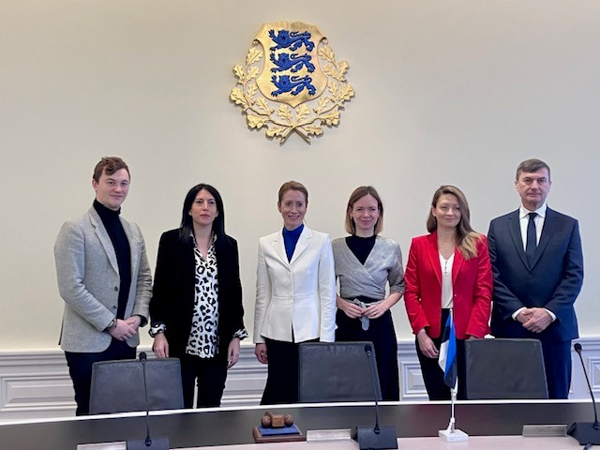A short meeting with Ms Kaja Kallas, a former substitute Member of IMCO (2014-2017), provided a chance to exchange with the Members on the current geopolitical context in Europe. The topics raised concerned Russia’s aggression against Ukraine, but also the EU’s response to the Inflation Reduction Act and the related subsidies race. The Prime Minister underlined the importance of competitiveness and of maintaining a level playing field, especially for smaller Member States. The IMCO Members gave a short overview of the main files currently deliberated in the committee, with special attention to the circular economy dossiers, and inquired about Estonia’s experiences in the green and digital transition.

Meeting with Ms Kristi Talving, Director General of the Consumer Protection and Technical Regulatory Authority - Ministry of Economic Affairs and Communications

The following visit took the Members to the Ministry of Economic Affairs, where the IMCO delegation met with several government officials, working on the day-to-day transposition, implementation and enforcement of EU legislation. The ensuing exchange concentrated on several key files, such as the proposals on Ecodesign, Consumer Credit, Media Freedom Act and the Corporate Sustainability Reporting Directive. The hosts highlighted some issues from the Estonian perspective and insisted on the good cooperation with other Member States’ consumer protection authorities. Members appreciated the expert level of the exchange and took note of the remarks made about ongoing legislative dossiers.

Visit to Stella Soomlais studio, Designer and circular economy entrepreneur

At the studio of the Estonian leather designer Stella Soomlais, the IMCO delegation heard how this SME entrepreneur aims to put circular economy principles into practice to be a pioneer in making the leather-use more sustainable and responsible. The crafters explained how their products are designed to maximise the use of materials, enable simple maintenance and after-care, and allow to direct refreshed bags into the next rounds of usage. Members were given an overview of the production process and exchanged with the crafters about the main challenges facing the sector (waste of leather, issues with supply chains etc).

Visit to AS Cybernetica, Meeting with Mr Dan Bogdanov, Chief Scientific Officer, Company developing IT solutions for public digital services

Cybernetica AS is an ICT company that has played an integral role in building Estonia's e-governance ecosystem, notably the digital identity and a secure data exchange called X-road. The IMCO delegation met with the company’s Chief Scientific Officer and Chief Technology Officer to discuss the current issues in digital transformation. In response to Members’ questions, the hosts delved more into certain topics, such as collaboration on data with non-GDPR territories, without giving full control of data, or how to connect digital governments or data networks, without creating numerous competing systems. The discussion finally also looked into the future - how can the public digital services’ ecosystem still be enhanced and what are challenges for the future.

Conclusions

The IMCO Committee mission to Helsinki and Tallinn allowed the participants:

• to exchange with state actors (parliament and government) about the achievements in the field of circular economy and public digital services - which solutions have worked best and what can be improved further in the future;

• to discuss with civil society about concrete IMCO files and listen to the concerns what the public has about planned or adopted EU legislation;

• to hear from the private sector how their activity in the field of circular economy or digital services could be boosted at state/EU level and which challenges they are currently facing.

This mission provided a good opportunity to get more in-depth knowledge about the state-of-play in both Member States and it will feed into IMCO’s future work in digital services and circular economy.