

December 2022 ERCOT Cold Weather Operations Report (PUBLIC):

Winter Storm Elliott Public Report

**Version 1.0**

Contents

1. Executive Summary 1

2. Report Summary 1

3. Peak Demand: Forecast and Actual 1

4. Renewable Generation: Forecasts and Actual 3

5. Committed Capacity and Generation Used by Fuel Type 6

6. Natural Gas Restrictions 9

7. Reliability Unit Commitment (RUC) and Firm Fuel Supply Service (FFSS) Summary 10

8. Generation and Transmission Outages 10

9. Winter Storm Elliott vs. Winter Storm Uri 17

10. Market Summary 18

10.1. System-Wide Pricing 18

10.2. Hub Average and Hub Bus Average Settlement Point Prices 19

10.3. Day-Ahead Prices 20

11. Ancillary Services 21

11.1. Deployment of Responsive Reserves 21

11.2. Deployment of Non-Spin 21

11.3. Energy Storage 21

12. Large Flexible Load Performance 24

13. Outreach During Winter Storm Elliott 24

13.1. Operations Outreach 24

13.2. Communications Outreach 25

13.3. Legislative Outreach 28

14. Conclusions and Lessons Learned 29

Executive Summary

The Cold Weather event that occurred from December 22nd to December 25th, 2022, was precipitated by severe winter weather, commonly referred to as “Winter Storm Elliott,” originating in the Pacific Northwest and covering a great portion of the United States (U.S.), including the entire ERCOT region. In parts of Texas during the event, temperatures stayed at or below freezing for extended periods. Due to the extended cold weather, ERCOT surpassed the previous peak demand record reaching 74,100 MW on December 23rd, 2022. However, the generation capacity was more than sufficient in meeting this record. Instantaneous Physical Responsive Capability (PRC), which indicates the amount of operating reserves, never fell below 4,052 MW during the storm. ERCOT does not declare a Level 1 Energy Emergency Alert (EEA) until PRC falls below 2,300 MW.

Throughout Winter Storm Elliot, there were far less generation outages due to cold weather when compared to Winter Storm Uri. Prior to Elliott, ERCOT’s Weatherization & Inspection team examined 255 resources, only 4 of which experienced weather-related outages between December 22nd to December 25th, 2022. Weather related outages that occurred on units that had recently been inspected for winter weather readiness will receive additional scrutiny and any lessons learned will be included in future inspections.

ERCOT did experience some discrepancies between the forecasted system demand versus actual system demand once the storm arrived. This was primarily due to a software upgrade; more detail is provided in Section 3 of this report. However, as mentioned previously, ERCOT’s operating reserves remained sufficient for the duration of the cold weather period.

During Winter Storm Uri, the extreme temperatures, prolonged duration, and widespread nature of the storm negatively impacted the ability of some natural gas providers to supply sufficient fuel to a portion of the natural gas-fired generation fleet within the ERCOT region to generate needed electricity. In order to mitigate this issue, ERCOT has implemented a tool called Firm Fuel Supply Service (FFSS), which requires participating generation resources to carry stored on-site fuel for the purpose of maintaining availability in the event of primary fuel supply disruption. This service helped reduce the amount of resources that were unavailable due to lack of fuel during Winter Storm Elliott. In addition, in connection with Winter Storm Elliot, ERCOT requested that the U.S. Secretary of Energy issue an order allowing generating units in the ERCOT region to operate in excess of their federal environmental permit limits so that these units could provide maximum output. The Secretary of Energy granted ERCOT’s request and issued an order on December 23, 2022. The order allowed certain identified units to exceed permitted limitations in the event ERCOT declared an EEA Level 2 or 3.

Report Summary

**Time Frame:** Thursday, December 22, 2022 – Sunday, December 25, 2022

**Summary:** This report summarizes the performance of the ERCOT grid throughout Winter Storm Elliott, detailing peak demand and forecasted demand, renewable resources performance, major generation and transmission outages, operational messages, generation breakdown by fuel type, Reliability Unit Commitment (RUC) deployments, and operational reserve margins. Additionally, ERCOT will summarize the outreach and communication efforts prior to and throughout Winter Storm Elliott. After Winter Storm Elliott, ERCOT sent requests for information (RFIs) to Market Participants whose resources experienced outages or derates for weather- or fuel-related issues. The final section of this report will be a summary of ERCOT’s lessons learned.

# Peak Demand: Forecast and Actual

In the days leading up to the storm, the weather forecast models and vendor-supplied weather forecasts changed significantly between forecast runs. These changes were reflected in the changes in the peak load forecast. As the front moved in on the 22nd the weather forecasts for the timing and the intensity of the front’s arrival were off. The front arrived several hours sooner in the major cities, and the temperature drop was more intense than the forecast in the days leading up to the storm.

For the operational load forecast, ERCOT primarily uses internally-developed forecast models, but also has two vendor-developed forecast models as a backup. The software used for the internally-developed forecast models was recently updated to a newer version. The new version contained a change in the way the software applies holidays to the forecast. This resulted in the forecast models double counting the typical reduction in load typically experienced due to holidays. As a result, the load forecasts produced by the internally-developed forecast models were obviously too low for the 23rd and 24th so ERCOT switched to the vendor-developed forecast models. The load forecasts produced by these vendor-developed forecast models were also too low because these models do not have the sophistication of ERCOT’s internally-developed forecast models but were still better in this case due to the double counting of the effects of the holiday in the internally-developed models.

The following charts show the forecasted peak load for Thursday, Friday, Saturday, and Sunday (December 22nd to December 25th) for the respective five prior days. The last bar is the actual peak.

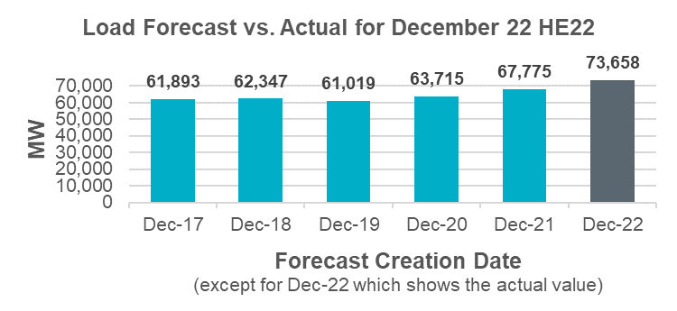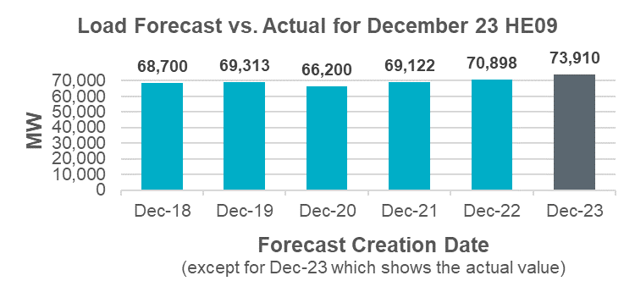

The following chart shows the actual peak load for Dec 22 to 25.

# Renewable Generation: Forecasts and Actual

Overall, the renewable generation forecasts performed well during the cold weather conditions. ERCOT’s staff meteorologists identified a risk that the normal wind and solar forecasts may over-forecast renewable generation output. Based on this, on Thursday December 22nd, ERCOT used the most conservative solar forecast and switched to the most conservative wind forecast in the afternoon, in advance of the cold weather and high load. The extreme weather forecasts – which account for icing impacts – were only slightly less than the normal 50th percentile forecast, so the 80th percentile forecasts were chosen as most conservative. The conservative wind and solar forecasts continued to be utilized until switching back on December 24th after the highest load peaks. High winds on Thursday December 22nd followed by a down ramp and low winds on December 23rd and 24th were predicted before the cold front arrived. Though the chosen 80th percentile forecast under-forecasted wind High Sustained Limit (HSL), it mitigated the potential effects of choosing the 50th percentile forecast, which would have slightly over-forecasted wind HSL during the December 22nd evening peak.

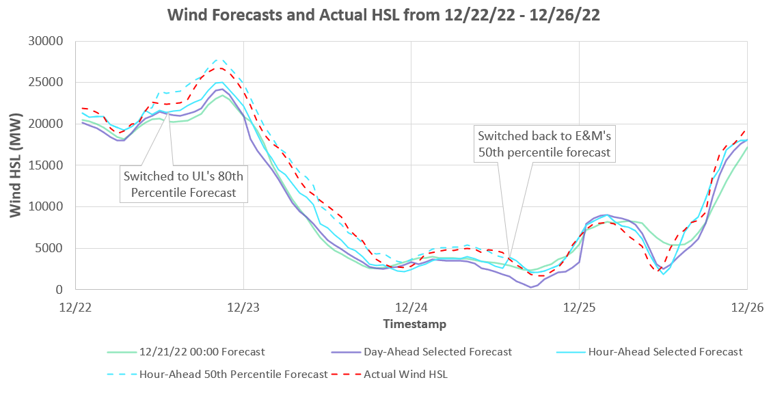

Due to cloud cover, the solar HSL was over-forecasted on December 22nd. The chosen 80th percentile forecast still over-forecasted the HSL, but by a lower margin than the 50th percentile forecast which is typically used.

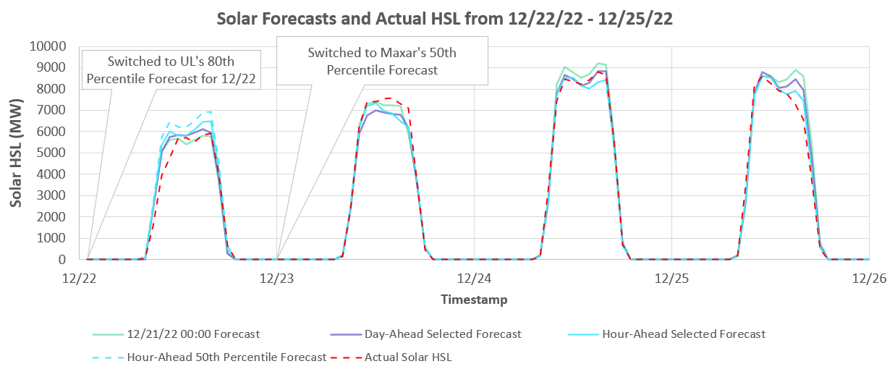

The table below summarizes the wind and solar forecast performance in Mean Absolute Percentage Error (MAPE) during the event compared to the monthly performance for December 2022.

|  |  |  |  |  |
| --- | --- | --- | --- | --- |
|  | Wind forecast  (Dec. 22-25, 2022) | Wind forecast  (Dec. 2022) | Solar forecast  (Dec. 22-25, 2022) | Solar forecast  (Dec. 2022) |
| Day-ahead Forecast Performance (MAPE) | 5.07% | 3.6% | 2.72% | 3.23% |
| 1-hour-ahead Forecast Performance (MAPE) | 2.83% | 1.9% | 2.55% | 2.53% |

Wind produced a significant amount of energy during the early morning of December 22nd and continued to increase during the early morning of December 23rd. Afterwards, wind output remained under 10 GW for the majority of Winter Storm Elliott until increasing back up on the morning of December 26th. The following charts show the actual output MW from Wind and Solar as well as any curtailments that were being observed. The output MW may be lower than the HSL due to curtailments, which are typically due to transmission capacity limitations.





# Committed Capacity and Generation Used by Fuel Type

Over 72 GW of capacity was committed for the evening of December 23rd. Most of this capacity was self-committed by market participants. Online reserves remained high throughout Winter Storm Elliott. The minimum Physical Responsive Capability (PRC) of 4,052 MW was observed on December 23rd at approximately 8:33 PM. PRC remained well above the EEA Level 1 criteria of 2,300 MW.

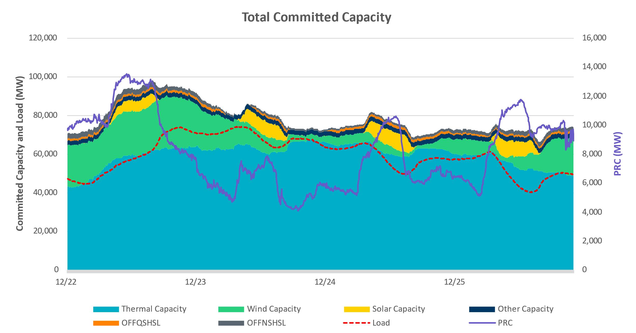

The following chart shows the breakdown of the generation used for the entire four-day period. Resources burning fuel oil were counted as natural gas generation for the purposes of this chart.

The instantaneous peak demand of 74,100 MW occurred on December 23rd at 7:30 am. The following chart illustrates the breakdown of the generation used during the peak demand. Additionally, ERCOT was importing and exporting varying amounts of energy across the Direct Current (DC) Ties from the morning of December 22nd through December 25th. During the peak demand on December 23rd, ERCOT was importing approximately 1,139 MW through DC Ties.

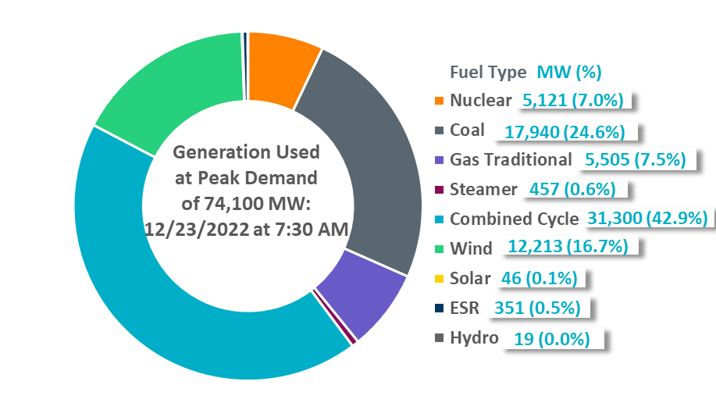

The following graph shows the level of several different types of reserves: online Operating Reserve Demand Curve (ORDC) reserves, offline ORDC reserves that could be online quickly, and Physically Responsive Capacity (PRC) which is the variable used to calculate the need to implement emergency operations procedures. Each of these measures of reserves remained high throughout the event.

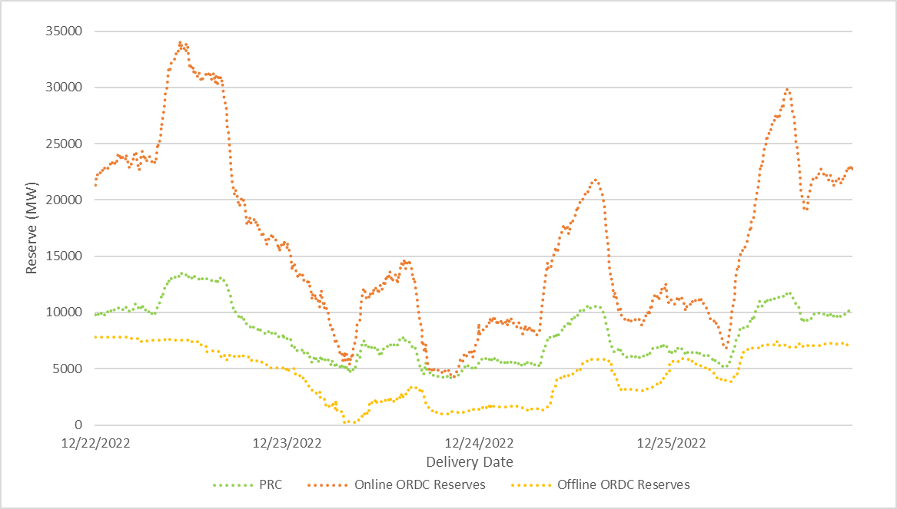

# Natural Gas Restrictions

The severe winter weather led to gas pipeline operators communicating to generator operators to be extra cautious with delivery overages and pipeline / shipper contract maximums.

Several pipeline operators issued Operational Flow Orders (OFO) to prevent shippers from moving additional gas beyond contract maximums during the cold weather. There was a report from one market participant that line pressure was beginning to fluctuate beyond normal levels, but ultimately, that caused no impact to their Resources’ output.



Additionally, gas generators that normally experience gas restrictions during cold weather were restricted during the week. However, gas restrictions were not a significant issue during this cold weather period, in part because Firm Fuel Supply Service was used to backfill capacity that was otherwise unavailable due to these gas restrictions.

# Reliability Unit Commitment (RUC) and Firm Fuel Supply Service (FFSS) Summary

The following chart shows the total RUC capacity and FFSS committed per hour. Each bar represents the cumulative capacity committed for the hour. Hours when there was not a change from the previous hour were omitted from the graphic for clarity.

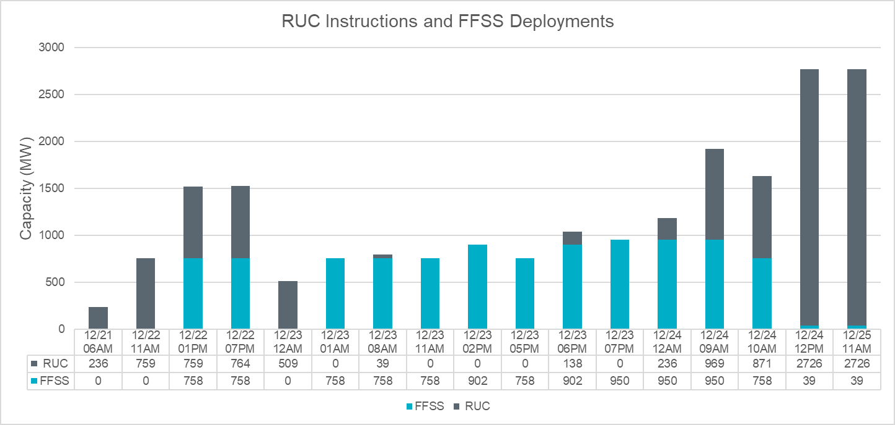

FFSS is a new service starting this winter season. Generators providing FFSS are required to have 48 hours of stored fuel. This service was beneficial in replacing generation capacity unavailable due to gas restrictions.

# Generation and Transmission Outages

At the beginning of the day on December 22nd, there were 11,988 MW of pre-existing generation outages and derates. Most of these outages were forced rather than planned. The maximum outage and derate capacity of 19,885 MW occurred on December 23rd at 08:00. The majority of this increase was due to an increase in gas resource outages. For Intermittent Renewable Resource (IRRs), wind and solar, seasonal capacity (High Sustainable Limit – HSL) rather than the expected IRR output was used to calculate the outaged and derated capacity.

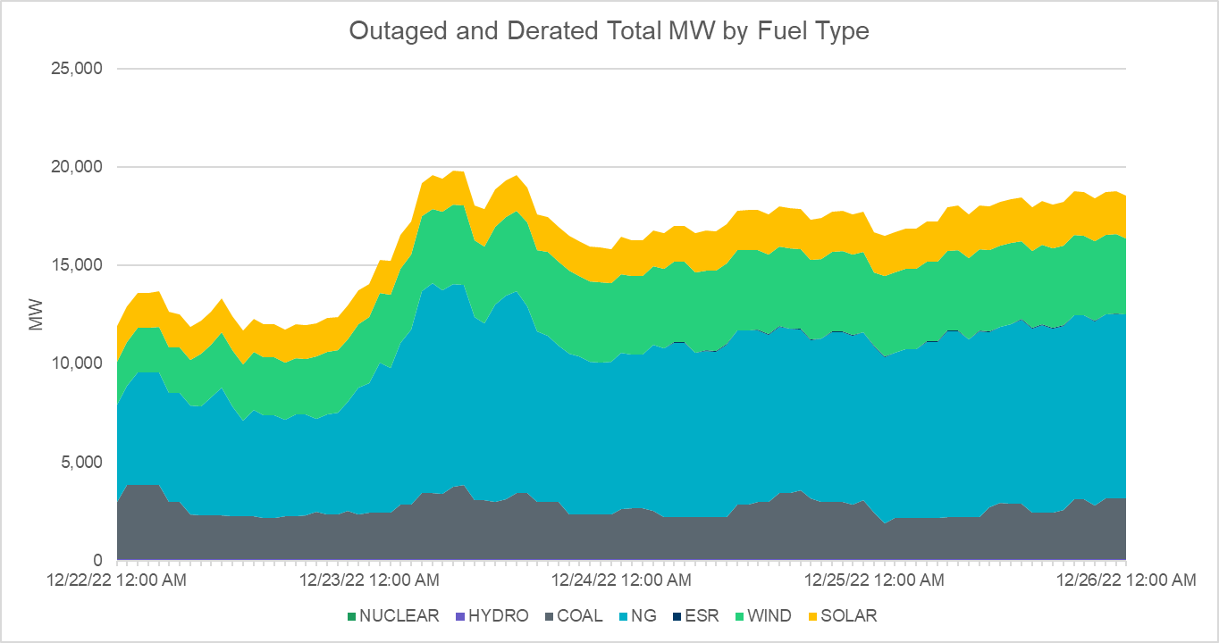

The following chart shows the preliminary breakdown of outages and derates by cause since December 22nd. “Faulted turbines or inverters” are wind turbine or solar inverter faults that did not mention icing. Requests For Information (RFIs) were sent by ERCOT to resources that experienced outages or derates due to weather- or fuel-related issues. The responses to these RFIs are broken down later in this section.

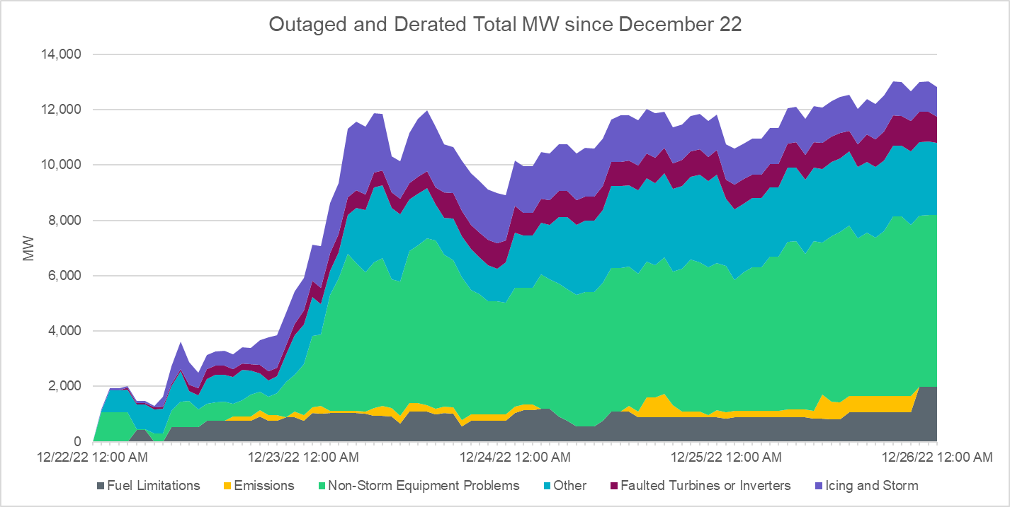

The following four charts show the outages and derates by cause since December 22nd for natural gas, coal, wind, and solar, respectively, along with an assessment of the cause category of the forced outages based on data entered by market participants into the ERCOT Outage Scheduler. Market participant’s responses to the RFIs clarified the causes of some of these outages.

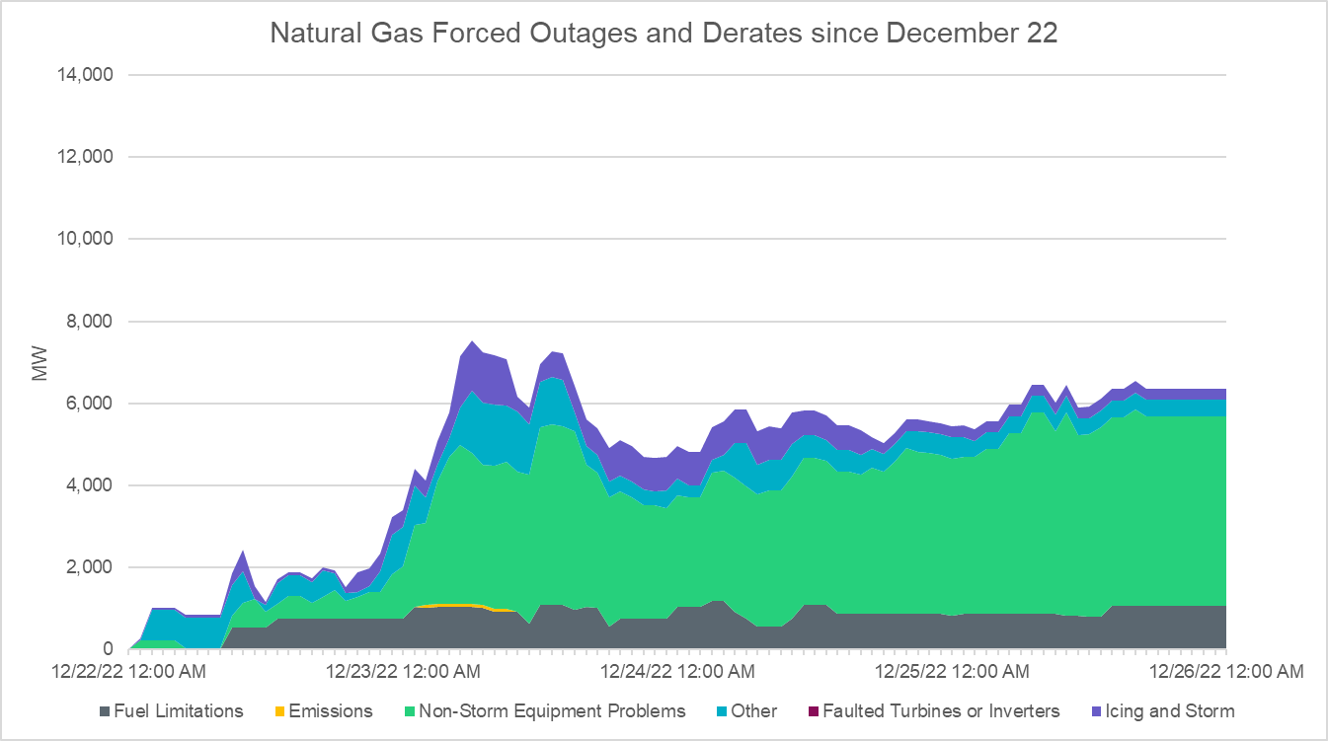

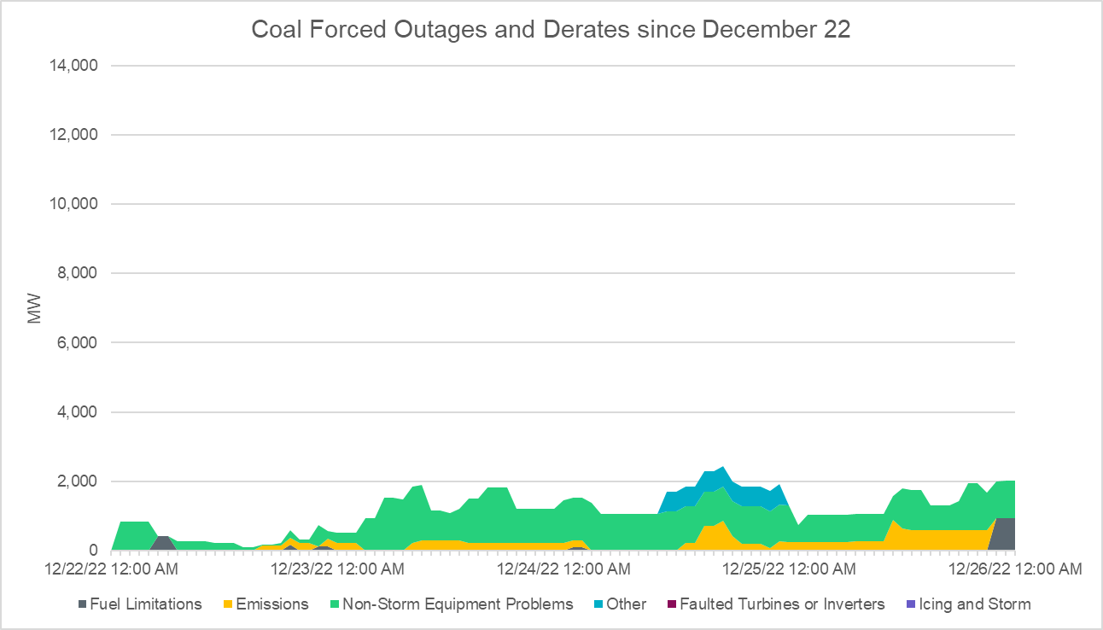

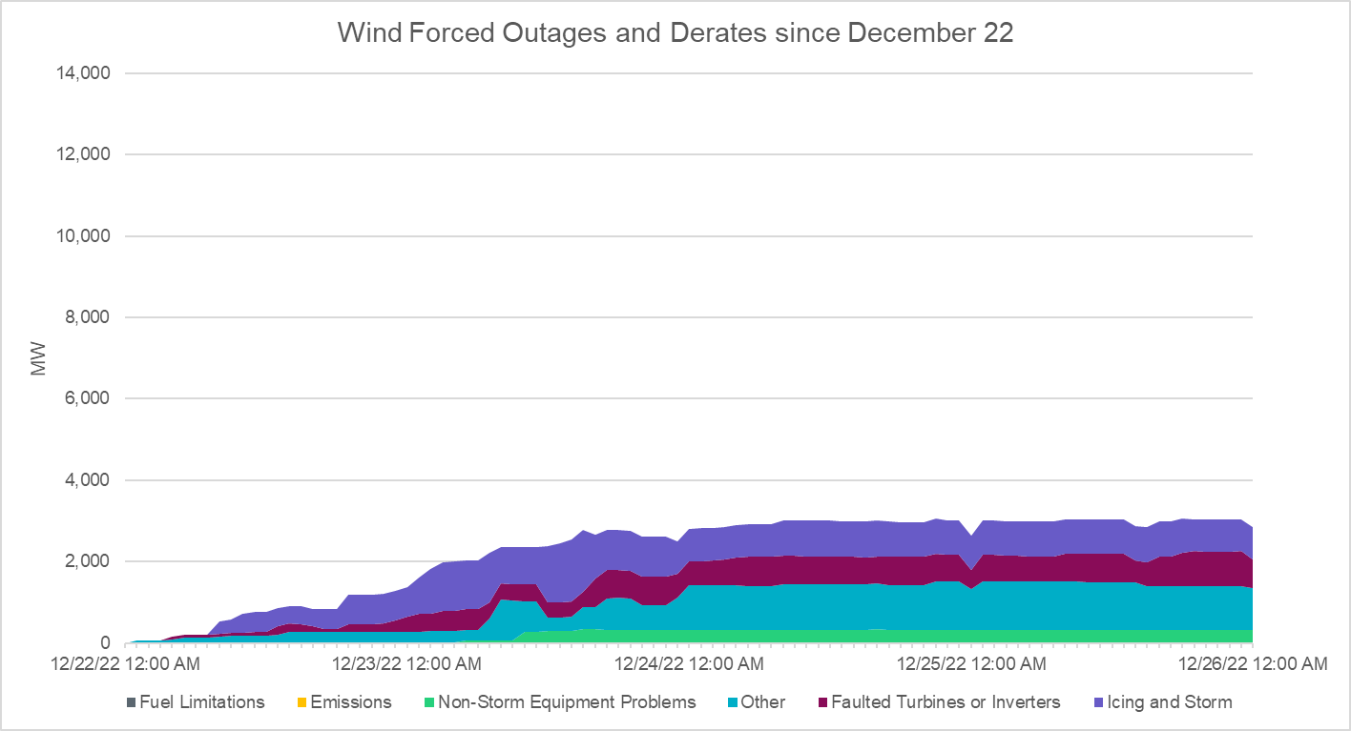

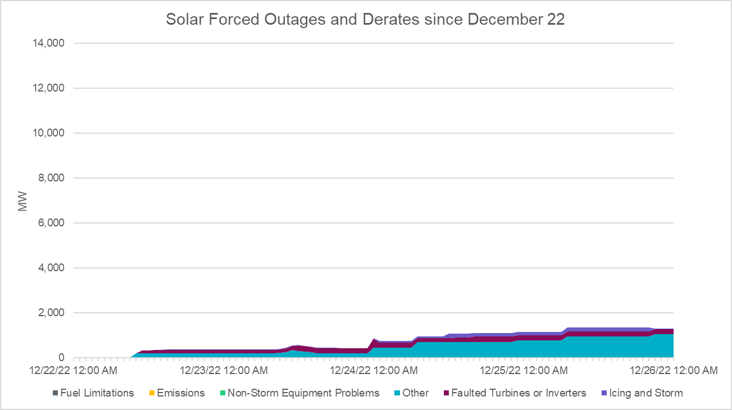

Following Winter Storm Elliott, ERCOT sent RFIs to market participants (MPs) whose resources experienced outages or derates for weather- or fuel-related issues. An initial list of impacted units was based on data entered by market participants into the ERCOT Outage Scheduler. The RFIs contained questions concerning the outage cause, outage duration, amount of MWs lost, gas pressure and flow (if relevant), etcetera. The following chart shows the amount of generation outaged or derated for reasons related to cold weather or fuel by type as well as the aggregate temperature (based on a weighted average) during Winter Storm Elliott.

Note that this is a subset of all outages that occurred during the cold weather period.

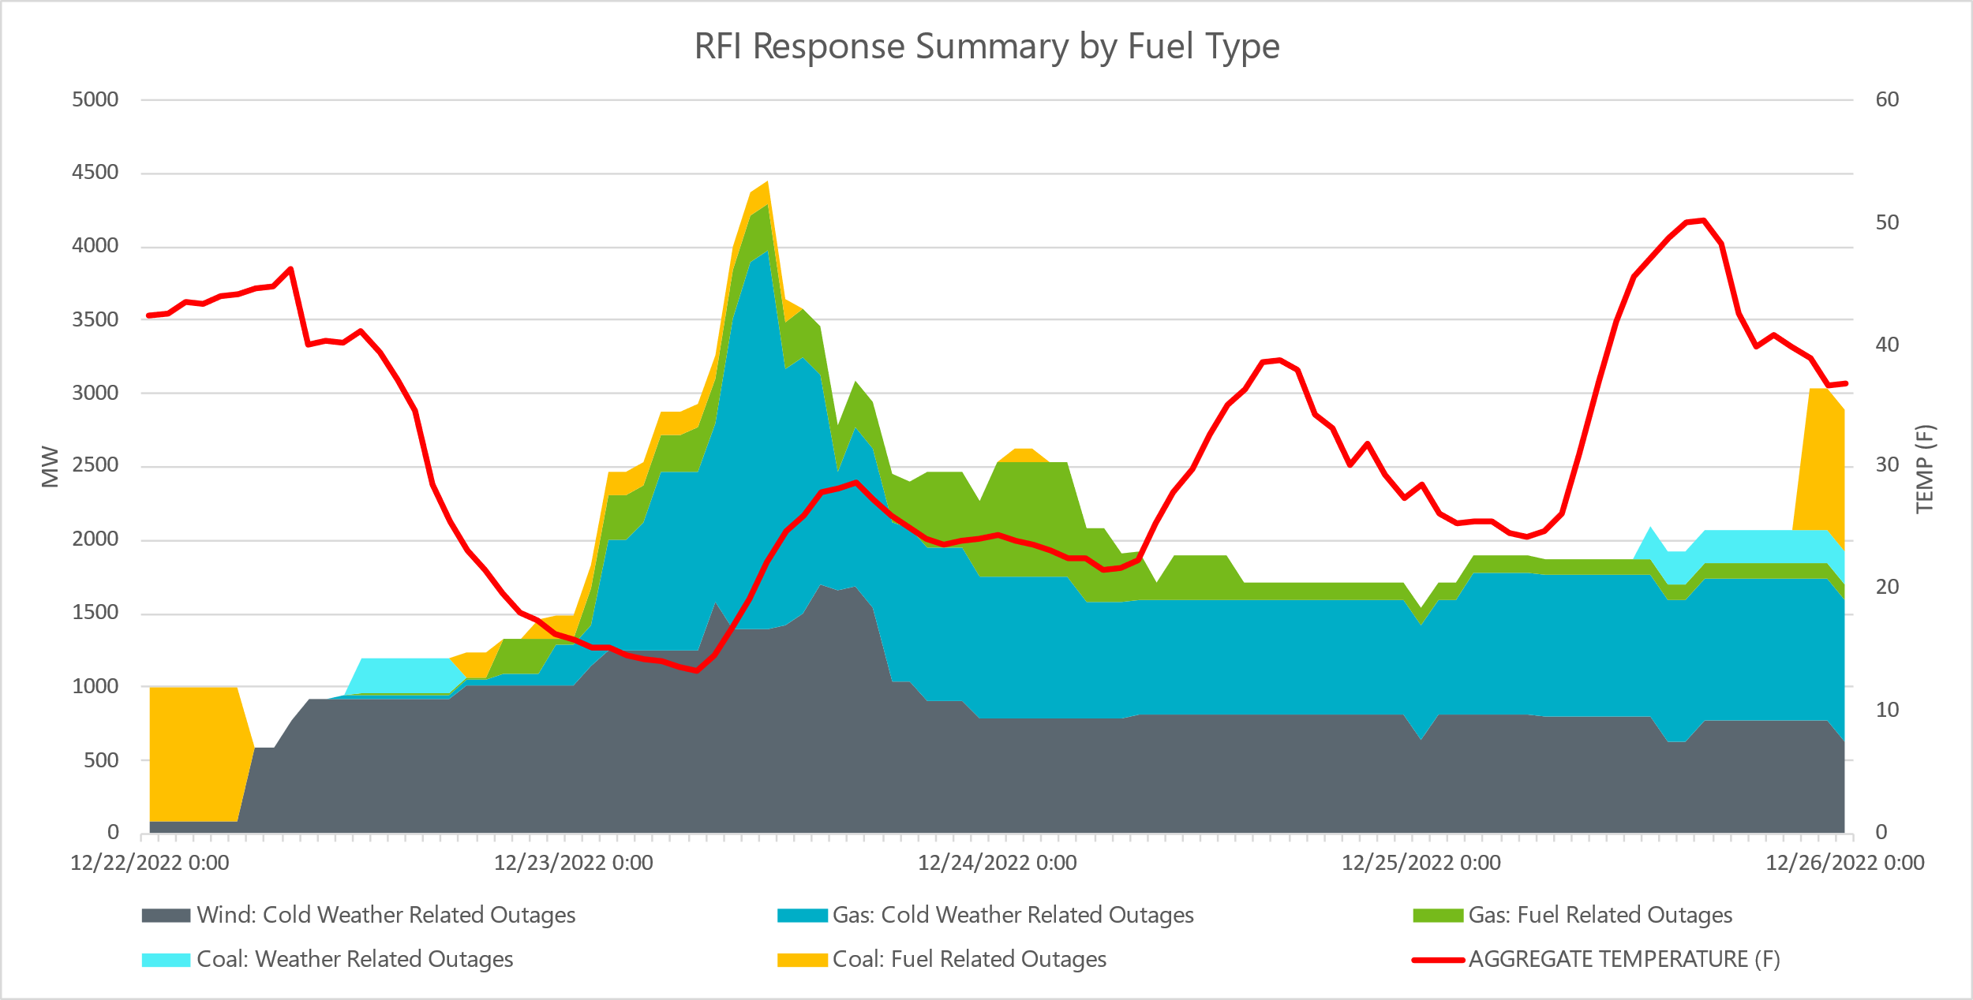

Total outages during Elliott peaked at close to 20,000 MW; outages reported as cold weather- or fuel-related made up approximately 4,500 MW of that. Before Winter Storm Elliott, ERCOT inspected 255 resources for winter weather readiness. Of those inspected sites, four were subsequently found to have weather-related outages or derates during the cold weather period (all of which were gas generators). Weather-related outages that occurred on units that had recently been inspected for winter weather readiness will receive additional scrutiny, and any lessons learned will be included in future inspections.

The following two charts show the transmission outages since December 22nd, 2022.

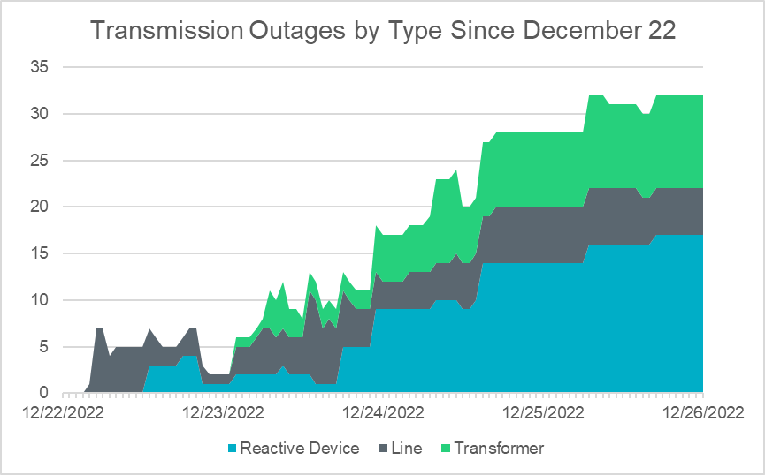

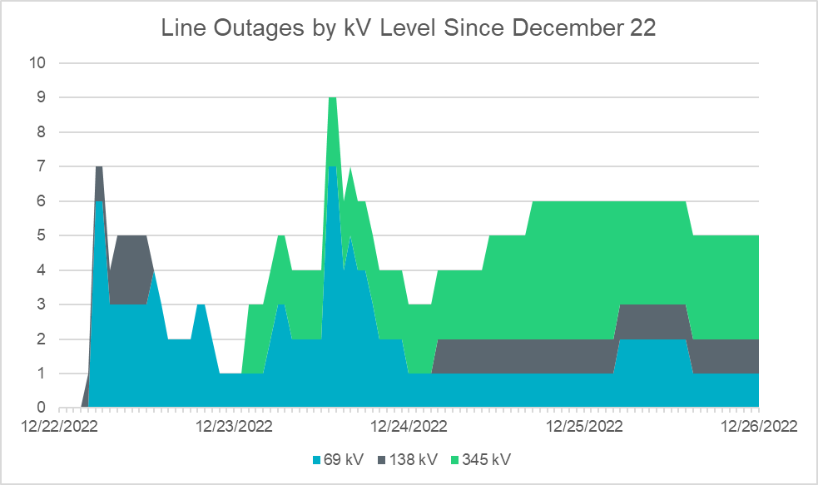

The transmission outages did not have a significant impact on the system during Winter Storm Elliott. The maximum resource curtailment caused by transmission constraints was below 500 MW, and it came down to 0 MW by December 24th.

# Winter Storm Elliott vs. Winter Storm Uri

|  |  |  |
| --- | --- | --- |
|  | Elliot | Uri |
| Peak Demand (MW) | 74,100 MW (Instantaneous 12/23/2022 HE08) | 69,812 (Hourly Actual)  76,819 (Hourly Back-cast) |
| Coldest Temperature (°F): | | |
| Dallas | 11 | -2 |
| Houston | 15 | 13 |
| Austin | 15 | 7 |
| San Antonio | 16 | 12 |
| Brownsville | 27 | 26 |
| Abilene | 10 | -4 |
| Midland | 10 | 4 |
| Precipitation (inch): does not separate rain, snow, sleet, and freezing rain/ice | | |
| Dallas | 0.00 | 0.37 |
| Houston | 0.00 | 1.37 |
| Austin | 0.00 | 1.76 |
| San Antonio | 0.00 | 1.32 |
| Brownsville | 0.00 | 0.60 |
| Abilene | 0.00 | 0.31 |
| Midland | 0.00 | 0.16 |

A strong polar cold front moved through the ERCOT region on December 22nd. The front moved through all but southern West Texas during the pre-dawn hours, reached Dallas-Fort Worth around 08:00, Austin around 12:00, Houston around 16:00, and the Rio Grande Valley between 18:00 and 20:00. Temperatures commonly dropped 10-20 degrees in a matter of minutes behind the front. Some West Texas locations dropped more than 20 degrees in less than an hour. Along with the sharp drop in temperatures, a strong North-Northwest wind of 20-30 MPH with gusts to 40 MPH was common behind the front across the ERCOT region on the 22nd and into the morning of the 23rd. Wind gradually diminished during the day on the 23rd and was much lighter heading into Christmas weekend. All locations, except for the Panhandle, recorded their coldest temperature on the morning of December 23rd. Wind chill values during the AM hours on December 23rd mostly ranged from the single digits above zero to single digits below zero. The Rio Grande Valley did not quite get to that level, with a peak wind chill of 13 at Brownsville. Afternoon highs on December 23rd were also well below normal, reaching the 20s over North and West Texas and 30s for most of the rest of the state.

Temperatures slowly moderated through the Christmas holiday but remained below normal on December 24th, 25th, and the morning of the 26th.

This winter storm was not to the level of February 2021 but was closest to the extremes faced in February 2011. West Texas was mostly colder in February 2011. The rest of the state was colder with the December 2022 event compared to February 2011. The most extreme temperatures in relation to normal occurred in the Coastal and South zones. The low temperature of 15 degrees in Houston on the morning of December 23rd was several degrees below the minimum temperatures from February 2011 and was only two degrees warmer than the February 2021 winter storm. Dallas, on the other hand, was 13 degrees warmer than the peak cold in February 2021.

From a system-wide perspective, ERCOT tracks a load-weighted system temperature. Winter Storm Elliott was the coldest in the last 15 years, except for Winter Storm Uri.

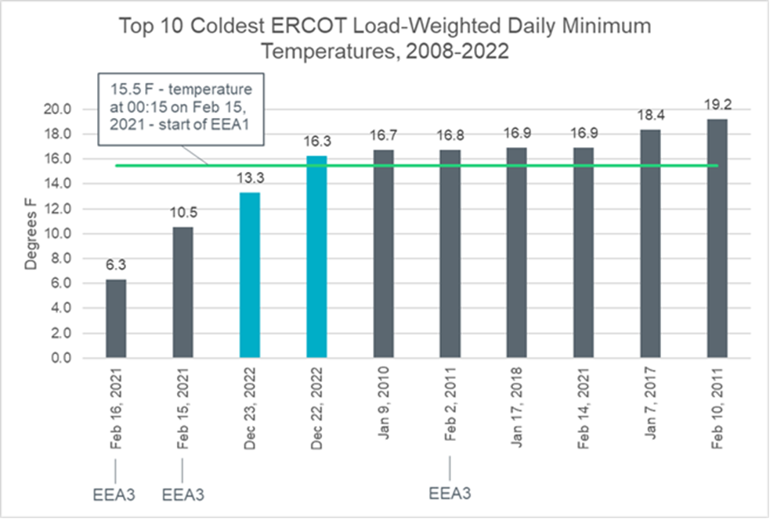

No significant precipitation fell with this extreme, late-December cold air.

# Market Summary

## System-Wide Pricing

The following chart shows the total real-time system price (blue trend) in addition to the individual price adders, including the Reliability Deployment Price Adder (gray trend) and Online Reserve Price Adder (purple trend) for ORDC. The highest real-time system-wide prices occurred on December 23rd, reaching its peak of $4,466.79/MWh during the SCED execution on December 23rd 06:52. Excluding December 23rd, the peak total Real-Time system-wide price was $155.24/MWh from the SCED execution on December 24th 07:40. These prices reflect the wholesale market prices for these four days and do not have a direct impact on the retail prices that customers pay.

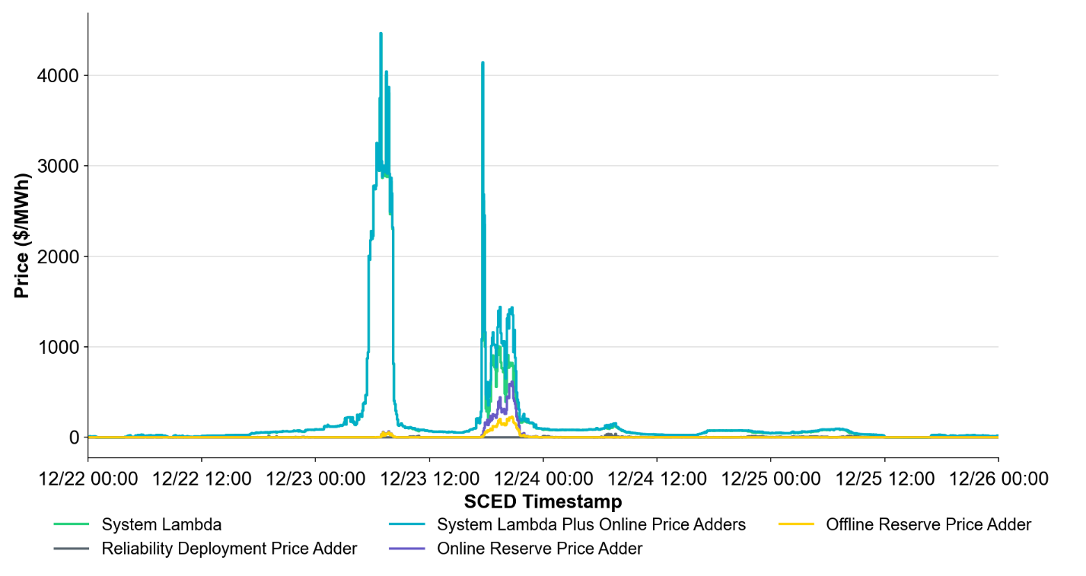

## Hub Average and Hub Bus Average Settlement Point Prices

The real-time hub average and hub bus average prices mirror the trend in total system-wide prices shown in section 10.1. The real-time prices were much greater than day-ahead prices on December 23rd. In contrast, day-ahead prices were much greater than Real-Time prices on December 24th. The graph below shows Real-Time Market (RTM) and Day-Ahead Market (DAM) Settlement Point Prices (SPPs) for the relevant time period.

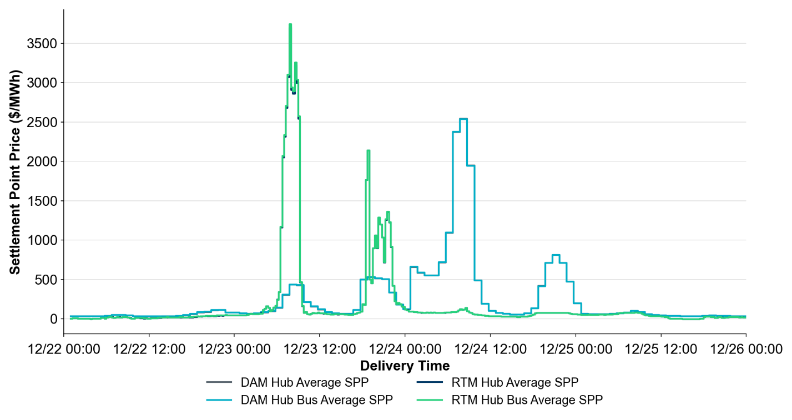

## Day-Ahead Prices

During this period, the DAM continued to clear and publish. The DAM Hub Average Settlement Point Price (DASPP) was the highest during the morning of December 24th, reaching a peak of $2,539.16/MWh during hour ending 08. Ancillary Service prices followed a similar trend as energy prices.

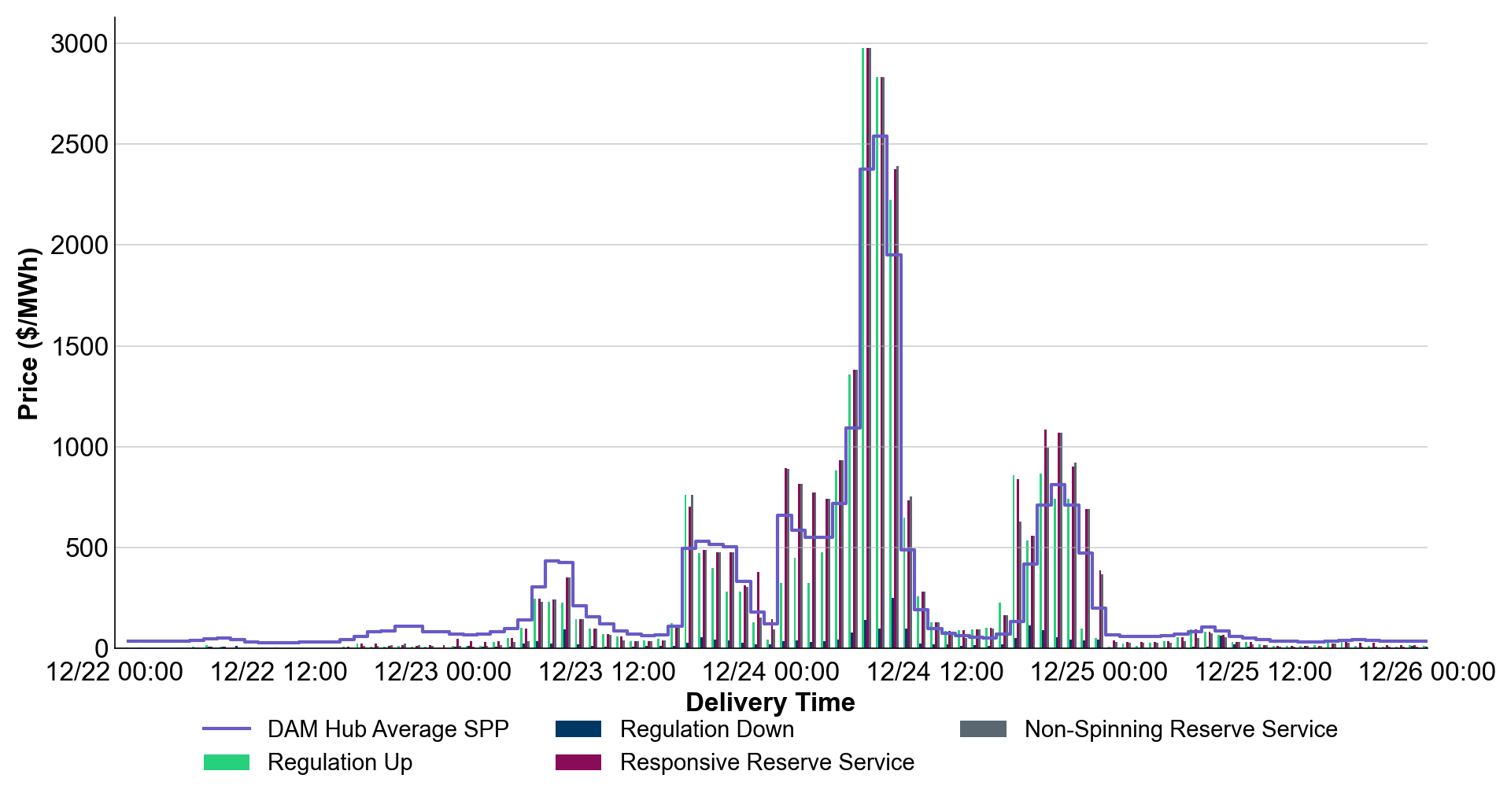

# Ancillary Services

Ancillary Services performed well during Winter Storm Elliott.

## Deployment of Responsive Reserve Service

Responsive Reserve Service was not deployed during this winter storm.

## Deployment of Non-Spin

Offline Non-Spin Reserve was deployed between 6:50 am to 10:00 am on December 23rd due to the projected ramping capability of available resources being below the forecasted load ramp. The maximum deployment was 3,222 MW. The chart below does not include Non-Spin Reserve provided by resources that were already online at the time.

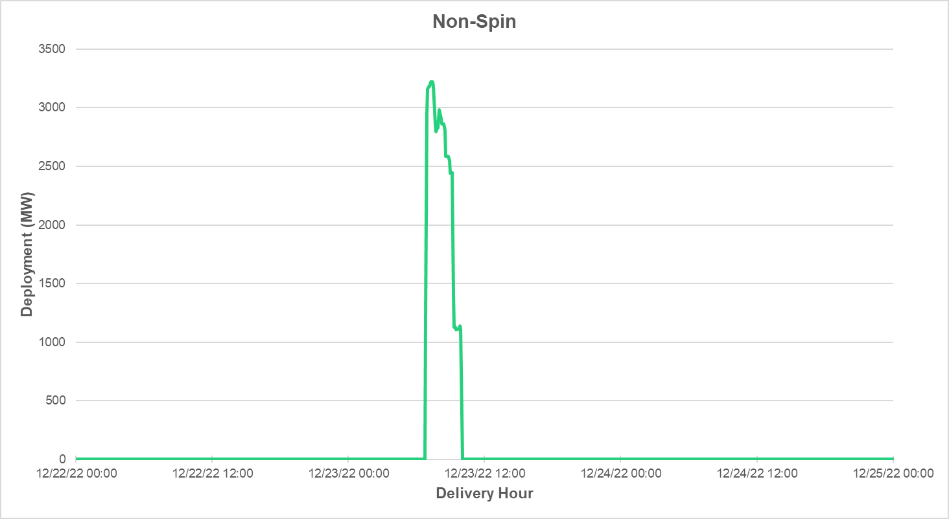

## Energy Storage

Energy Storage Resources carried a meaningful amount of Ancillary Services during the cold weather. The following chart shows the total MW and percent contribution of Ancillary Services with a focus on Regulation Up, Responsive Reserve Service (RRS), and Non-Spin Reserve that ESRs were carrying during the week. The trend shows that Energy Storage Resources (ESRs) carry more percentage of total Regulation Up from hours 16-22. ESRs were carrying roughly 45-55% of total RRS-Primary Frequency Response (PFR) and up to 88% of Regulation Up. On December 22nd, over peak load hours about 50% of Regulation Up was being carried by ESRs, which allowed more conventional capacity to be available to serve demand.

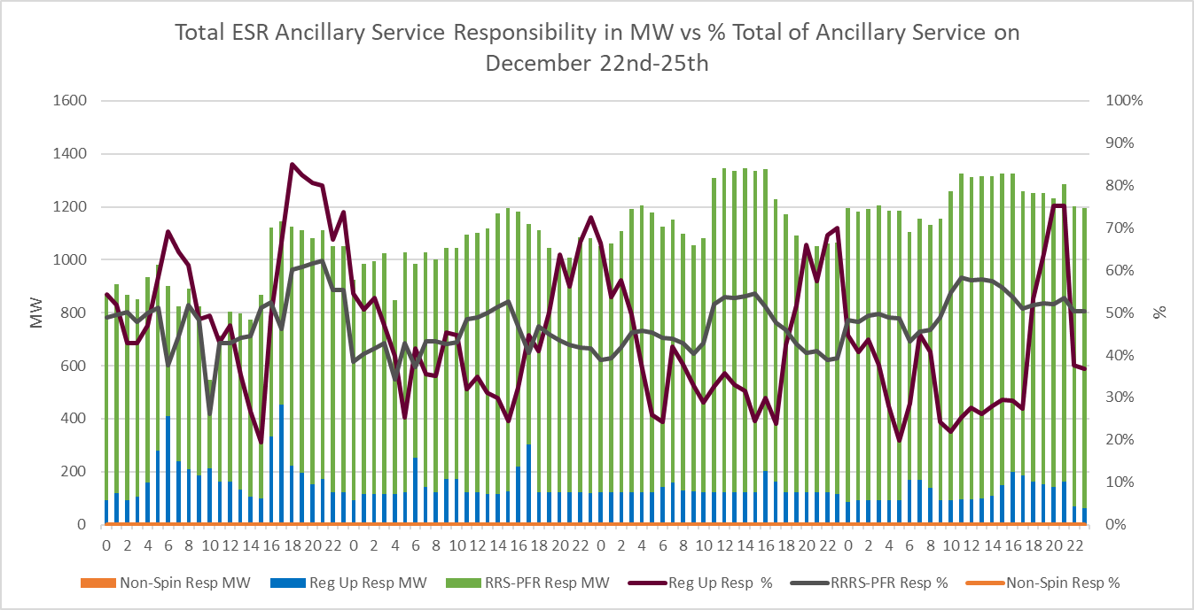

Below is a chart indicating the amount of State of Charge (SOC) in MWh that was being maintained amongst all ESRs carrying Ancillary Services over the week. As can be seen the minimum amount of delta SOC (Actual SOC – Minimum Required SOC) is seen during the peak period on December 23rd. This can be seen due to sustained deployments for energy and regulation deployments. Overall, the expected amount of SOC was maintained by ESRs carrying Ancillary Services during this period.

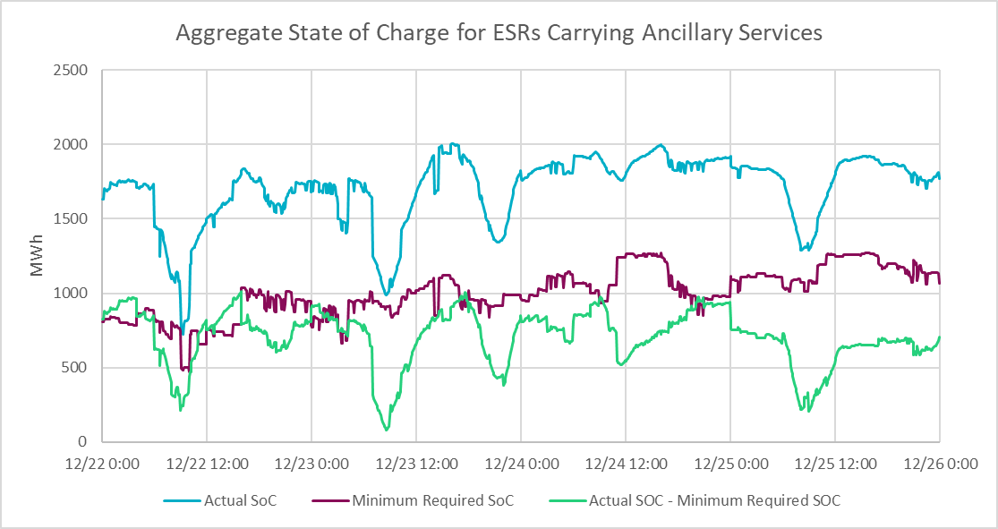

The chart below shows a breakdown of all ESRs and their expected generation (Updated Desired Base Point (UDBP), Regulation dispatch, and PFR) vs the percentage of SOC available. The general observation is that ESRs were maintaining SOC before being depleted during the peak load hours followed by ESRs charging back up to prepare for the next peak period. ESRs were also maintaining SOC to meet the Ancillary Service obligation they were carrying throughout the day. On December 23rd, a significant amount of MW contribution due to ESR SCED dispatchable capacity and a sharp decline in SOC is observed due to continued dispatch. The total real-time system-wide price peak was a ~$4,460 MWh during the morning peak of December 23rd from SCED interval 06:55 to 07:00 which contributed to the sustained dispatch of ESRs.

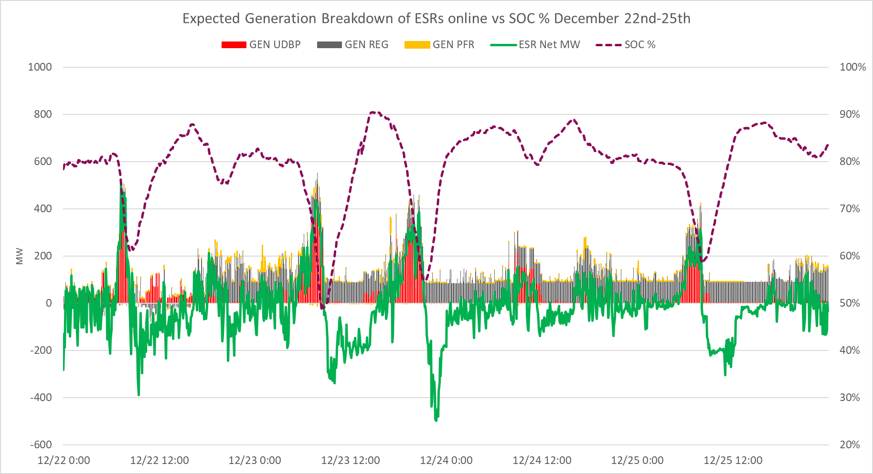

# Large Flexible Load Performance

During Winter Storm Elliot, Large-Flexible-Loads (LFLs) registered with ERCOT, which consist of loads such as Bitcoin mining facilities and other datacenters, curtailed their consumption from 1,530 MW to 130 MW (a 91.5% reduction) during the peak demand. Additionally, they provided 75 MW of RRS throughout the event. Of the approximately 20 known LFL sites, all curtailed their load to some extent. Several responded by shutting off completely for the entirety of the event, while most sites curtailed when prices rose above the $70/MWh to $110/MWh range.

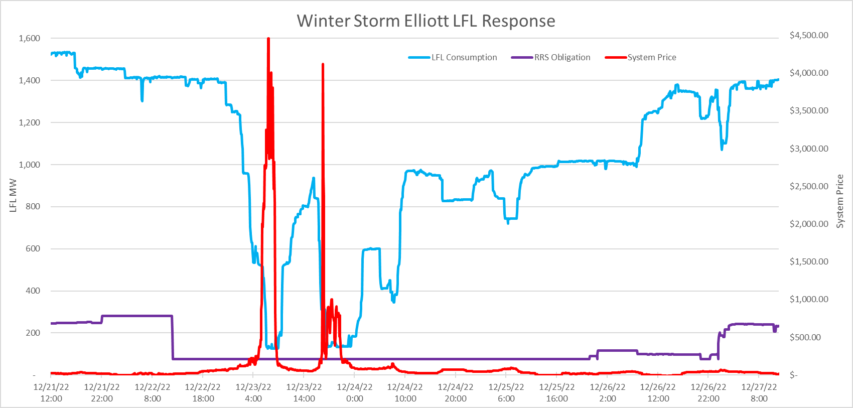

# Outreach During Winter Storm Elliott

## Operations Outreach

The following table outlines the timeline for ERCOT operations communications, including Operating Condition Notices (OCN[1]) and Control Room Advisory:

|  |  |  |  |
| --- | --- | --- | --- |
| Date Time | Notice | Type | Status |
| 12/16/2022 8:59 | OCN issued for the predicted extreme cold weather event for the ERCOT Region Thursday morning, December 22, 2022, through Monday, December 26, 2022. | Operational Information | Active |
| 12/19/2022 13:26 | Advisory issued for the predicted extreme cold weather event for the ERCOT Region Thursday morning, December 22, 2022, through Monday, December 26, 2022. | Advisory | Active |
| 12/21/2022 10:00 | At 10:00, Watch issued for the predicted extreme cold weather event for the ERCOT Region Thursday morning, December 22, 2022, through Monday, December 26, 2022. | Watch | Active |
| 12/21/2022 12:00 | At 12:00, QSEs representing Firm Fuel Supply Service Resources (FFSSRs) shall begin preparations for potential FFSS deployment. | Watch | Active |
| 12/25/2022 11:52 | ERCOT has cancelled the following notice: At 10:00, Watch issued for the predicted extreme cold weather event for the ERCOT Region Thursday morning, December 22, 2022, through Monday, December 26, 2022. | Watch | Cancelled |
| 12/25/2022 11:54 | ERCOT has cancelled the following notice: At 12:00, QSEs representing Firm Fuel Supply Service Resources (FFSSRs) shall begin preparations for potential FFSS deployment. | Watch | Cancelled |

## Communications Outreach

**Winter Storm Elliott Communications Outreach - December 2022**

ERCOT kept Texans informed of the week’s weather events, grid preparation, and active storm response efforts on an ongoing basis. ERCOT Public Affairs used several key avenues in this effort, including:

* **Press Briefing.** Participated in press briefing at the State Operations Center, along with Governor Abbott and representatives from the Texas Department of Emergency Management (TDEM) and Texas Public Utility Commission (PUC)
* **Grid Communicators Outreach.** Hosted pre-storm call with the communications staff of a small group of grid/market participants to discuss the current grid situation, messaging, and best practices through the duration of the weather event
* **News Release.** Distributed a news release summarizing the grid preparedness and storm outlook in advance of the weather
* **Media Engagement/Response.** Responded to approximately 100 media inquiries from local, regional, and national reporters
* **Social Media**. Shared messaging on social media (Facebook and Twitter) before, during, and after the winter storm
* **Website/Dashboards.** Directed the media and the public to the Grid Dashboards to monitor the grid in real-time

|  |
| --- |
| **Key Public Affairs Communication Event Timeline** |
| * **12/15/22, 9 am** – ERCOT provided update of potential cold weather event at PUC Open Meeting * **12/16/22, 9:30 am** – Informed market participant/grid communicators of anticipated weather situation * **12/16/22, 1 pm** – Distributed news release ahead of winter storm to ERCOT Board, Executive Staff, PUC, state officials and Texas Congressional delegation; ERCOT employees; market participants; and statewide media * **12/16/22, 1:30 pm** –Initial post on social media linking to news release about reforms implemented since February 2021 * **12/19/22, 9:30 am** – Participated in the State Agency communicators call led by Governor’s Office regarding grid enhancements in preparation for the winter storm * **12/20/22, 9:30 am** – ERCOT CEO addressed upcoming winter storm at the beginning of the ERCOT Board meeting * **12/21/22, 10 am** – ERCOT CEO participated in Gov. Abbott’s State Agency briefing at State Operations Center (SOC), along with TDEM, PUC, RRC, and other state officials * **12/21/22, 11 am** – ERCOT CEO participated in Gov. Abbott’s Press Briefing at SOC, along with TDEM and PUC * **12/22/22, 10:30** **am** – Posted an update on social media, sharing how the general public and media can follow current grid conditions on the dashboards page on the ERCOT website * **12/22/22, 5:30** **pm** – Posted an update on social media, sharing what steps to take if experiencing a local outage, which is not an ERCOT grid issue * **12/24/22, 1 pm** – Posted an update on social media, thanking all those working hard to keep the grid operating reliably * **12/25/22** – Posted final update of returning to normal conditions |

**Social Media (Facebook and Twitter) Analytics**

**December 16, 1:30 pm** — Initial post linking to news release about reforms implemented since February 2021.

* + **Twitter**: 75,000 views, 110 comments, 95 retweets, 97 likes
  + **Facebook**: 135 reactions, 107 comments, 71 shares

**December 22, 10:30 am** — 2nd post sharing how the general public and media can follow current grid conditions on the ERCOT dashboards page on the ERCOT website

* + **Twitter:** 129,200 views, 65 comments, 143 retweets, 325 likes
  + **Facebook:** 388 reactions, 234 comments, 244 shares

**December 22, 5:30 pm** — 3rd post, sharing what steps to take if experiencing a local outage, which is not an ERCOT grid issue

* + **Twitter:** 155,100 views, 98 comments, 110 retweets, 339 likes
  + **Facebook:** 69 reactions, 55 comments, 39 shares

**December 24, 1 pm** — 4th post, thanking all those working hard to keep the grid operating reliably

* + **Twitter:** 104,900 views, 82 comments, 69 retweets, 656 likes
  + **Facebook:** 422 reactions, 86 comments, 18 shares

**December 25, 1:30 pm** — 5th and final post, sharing ERCOT was returning to normal operations

* + **Twitter:** 73,200 views, 31 comments, 45 retweets, 303 likes
  + **Facebook:** 161 reactions, 17 comments, 9 shares

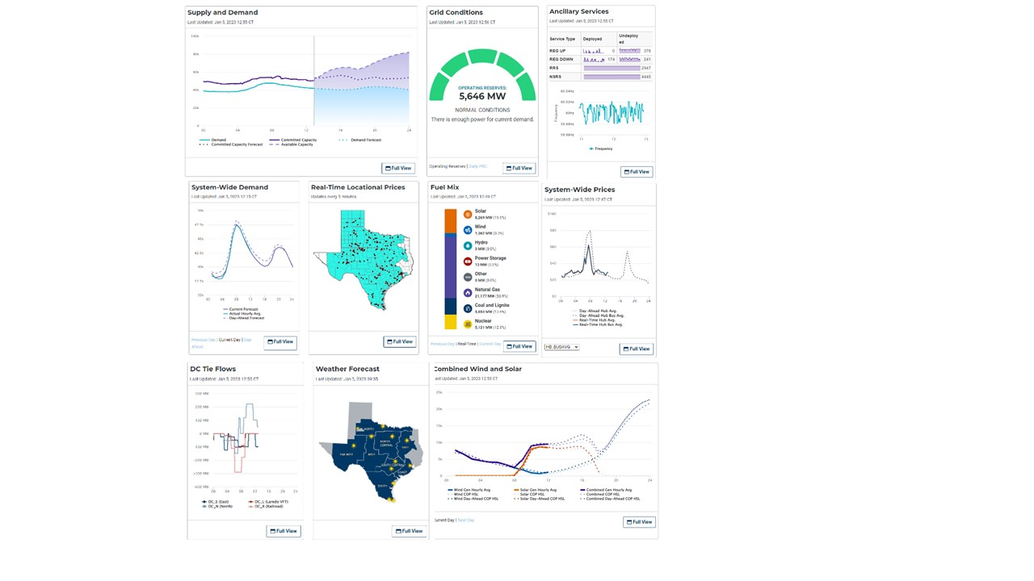

**ERCOT Dashboard Analytics December 21-24**

|  |  |  |
| --- | --- | --- |
| **Page Title** | **Views** | **Total Users** |
| Grid and Market Conditions | 532,144 | 212,578 |
| Supply and Demand | 108,516 | 56,402 |
| Grid Conditions | 67,021 | 32,799 |
| System-Wide Demand | 20,000 | 10,341 |
| System-Wide Prices | 13,040 | 4,352 |
| Fuel Mix | 12,439 | 8,470 |
| Combined Wind and Solar | 6,353 | 4,893 |
| Weather Forecast | 4,299 | 3,764 |
| Grid and Market Conditions | 2,138 | 507 |
| Ancillary Services | 1,981 | 1,048 |
| DC Tie Flows | 1,395 | 1,189 |
| **Total** | **769,451** | **258,552** |

## Legislative Outreach

ERCOT provided daily updates to both PUC Commissioners and Legislative leadership offices through calls and emails. Legislative leadership offices included representatives from the Governor’s office, Lt. Governor’s office, Speaker’s office, Chairman of Senate Business & Commerce’s office, and Chairman of House State Affairs office. The updates provided those offices with current and forecasted grid conditions, advisories, ERCOT news releases, and other information that could have an impact on grid operations.

|  |
| --- |
| **Key Legislative & Regulatory Communications Timeline** |
| * **12/15** – Notice given of upcoming weather event potential at PUC Open Meeting * **12/16** – Grid Conditions email to PUC Commissioners and legislative leadership offices – OCN issuance * **12/16** – Email to notify legislative leadership offices of press release * **12/19** – Grid Conditions email to PUC Commissioners and legislative leadership offices – Advisory issuance * **12/20** – Updates and communication call with PUC Commissioners and Executive PUCT leadership * **12/21** – Updates and communication call with PUC Commissioners and Executive PUCT leadership – 09:00 update * **12/21** – Grid Conditions email to PUC Commissioners and legislative leadership offices – Watch issuance * **12/22** – Updates and communication call with PUC Commissioners and Executive PUCT leadership – 09:00 update * **12/22** – Grid Conditions email to PUC Commissioners and legislative leadership offices – 09:30 update * **12/22** – Updates and communication call with PUC Commissioners and Executive PUCT leadership – 14:30 update * **12/22** – Grid Conditions email to PUC Commissioners and legislative leadership offices – 16:45 update * **12/22** – Grid Conditions email to PUC Commissioners – 22:30 update * **12/23** – Grid Conditions email to PUC Commissioners – 05:00 update * **12/23** – Updates and communication call with PUC Commissioners and Executive PUCT leadership – 09:00 update * **12/23** – Grid Conditions email to PUC Commissioners and legislative leadership offices – and 10:00 update * **12/23** – Updates and communication call with PUC Commissioners and Executive PUCT leadership – 13:30 update * **12/23** – Grid Conditions email to PUC Commissioners – 14:00 update * **12/23** – Updates and communication call with PUC Commissioners and Executive PUCT leadership – 17:30 update * **12/23** – Grid Conditions email to PUC Commissioners and legislative leadership offices – 18:30 update * **12/23** – Grid Conditions email to PUC Commissioners – 22:30 update * **12/24** – Updates and communication call with PUC Commissioners and Executive PUCT leadership – 09:00 update * **12/24** – Grid Conditions email to PUC Commissioners and legislative leadership offices – 09:30 update * **12/25** – Grid Conditions email to PUC Commissioners – 11:30 update |

# Conclusions and Lessons Learned

Winter Storm Elliott represented the coldest temperatures the ERCOT region has experienced since Winter Storm Uri and the second coldest temperatures over the last fifteen years. In fact, temperatures were colder than when ERCOT entered Energy Emergency Alert (EEA) on February 15, 2021, and load was more than 4,000 MW higher at the peak on December 23, 2022. Despite this, the ERCOT grid did not experience the level of generation outages as was observed during Winter Storm Uri and maintained adequate reserves throughout the cold weather period. This likely indicates that winterization efforts led by the PUCT and implemented by generation owners have had a positive impact on the ability of generators to perform under extreme cold conditions. Nevertheless, despite these efforts, a subset of generators did have cold weather-related outages. ERCOT will continue investigating the specific issues that caused these outages and report any findings to stakeholders, as appropriate.

A change in the vendor-supplied software that ERCOT uses to create its internally developed load forecast caused the forecast to double count the typical demand reduction that occurs during holidays. As a result, ERCOT had to rely on its backup load forecast, which is supplied by an external vendor. This forecast, which is not as sophisticated as ERCOT’s internally developed forecast, performed poorly during Winter Storm Elliott. ERCOT has identified four corrective actions based on load forecasting lessons learned:

1. Reduce forecast errors from the alternative load forecasting source by procuring a new external load forecast,
2. Develop an innovative process for developing load forecast models specifically designed for extreme cold weather,
3. Reduce weather forecast error by procuring additional raw weather forecasting models; and
4. Improve the forecasting software upgrade testing process, including updating testing procedures to include holiday and other outlier phenomena.

Other processes performed well during the cold weather conditions. Specifically, there were no significant issues with the renewable generation forecasts, Ancillary Services, Firm Fuel Supply Service, transmission system performance, and communications.

1. An OCN is the first of three levels of communication issued by ERCOT to market participants and the public in anticipation of a possible Emergency Condition. The second level is an Advisory and the third level is a Watch.