European Parliament  2019-2024 | 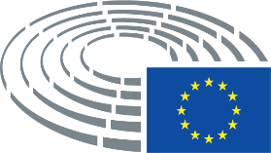

<Commission>{BUDG}Committee on Budgets</Commission>

<Date>{28/09/2023}28.9.2023</Date>
<TitreType>MISSION REPORT</TitreType>
<Titre>following the Committee on Budgets’ ad hoc delegation to Maputo and Beira (Mozambique), 23-28 July 2023</Titre>
<Commission>{BUDG}Committee on Budgets</Commission>
Members of the mission:

José Manuel Fernandes (EPP) (Leader of the mission)
Robert Biedroń (S&D)
Valérie Hayer (Renew)
Bogdan Rzońca (ECR)
Hervé Juvin (NI)

Contents
I. Overview of the mission 3
II. Meetings and visits summaries 5
1. Meeting with Mr Antonino Maggiore, Head of the EU Delegation de Mozambique 5
2. Meeting with Mr Manuel José Gonçalves, Deputy Minister of Foreign Affairs 6
3. Meeting with Member States agencies (Austria, Germany, Italy, Portugal, Spain) 7
4. Meeting with UN agencies (UNFPA, UNICEF and UNDP) and World Bank 11
5. Meeting with Civil Society, NGOS, including Women, LGTIBQ+ and student organisations and Trade Unions 15
6. Visit of the Estoril Secondary school - Mozambique Recovery Facility (MRF) 17
7. Meeting with the office of the Secretary of State of the province of Sofala (with participation of the Governor staff) 18
8. Visit of the Mozambique Integrated Urban Development by Actions and Relationships (MUDAR) 19
9. Visit of a Vocational Education and Training centre of Young Africa - DelPaz programme 20
10. Visit of the EU Training Mission in Mozambique (EUTM-MOZ) 21
11. Meeting with Manuel Bazo, Vice Minister of Education and Human Development 22
12. Meeting with Esperança Bias, President of the Assembly of the Republic 23
13. Meeting with the Budget Committee of the Assembly of the Republic 24
14. Meeting with Ernesto Max Elias Tonela, Minister of Economy and Finance 25
15. Press conference 26
III. Programme 27
IV. Participants 29

BUDG ad-hoc delegation to Mozambique
23-28 July 2023

Mission Report

I. Overview of the mission

The objective of this mission was to analyse and investigate the EU financial assistance to Mozambique aimed at generating a resilient society and promoting a stable economy through supporting job creation, fostering rural competitiveness and better engaging the private sector. To this effect, meetings were held in Maputo as well as in Beira to ensure that Members had a broader understanding of the issues at stake, particularly from a regional and local perspective. Five BUDG Members participated in the mission, with Mr José Manuel Fernandes (EPP), as Head of the mission.

Over the three days of the mission, Members had fruitful exchanges with political actors from the Government, members of the Mozambican Parliament, regional and local authorities and with a broad range of stakeholders. Moreover, the Delegation visited three projects to grasp the practical implications and challenges of using EU funds in different contexts.

Background information - EU financial support to Mozambique

The EU supports Mozambique through various budgetary instruments, such as NDICI, EDF, ICSP, Humanitarian Aid, etc. In its Multiannual Indicative Programme 2021-2027, the Commission (DG INTPA) planned the following budgetary allocation for the following priority areas:

Priority Area | EUR | Share of Total
Growing Green | 150 000 000 | 35%
Growing Youth | 163 000 000 | 38%
Governance, Peace and a Just Society | 94 000 000 | 22%
Other support measures | 21 000 000 | 5%
TOTAL (2021-2024) | 428 000 000 | 100%

Mozambique also receives support from the European Peace Facility (EPF), an off-budget funding mechanism for EU actions with military and defence implications under the Common Foreign and Security Policy (CFSP).
Conclusions

During the mission, Members assessed the use of the EU budget in Mozambique. The main conclusion of the mission is that EU development and humanitarian aid are essential factors to help Mozambique support its economic, social and territorial cohesion

Furthermore, Members concluded that:
• The EU Mozambique relations should be based on a strong partnership, considering the need to promote EU interests and values in a competitive environment in a strategic region. Strategic communication, including on the use of EU funds, should reflect this partnership based on common principles and values.
• Supporting peace and stabilisation efforts in Mozambique, as well as fighting climate change are shared interests of Mozambique and the EU.
• Budget support, if political and policy conditions are met, is a good tool to reinforce this partnership; moving away from the donor/recipient relation towards a true partnership is the way forward.
• The EU should closely follow the situation in terms of human rights, political and press freedoms in the build up to the upcoming electoral cycle (municipal elections in October; Presidential, legislative and provincial in 2024). Through the EU budget, it is essential to continue supporting progress in democracy, rule of law and respect of human rights.
• The Mozambican youth is an asset for the modernisation of the country and the EU should continue to support it financially, particularly through basic education and vocational training (linked to employment creation in association with the private sector).
• Teenage pregnancy and child marriage are impediments to gender equality and inclusive development. The financing of programmes such as Spotlight should continue.
• The use of the EFSD+, in the framework of the Global Gateway, should be promoted to attract investment to the country.
• The current EEAS/INTPA mission budget limitations, in a country with the dimensions of Mozambique, with extremely poor road infrastructure, jeopardize the appropriate understanding of this very diverse country and limits the monitoring of projects financed through EU funds.

Mission debriefing: The mission debriefing took place in the BUDG meeting of 20 September 2023.

II. Meetings and visits summaries

During the mission, Members had the opportunity to meet with central, regional and local authorities of Mozambique as well as to visit three project sites with a view to analyse the use of the EU budget and to see possible new needs and challenges for the future.

1. Meeting with Mr Antonino Maggiore, Head of the EU Delegation de Mozambique

The EU Ambassador
- Pointed to the important economic potential of Mozambique deriving from gas projects in the region of Cabo Delgado, and explained that the current government has significantly increased its efforts to stabilize that region, with the help of the EU Member States through the European Peace Facility (of which Mozambique is the second largest beneficiary, following Ukraine),

- Insisted on the importance of the EU-Mozambique partnership, with an ongoing portfolio of around EUR 1 billion, including a significant NDICI contribution, organised around three priorities: Growing Green, Growing Youth, and Governance, Peace and a Just Society, but admitted that the important EU budgetary engagement still needs to be translated into political influence.

The Members

- Enquired about the neutral position of Mozambique regarding the Russian war of aggression against Ukraine, and the relationship between Mozambique and global players,

- Highlighted the importance of education, youth, gender, and human rights when deciding the allocation of EU funds in Mozambique.

2. Meeting with Mr Manuel José Gonçalves, Deputy Minister of Foreign Affairs
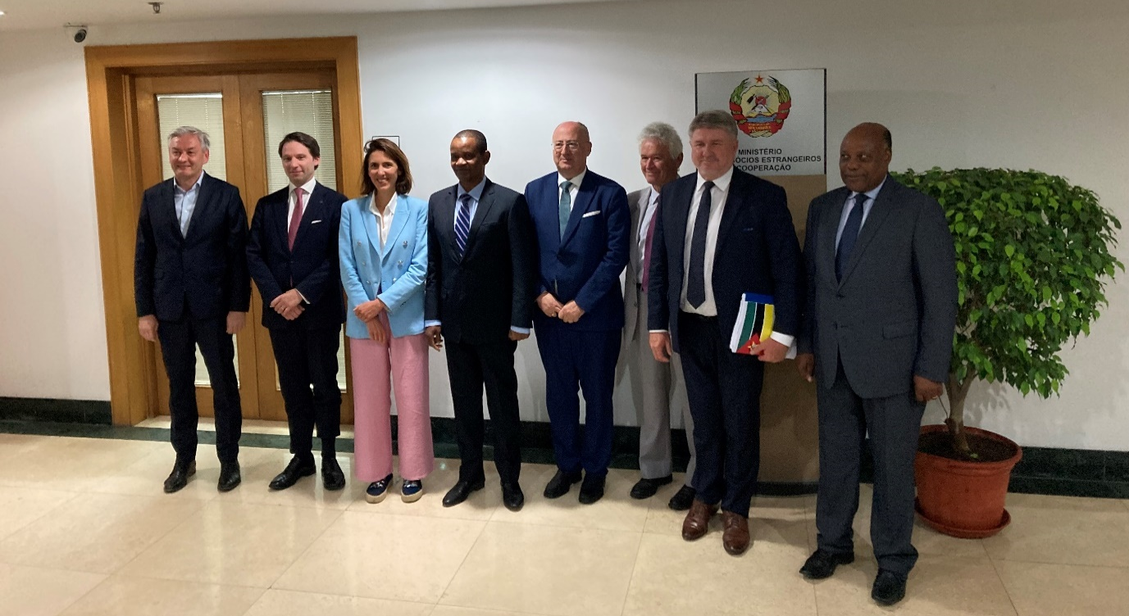
The Deputy Minister
- Stressed that the relationship between the EU and Mozambique is very strong, consistent and exemplary, as the EU is one of the country’s main partners in humanitarian aid, development and trade,

- Reviewed the recent developments regarding the peace process in Cabo Delgado, highlighting the important EU contribution through the EU Training Mission, but emphasized on the need for lethal equipment (the EU only provides non-lethal equipment) since terrorists have sophisticated weapons,

- Highlighted that Mozambique is now a non-permanent Member of the UN Security Council, that has a relationship with both Ukraine and Russia and seeks for the conflict opposing them to end quickly since it impacts energy, grains and inflation,

- Explained that the government has four priority areas for foreign investment: infrastructure, energy, tourism and social development, identified as key steps in the development of the country.

The Members

- Inquired about challenges which are common to the EU and Mozambique, such as climate change, migration, the energy crisis, and agreed with the Deputy Minister on the need to invest in the African continent to create jobs and create opportunities for the youth,

- Expressed concerns regarding the high number of child marriages and the limitations to the right of demonstrating, while congratulating Mozambique for its high percentage of female parliamentarians (42%).

3. Meeting with Member States agencies (Austria, Germany, Italy, Portugal, Spain)

Member State agencies

- Described projects implemented in partnership with the EU, such as EYouth, Procultura, +EMPREGO, and insisted on the necessity to support youth in the country to keep them from turning to terrorist groups out of despair and lack of opportunities;

- Praised the Team Europe approach for development policies in Mozambique as a real value added, and welcomed the coordinating role of the EU Delegation, which organises monthly meetings of Member State, in order to ensure a coherent EU approach and avoid double-funding;

- Regretted nevertheless the lack of cooperation with other global players, which probably leads to double-funding in some sectors;

- Explained that in order to intervene in Mozambique, the central authorities have to be involved, and they sometimes capture the visibility of the project;

- Highlighted that EU rules of procurement are a barrier for local companies which do not have the capacity or the envy to follow them.

The Members

- Inquired about the three main daily issues of an average Mozambican citizen, which were described as being:
• food,
• transport to school for children (and is it safe to go to school, especially for girls),
• how to do business in urban areas;

- Emphasised the importance of making the EU visible to beneficiaries of projects co-financed by it, especially in light of the visibility of other global players.

The EU Delegation

- Provided the below table on the delegation of the management of EU funds to Member State agencies in Mozambique:

EU Support to the EUMS in Mozambique (August 2023)
Domain | Year | Status | Contract title | Partner | Amount | Action location | Sector
FED | 2023 | Ongoing | ElectriFI Country Window for Mozambique | OVS | 15.000.000 | Nationwide | Energy generation, renewable sources – multiple technologies
FED | 2022 | Ongoing | Rehabilitation of the sanitation system in Beira | AFD | 20.600.000 | Selected districts in Sofala | WASH
FED | 2022 | Ongoing | Addendum 1 to FED/2020/419-614 - DELPAZ: Manica and Tete Sub-programme - Additional contribution | AICS | 1.500.000 | Manica, Tete | Peace, Economic development
FED | 2022 | Ongoing | GET FiT Mozambique II | KFW | 20.421.920 | Nationwide | Energy generation, renewable sources – multiple technologies
FED | 2022 | Ongoing | Rehabilitation of the Cahora Bassa Hydropower Plant in Mozambique | AFD | 22.671.000 | Tete | Energy generation, renewable sources – multiple technologies
FED | 2021 | Ongoing | Non-technical losses reduction project - support to Electricidade de Moçambique (EDM) | AFD | 10.000.000 | Nationwide | Electric power transmission and distribution (centralised grids)
FED | 2021 | Ongoing | EU Support to Decentralization (SO2): the human resource capacity of decentralised governance bodies and municipalities strengthened to effectively and accountably manage public resources and services. | GIZ | 8.100.000 | Nationwide | Decentralisation and support to subnational government
FED | 2020 | Ongoing | Local Development for the Consolidation of Peace in Mozambique - DELPAZ: Manica and Tete Sub-programme | AICS | 9.800.000 | Manica, Tete | Peace, Economic development
FED | 2020 | Ongoing | WASH Programme - Technical Assistance for Mozambique Climate Resilient Framework Loan | EIB | 10.608.000 | Nationwide | WASH
FED | 2020 | Ongoing | PROLER + | AFD | 27.329.000 | Nationwide | Energy generation, renewable sources – multiple technologies
FED | 2020 | Ongoing | Apoio ao Combate a Corrupção em Moçambique | AECID | 8.500.000 | Nationwide | Democracy, Governance
FED | 2020 |  | Covid-Plus: Support scheme for renewable energy businesses that provide access to energy in Mozambique during the Covid-19 pandemic | GIZ | 5.000.000 | Nationwide | Energy generation, renewable sources – multiple technologies
FED | 2020 | Ongoing | Local Development for the Consolidation of Peace in Mozambique -DELPAZ: Sofala Sub-programme | ADA | 9.500.000 | Mozambique | Peace, Economic development
FED | 2020 | Ongoing | EMPREGO em parceria público-privada para os jovens de Cabo Delgado | IC | 4.000.000 | Mozambique | Employement
FED | 2019 | Ongoing | PALOP-TL Culture & employment programme - PAGODA Camoes | IC | 17.750.000 | Several Countries and Regions at global level | Culture and recreation
FED | 2019 | Ongoing | PROMOVE Agribiz - GIZ Sub-Programme | GIZ | 20.000.000 | Mozambique | Agriculture
 |  |  | Sub-Total |  | 210.779.920
NDICI AFRICA | 2023 | Ongoing | VAMOZ DIGITAL - Digital skills, entrepreneurship and services as opportunities for youth in Mozambique | AICS | 7.500.000 | Cabo Delgado, Nationwide | Employment creation
NDICI AFRICA | 2023 | Ongoing | CULTIV'ARTE - Strengthening the cultural sector in Mozambique | EF | 4.850.000 | Nationwide | Culture and recreation
NDICI AFRICA | 2022 | Ongoing | EU SUPPORT TO THE EDUCATION SECTOR SUPPORT FUND - FASE | KFW | 50.000.000 | Nationwide | Education policy and administrative management
NDICI AFRICA | 2022 | Ongoing | National Control Center for Energy | KFW | 18.000.000 | Nationwide | Energy generation, renewable sources – multiple technologies
 |  |  | Sub-Total |  | 80.350.000
EU TOTAL |  |  |  | € | 291.129.920

4. Meeting with UN agencies (UNFPA, UNICEF and UNDP) and World Bank
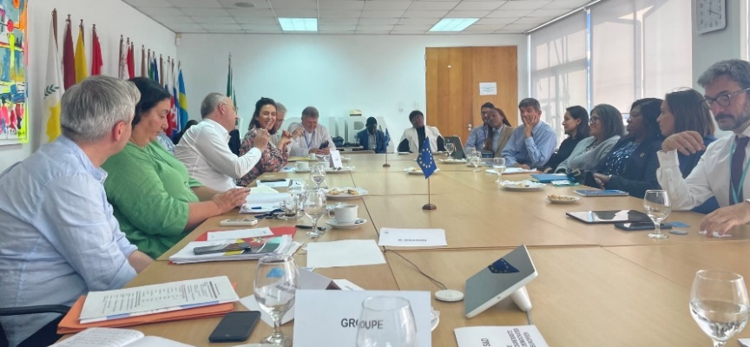
The UNFPA (United Nations Fund for Population Activities)

- Saluted the Spotlight initiative (a UN-EU initiative to eliminate violence against women and girls) as a key collaboration effort with the EU.

The UNICEF (United Nations International Children's Emergency Fund)
- Informed Members that the EU had provided 20% of the UNICEF funding in the last budgetary cycle and praised the strong collaboration between UNICEF and the EU;
- Described the situation of education in Mozambique: 56% of the population is below 18, 2.4 million children are out of school, the drop-out rate at primary stage is 50%, teachers have an average of 60 students each, and the enrolment rate at 6 years-old is now back to 90% (where it was before COVID-19);
- Underlined that 38% of children under five are malnourished, 14% of women become pregnant before 15, and 87% before 18;
- Expressed that the Mozambican government is the best-placed actor to coordinate international donors and ensure that there is no double-funding.
The UNDP (United Nations Development Programme)
- Informed that our 40% of the UNDP envelope in Mozambique comes from the EU and EU Member States;
- Praised the EU for intervening quickly when cyclone Freddy hit Mozambique in February 2023 and explained that cyclones have become less deadly thanks to the joint work of various donors;
- Called on the EU to collaborate on its actions in the context of the upcoming Mozambican elections (countering hate speech and fake news).
The World Bank
- Described its country engagement strategy (since February 2023, with USD 5 billion of active commitments) and its three pillars: inclusive institutions, inclusive green job creation, and human capital;
- Reminded that the Mozambique economic growth rate is still below the population growth rate, and that there is very little space for public investments;
- Expressed its conviction that the most effective development actions are those in which the government is fully engaged and deemed that donor collaboration in Mozambique is quite elaborate.
Members
- Welcomed the work undertaken by the UN agencies and the World Bank;
- Insisted on the need to cooperate amongst donors to avoid double funding;
- Learnt that as an average, 30% of the funding of the UN agencies and the World Bank in Mozambique comes from the EU.
The EU Delegation
- Provided the below table on the EU support to the UN in Mozambique:
EU Support to the UN in Mozambique (August 2023)
Domain | Year | Status | Contract title | Partner |  | Amount |  | Action location | Sector
FED | 2021 | Ongoing | Support to the Implementation of the Maputo Accord for Peace and Reconciliation – Phase 2 | UNOPS |  | 2.000.000 |  | Manica, Sofala | Peace, economic development
FED | 2021 | Ongoing | EU Support to Decentralization (SO1): Decentralization for Development – D4D. | UNDP |  | 4.300.000 |  | Nationwide | Democracy, governance
FED | 2020 | Ongoing | Mozambique Recovery Facility – EU contribution to the UNDP Multi-partner Basket Fund | UNDP |  | 34.300.000 |  | Sofala, Cabo Delgado and central level | Social/economic recovery
FED | 2020 | Ongoing | MZ - UNICEF - Improving Child Nutrition and Building Resilience in cyclones affected areas in Mozambique (SOFALA) | UNICEF |  | 14.700.000 |  | Selected districts in Sofala | Nutrition
FED | 2020 | Ongoing | Local Development for the Consolidation of Peace in Mozambique - DELPAZ: Local Governance Sub-programme | UNCDF |  | 3.000.000 |  | Manica, Sofala | Resilience, economic development
FED | 2019+ 2022 | Ongoing | PROMOVE Agribiz - FAO Sub-Programme | FAO |  | 44.000.000 |  | Nampula, Zambezia and central level | Agribusiness
FED | 2019 | Ongoing | PROMOVE Comércio - Building Competitiveness for Exports | UNIDO |  | 6.500.000 |  | Nationwide | Trade
FOOD | 2019 | Ongoing | Pro-Resilience Action in Mozambique - PRO-ACT | WFP |  | 3.000.000 |  | Mozambique | Resilience
FED | 2018 | Ongoing | Programme for Consolidating Economic Governance and Public Finance Management systems in the PALOP-TL (Pro PALOP-TL SAI (Phase II) | UNDP |  | 7.750.000 |  | PALOP-TL | Economic development
ENV | 2018 | Ongoing | Building Local Climate Resillience in Mozambique | UNCDF |  | 4.300.000 |  | Nampula, Zambezia | Resilience
FED | 2017 | Ongoing | MZ - UNICEF - Improving nutritional status of children in Mozambique | UNICEF |  | 24.200.000 |  | Selected districts in Zambezia and Nampula | Nutrition
 |  |  | Sub-Total |  |  | 141.750.000
ICSP | 2021 | Ongoing | Strengthening community security and stability in communities affected by violence in the Northern Region of Mozambique through police capacity building and community engagement | IOM |  | 4.000.000 |  | Cabo Delgado, Nampula | Civilian peace-building, conflict prevention and resolution
ICSP | 2019 | Ongoing | Building Resilience Through Education and Youth Engagement in the cyclone-affected schools in Mozambique | UNICEF |  | 7.000.000 |  | Mozambique | Education
 |  |  | Sub-Total |  |  | 11.000.000
NDICI AFRICA | 2023 | Ongoing | Laying the foundation for VaMoz Digital! | ITU |  | 2.300.000 |  | Cabo Delgado | Telecommunications
NDICI AFRICA | 2023 | Ongoing | Building Resilience for Women and Girls in the North | UNFPA |  | 5.000.000 |  | Malawi & Regional | Reproductive health care
NDICI AFRICA | 2023 | Ongoing | The EU contribution to the UNDP Immediate Stabilization and Recovery Programme for Cabo Delgado Province, Mozambique | UNDP |  | 15.000.000 |  | Cabo Delgado | Immediate post-emergency reconstruction and rehabilitation
NDICI AFRICA | 2023 | Ongoing | AGUANORTE - ACCESS TO WATER, SANITATION AND HYGIENE IN NORTHERN MOZAMBIQUE | UNICEF |  | 19.800.000 |  | Nationwide | WASH
 |  |  | Sub-Total |  |  | 42.100.000
ECHO | 2020 | Ongoing | Strengthening disaster risk resilience through enhanced coordination mechanisms | UNDRR |  | 500.000 |  | Malawi & Regional | DRR
ECHO | 2020 | Ongoing | Lifesaving humanitarian food assistance to conflict affected populations in Cabo Delgado | WFP |  | 1.150.000 |  | Cabo Delgado | Food Security, Livelihood
ECHO | 2020 | Ongoing | Strengthening National Institutions and Programmes in Early Warning and Early Actions using innovating technologies and approaches, including floods modelling, enhanced rapid Post Disaster Assessment, contingency planning and social protection schemes in Mozambique | WFP |  | 900.000 |  | Nationwide | DRR/DP
ECHO | 2020 | Ongoing | Life-saving food and nutrition support to disaster-affected communities of Mozambique | WFP |  | 3.500.000 |  | Drought-affected southern and central provinces, post-cyclones areas and conflict-affected IDPs in Cabo Delgado | Food Security
ECHO | 2019 |  | Growing safer: Supporting school disaster prevention & Building back better reconstruction | UNICEF |  | 500.000 |  | Zambezia and Inhambane Provinces | Education in Emergencies
ECHO | 2019 | Ongoing | Provision of life-saving food assistance to cyclone and flood affected populations of Mozambique | WFP |  | 2.500.000 |  | Sofala, Tete | Food security, Livelihood
ECHO | 2019 | Ongoing | Life-saving food and nutrition support to disaster-affected communities of Mozambique | WFP |  | 7.500.000 |  | Nationwide | Food assistance, pre-positioning
ECHO | 2019 | Ongoing | Provision of Logistics Cluster Common Services in Support of the Humanitarian Community responding to Cyclone Idai in Mozambique | WFP |  | 1.000.000 |  | Zambezia, Manica | Logistics
ECHO | 2018 | Ongoing | WFP support to Government disaster risk reduction, early response, recovery systems and policies | WFP |  | 800.000 |  | Nationwide | DRR, early response
 |  |  | ECHO Sub-Total |  |  | 18.350.000
EU TOTAL |  |  |  |  | € |  | 213.200.000

5. Meeting with Civil Society, NGOS, including Women, LGTIBQ+ and student organisations and Trade Unions

Civil society organisations

- Have been engaged in the laws to decriminalize abortion (2014), the family law (2019), the Act on Domestic Violence Perpetrated against Women (2010) and now work on rural laws;

- Warned of a current trend of going back in time on social issues and expressed that they would fight to keep the acquired rights and victories;

- Explained that they do not receive financial support from rich individuals or companies as those demand alignment with their commercial interests and want results that can be immediately “photographed” and promoted, while real change takes time.

- Informed Members that homosexuality has been decriminalized in Mozambique in 2015 and that a law forbids discrimination based on gender, but insisted that LGBTQI+ minorities are still suffering from discriminations, in particular due to the low level of literacy in the country;

- Thanked the EU for the political support it receives and called for further resources to be able to provide trainings and raise awareness in the Mozambican society.

Student organisations

- Explained that it is difficult to receive funding from the EU because of the very complex procedures organisations have to go through;

- Warned that many students finishing college are unable to find jobs and fall into depression and asked for a programme targeting young people from beginning to end.

Trade Unions

- Described that they currently engage in revising the labour law, extending the maternity and paternity leaves, having Mozambique ratify the ILO Convention 190 on violence and harassment;

- Described that the oil and gas sector is new in Mozambique, that it therefore needs trade unions to organise in order to face its particular challenges and that companies in that sector are not very keen in letting workers organise themselves.

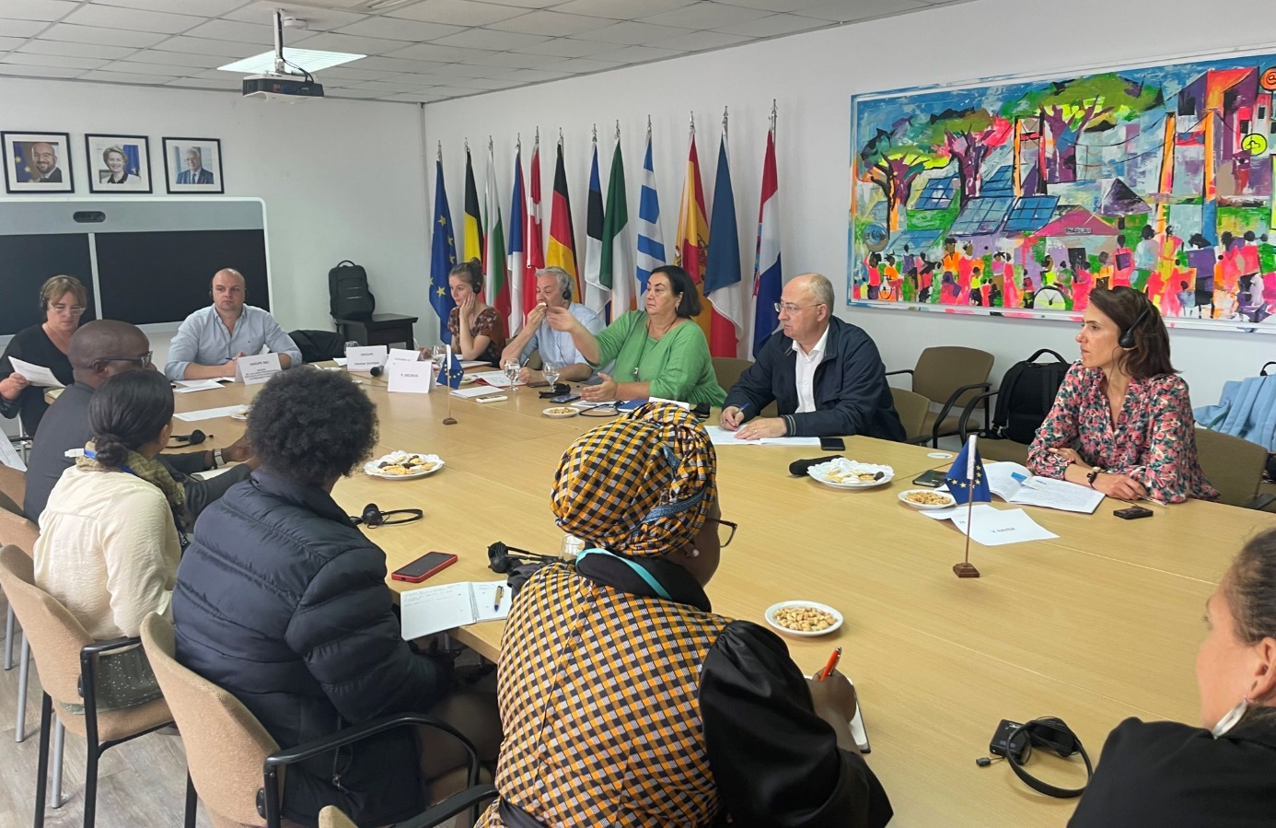

Members

- Were informed that the possibilities of expressing dissatisfaction on social issues through demonstration have been reduced in the past years (violence, threats, discrimination);

- Inquired about the minimum wage in the country (5800 MZN per month = 84.81 EUR) and poverty levels;

- Learnt that Mozambican children do not have dreams anymore and civil society organisations do their utmost to offer them a new positive model of reference.

6. Visit of the Estoril Secondary school - Mozambique Recovery Facility (MRF)

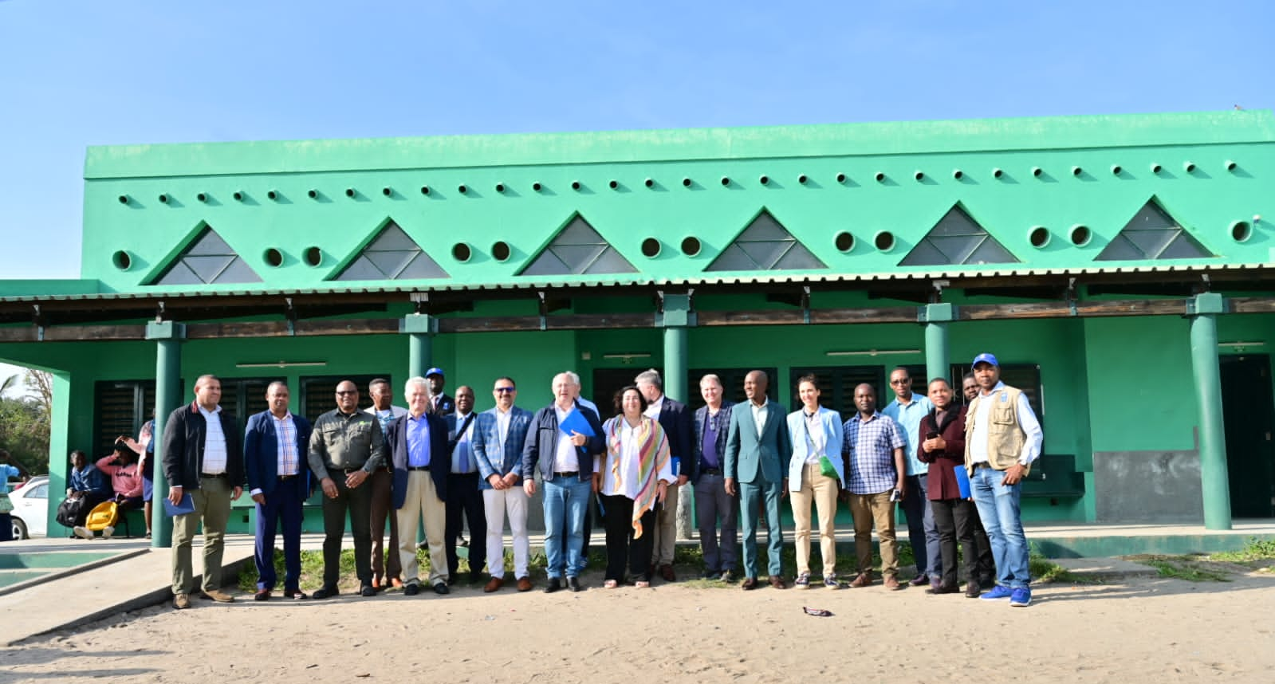

The UNDP

- Manages the Mozambique Recovery Facility (MRF), a programme running from 2019 until 2024, aiming for resilient recovery of livelihoods, community infrastructures and houses to facilitate income generation provisions and access to basic services for the communities most affected by and vulnerable to cyclones, financed by the EU, Canada, China, Finland, India, the Netherlands, Norway, and UNDP with own resources;

- Supervised the rehabilitation of 19 classrooms, one administrative block, one library and one lunchroom of the Estoril Secondary school between 2021 and 2022;

- Gave example of other projects financed through the MRF, such as giving bicycles to women to enable them to sell fish, providing solar panels for businesses so that they can sell electricity to people wanting to charge their phones, rehabilitating health centres, training people to save money, etc.

Members

- Were informed by the school principal that teachers, school board and parents feel like the reconstruction was well done and are thankful to the EU for participating in this action;

- Observed the technicalities of the reconstruction work described by the Government Post-Cyclones Reconstruction Cabinet (GREPOC), in particular the roofs, windows/doors and the connexion between wall and roof which have been designed to withstand future cyclones;

- Interacted with school children and learnt that they have to walk between 3 and 7 km in average to come to school.

7. Meeting with the office of the Secretary of State of the province of Sofala (with participation of the Governor staff)

Members
- Exchanged with the team of the Governor, including the head of cabinet, the director for planning and finance and the advisor for the economic area;
- Learnt that the province has not yet recovered from the 2019 cyclone and key equipment has not yet been rebuilt, such as the provincial library, sports equipment, the cultural house;
- Inquired about the participation of the citizens to decision-making in the region and learnt that consultations do take place in the context of a decentralised system, for example citizens are asked how the provincial budget should be spent.
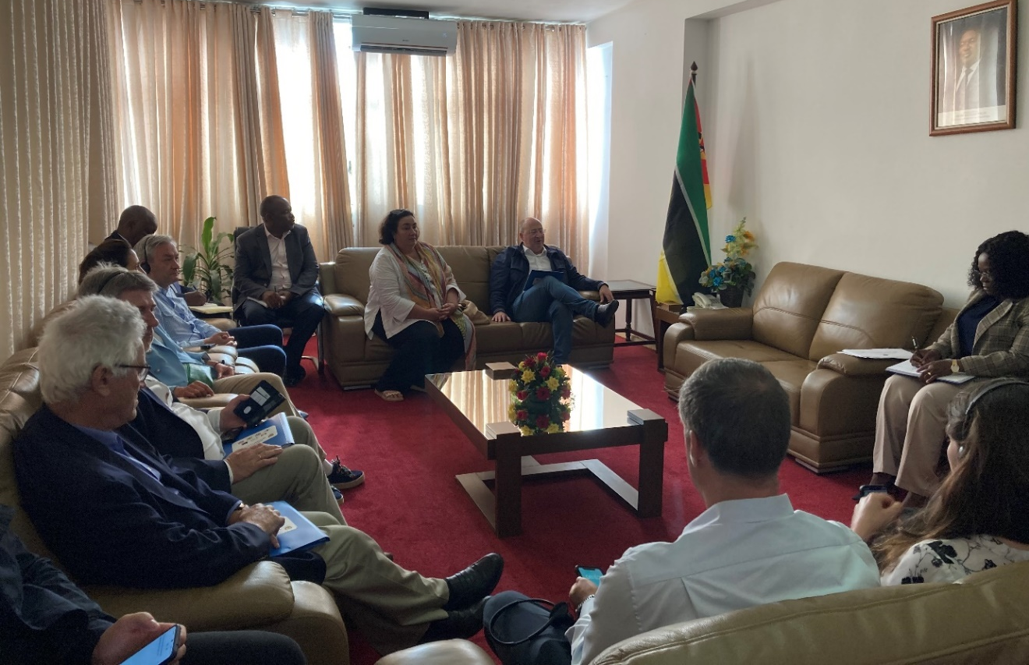
The Governor’s office
- Described how the province suffered from cyclones and has enormous needs for resilient infrastructure (water management systems, roads, bridges, housing), support to the youth and job creation;
- Highlighted the high potential of the agriculture and fishing sectors in the region and the need for investments to build roads to transport production as well as processing factories;
- Explained that there are no local taxes to finance the local budget and that taxes collected in the port of Beira (which is a key infrastructure for neighbour landlocked countries) go directly to the State.

8. Visit of the Mozambique Integrated Urban Development by Actions and Relationships (MUDAR)

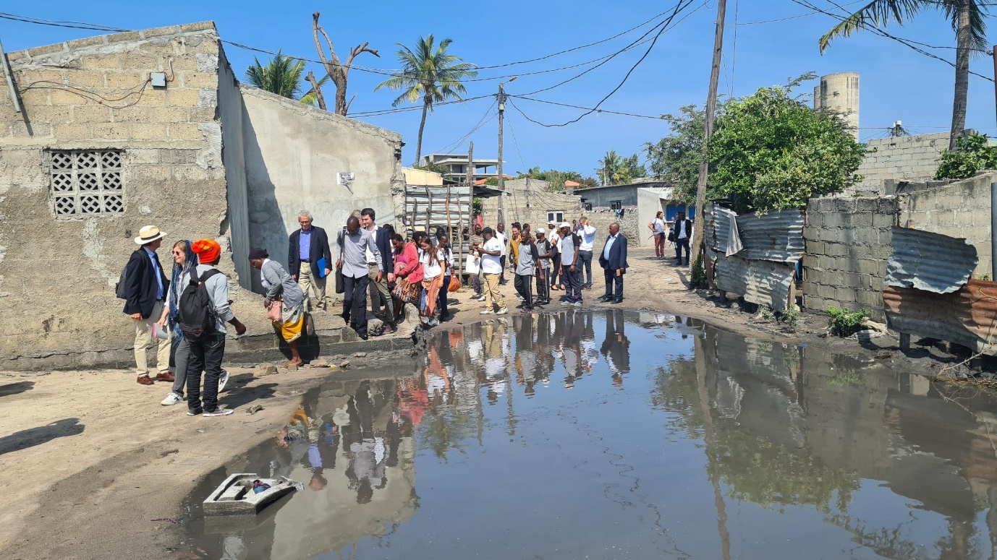
The Mayor of Beira
- Saluted the EU for its help in making Beira a city resilient to climate change and called for further investments in youth and women;
- Explained that the annual city budget amounts to EUR 10 million, with no support from the central government.
The project manager
- Described how the project (EUR 3,2 million / 94,95% of which are financed by the EU) has been designed in cooperation with the inhabitants of the Macuti neighbourhood to face their problems (rains, floods, water distribution, green areas) and improve their living conditions;
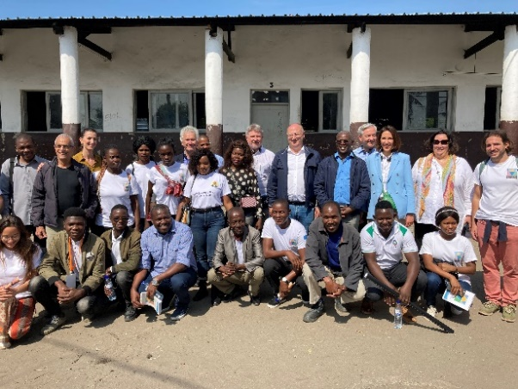
- Walked Members through the neighbourhood, showing where it was decided following a public consultation of 1000 people to build a road to allow for a better circulation, including for emergency vehicles, and improve waste collection.
Members
- Reminded that they were in Beira to learn from the people, cooperate in improving their lives and succeed together in the climate transition.

9. Visit of a Vocational Education and Training centre of Young Africa - DelPaz programme

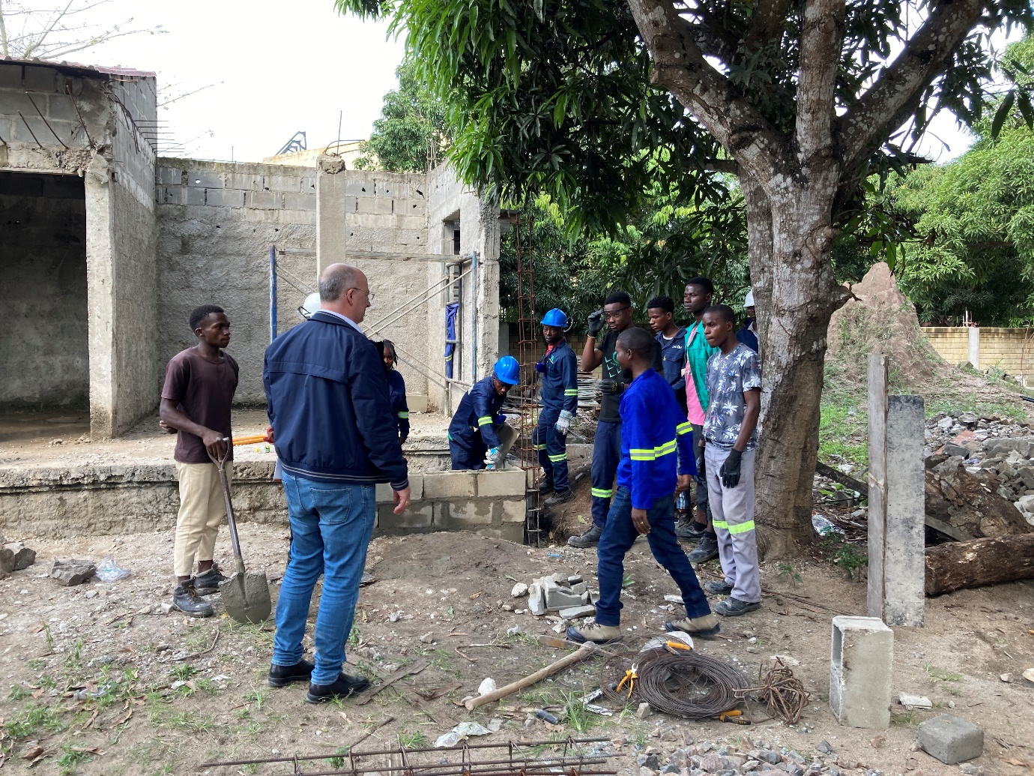

Members

- Visited the centre, a result of the EU’s commitment to Mozambique’s October 2019 Peace Agreement and funded by the 11th European Development Fund, with the goal of supporting the consolidation of peace in Mozambique (the programme is referred to as “DELPAZ”) through a combination of territorial and social targeting, working through local structures to enhance livelihood opportunities with a special focus on women, youth, and disadvantaged groups as well as on vulnerable conflict affected communities;

- Learnt that the total budget for the Action is EUR 29 million (EU contributing with EUR 28 million and Austria with EUR 1 million) and the implementation period runs from November 2020 to December 2024;

- Interacted with vocational training students in the field of mechanics, cooking/baking, carpentry, metallurgy, sewing, electricity, masonry, and heard that many had the goal of starting their own company and had parents who are demobilized military.

10. Visit of the EU Training Mission in Mozambique (EUTM-MOZ)

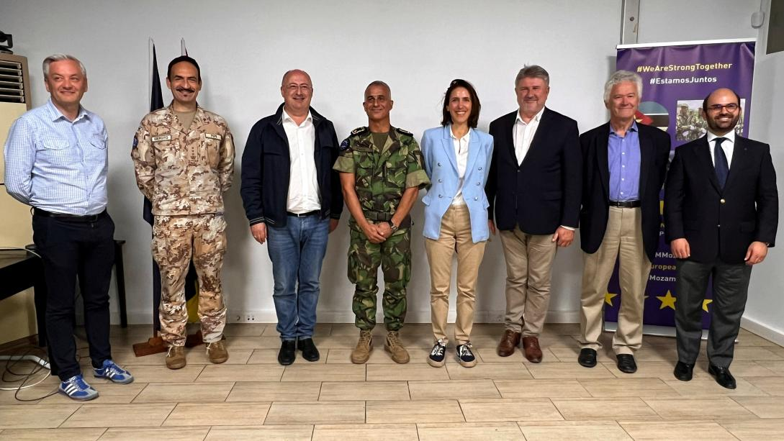

The EU Training Mission commanding officers

- Briefed Members on the mission, financed through the European Peace Facility (an off-budget instrument / EUR 89 million for EUTM-MOZ), with military personnel from 12 Member States, and launched in October 2021 at the request of the Mozambican government in order to provide training and support to the Mozambican armed forces to protect the civilian population and restore security in the Cabo Delgado province;

- Explained that the mission will be concluded once the goal of training eleven companies (quick reaction forces - each of 140 units) and enabling them to operate in any designated area of operations, including Cabo Delgado, is completed;

- Described that so far eight companies have been fully trained, two are currently under training and only one company and the OPS are still to be trained, and that the objective is to create a self-sustainable cycle in which Mozambican forces are fully able to train themselves.

Members

- Learnt that the EUTM-MOZ provides only non-lethal equipment to Mozambican armed forces and that this is a political decision of EU Member States;

- Learnt that Mozambique is the second beneficiary of the European Peach Facility after Ukraine, and that the mandate of the EUTM-MOZ will be reviewed in September 2023;

- Regretted that Mozambican special forces are only men, but welcomed the inclusion of a week of training on human rights, children rights, women rights, civil-military relationship, etc, in the cursus.

11. Meeting with Manuel Bazo, Vice Minister of Education and Human Development

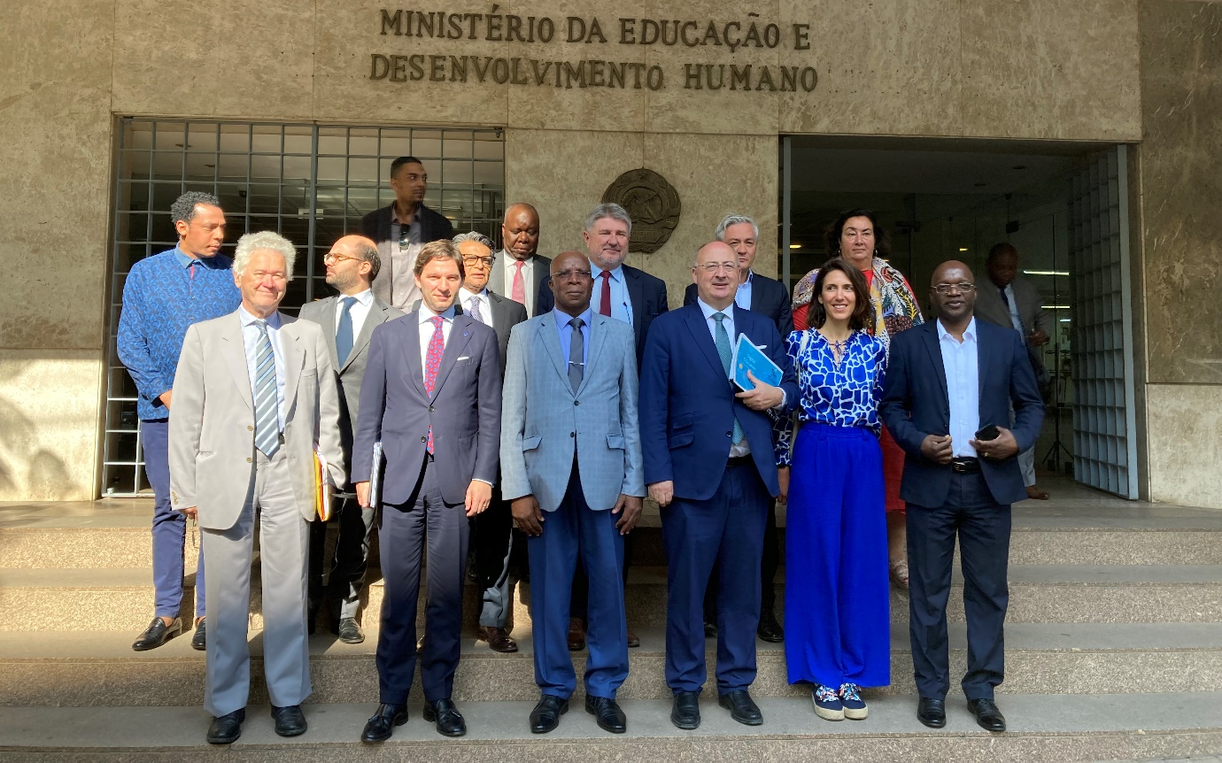

The Vice Minister and his team
- Explained that the Ministry for Education and Human Development is responsible for elementary and secondary schooling, and has the goal of introducing 9 year mandatory schooling in the country, which necessitates trained teachers, school premises, furniture, etc;
- Pointed out that 25% of the Mozambican government budget goes to education;
- Described their objective of expanding distance learning in Mozambique through digitalisation as part of the distance learning strategy 2023-2032 and reminded that further funding is very welcome;
- Highlighted the importance given by the Ministry to the participation of girls in education and detailed a project which provided bicycles to girls to enable them to go to school;
Members
- Were informed that the illiteracy rate among adults in Mozambique is 39%, 9.5 million children are currently enrolled in the school system (made of 11 000 schools of grade 1-6, 1450 schools of grade 1-9 and 669 schools of grade 7-12) and 1.5 million children enter the schooling system every year;
- Learnt that 7,8% of schools provide meals and partners are needed to increase that number.

12. Meeting with Esperança Bias, President of the Assembly of the Republic

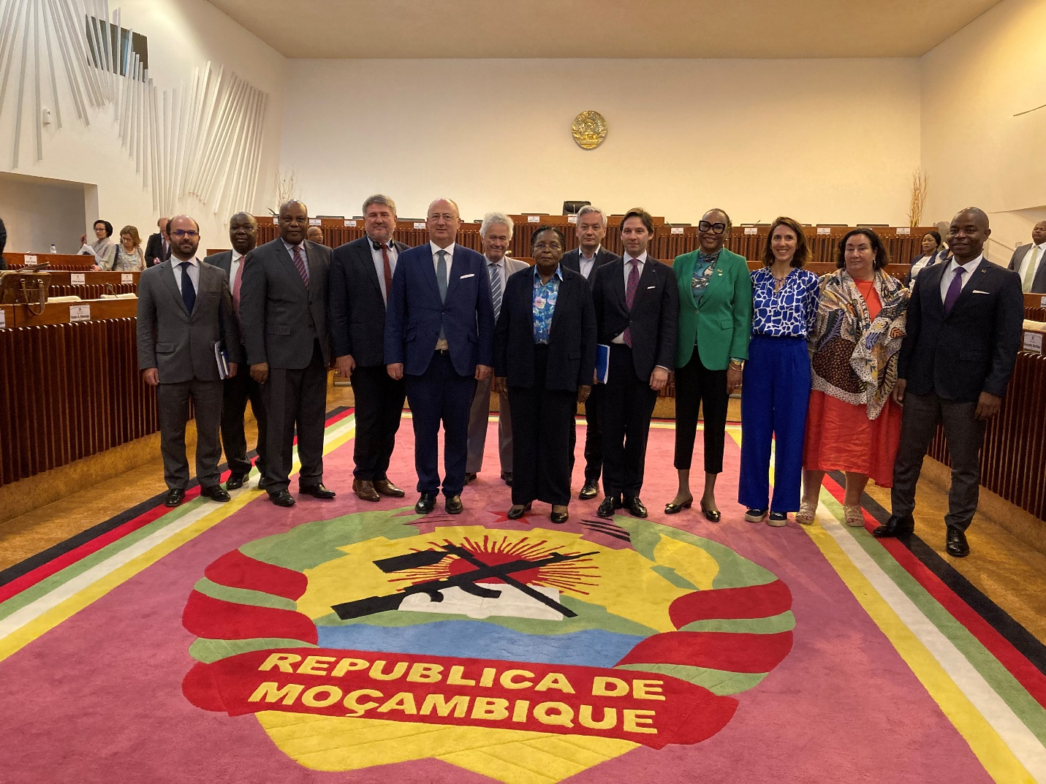

The President

- Introduced the Assembly of the Republic, which gathers 250 Members since 1977, two years after the independence of Mozambique, and reminded of the neutral position of the country, which means they will not pick a side between Russia and Ukraine but encourage both to find a peaceful solution to the war through dialogue;

- Highlighted that Mozambique is a democratic country, with free elections, respect of human rights, freedom of the press and strong institutions; added that in the Assembly of the Republic, the opposition sits in all committees;

- Thanked the EU for its support in fighting terrorism in Cabo Delgado and argued for the provision of lethal equipment and the extension of the EU Training Mission.

Members

- Explained the EU budgetary process and the role of the EP Committee on Budgets;

- Invited the Assembly of the Republic to visit the European Parliament in order to reinforce the good relationship between the two institutions.

13. Meeting with the Budget Committee of the Assembly of the Republic

António Rosário Niquice, Chair of the Budget Committee

- Explained that the main concern of its Committee is about how to finance public expenditure as the State budget runs a deficit (in 2022, the State budget amounted to MZN 476 billion and the deficit amounted to MZN 150 billion), in order to invest in education, health, fight against poverty, climate change adaptation and infrastructure;

- Highlighted that the main source of revenue of the Mozambican budget is taxes; added that before the hidden debt scandal, there was also a lot of direct budgetary support from international partners; concluded that with the withdrawal of the direct support, the situation has become dire for Mozambican finances;

- Pointed that the oil and gas potential in Cabo Delgado brings hope, and that the government is creating a sovereign fund to manage the revenue coming from the extraction of oil and gas, to be managed in a transparent and inclusive way.
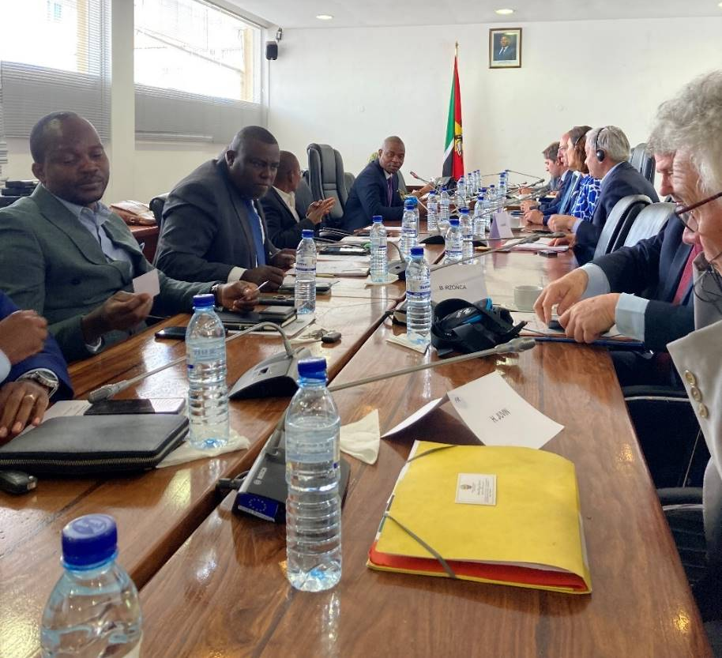

Members

- Were informed that the support provided by the EU to Mozambique is on an off-budget basis, which prevents parliamentary scrutiny and received calls for budgetary support;

- Inquired about gender budgeting in Mozambique.

14. Meeting with Ernesto Max Elias Tonela, Minister of Economy and Finance

The Minister and his team

- Thanked the EU for being the largest donor for development in Mozambique, highlighting the help the EU provided during the COVID-19 pandemic, and mentioned that more funds could be put to good use, in particular through direct budgetary support;

- Announced that economic growth should be 7% in 2023, and the same is expected for 2024 and 2025; highlighted recent initiatives undertaken to support economic growth: visa removed for a number of countries to promote tourism, exchange rate policy, investment legislation, management of public debt, creation of a sovereign fund with part of the revenue collected from oil and gas exploitation and invested for future generations;

- Described the challenges faced by Mozambique, in particular climate change and terrorism; explained that 10% of the revenue from mining and gas is allocated to the districts where the extraction takes place, to reduce development inequalities within the country;

Members

- Inquired about the amount provided by other global players to Mozambique and about gender budgeting;

- Were informed about the efforts undertaken by the government to increase transparency in the use of public funds.

15. Press conference

José Manuel Fernandes, head of the ad-hoc delegation

- Highlighted the positive findings of the BUDG mission, the will to reinforce cooperation between the EU and Mozambique, learn from each other and the common objective of both to promote peace;

- Affirmed that education and youth are an incredible opportunity for Mozambique and should be the priority of public investments;

- Reminded that the EU has strong internal rules that have to be respected before direct budget support to a third country can be considered.

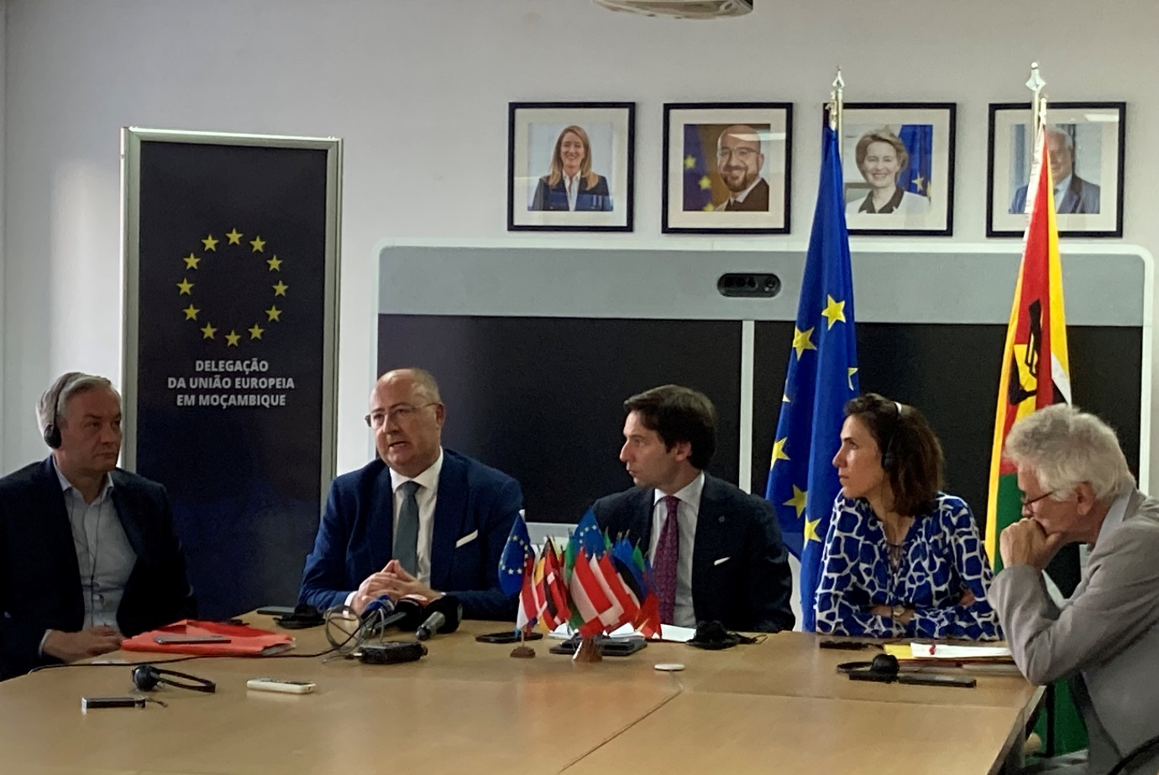

III. Programme

COMMITTEE ON BUDGETS OF THE EUROPEAN PARLIAMENT
Ad hoc delegation to Mozambique
23-28 July 2023
PROGRAMME

Monday 24 July 2023

15.00 - 16.10 Briefing with Antonino Maggiore, Head of the EU Delegation to Mozambique - Hotel Radisson Blu

16.30 - 17.30 Meeting with Manuel José Gonçalves, Deputy Minister of Foreign Affairs

18.00 - 20.30 Cocktail reception - EU Ambassador Residency

20.30 End of official programme for the day

Tuesday 25 July 2023

08.30 Departure from hotel

09.00 – 10.30 Meeting with Member States agencies - EU Delegation premises

10.40 – 12.30 Meeting with implementing partners of the EU programmes: UN agencies (UNFPA, UNICEF and UNDP) and World Bank - EU Delegation premises

14.50 - 16.20 Meeting with Civil Society, NGOS, including Women, LGTIBQ+ and student organisations and Trade Unions - EU Delegation premises

18.00 - 19.40 Flight to Beira

20.30 End of official programme for the day
Wednesday 26 July 2023

07.00 Departure from hotel in Beira

07.15 - 08.30 Mozambique Recovery Facility (MRF) - Visit to one rehabilitated school

08.50 - 09.40 Meeting with the office of the Secretary of State of the province of Sofala (with participation of the Governor staff)

10.10 - 11.25 Mozambique Integrated Urban Development by Actions and Relationships (MUDAR)

12.00 - 13.15 DelPaz programme - Vocational Education and Training centre of Young Africa

15.00 - 16.20 Flight to Maputo

18.30 - 20.00 Meeting with the EU Training Mission in Mozambique

20.30 End of official programme for the day

Thursday 27 July 2023

8.15 Departure from hotel

08.50 - 09.50 Meeting with Manuel Bazo, Vice Minister of Education and Human Development

10.15 - 11.15 Meeting with Esperança Bias, President of the Assembly of the Republic

11.25 - 12.00 Meeting with the Budget Committee, Assembly of the Republic

12.40 - 14.00 Meeting with Ernesto Max Elias Tonela, Minister of Economy and Finance

16.00 - 16.30 Press conference - EU Delegation premises

16.30 End of official programme

IV. Participants

MEPs BUDG | Group |  | Country
José Manuel Fernandes | EPP |  | Portugal
Robert Biedroń | S&D |  | Poland
Valérie Hayer | Renew |  | France
Bogdan Rzońca | ECR |  | Poland
Hervé Juvin | NI |  | France
Secretariat staff
Alice Rouquette |  | Administrator | BUDG Secretariat
Vanessa Aulehla |  | Administrator | BUDG Secretariat

Political Group staff | Group
Benjamin Descamps | EPP
Nikola Turčinov | S&D
Katharina Burlafinger | Renew
Jan Van Brussel | ECR

Interpreters | Intepretation
Cristovao Leitao | PT-EN
Paula Cunha MATTOS | PT-EN

