GOVERNMENT OF BELIZE
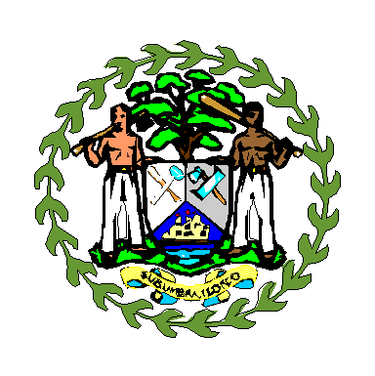
Ministry of Finance
Belmopan, Belize
_____________________________________________________________

Please Quote
Ref: TEN/01/03/21(55)

June 21, 2021

Public Sector Suppliers/Banks and Insurance Companies
Belize

ADMINISTRATIVE NOTE FROM CARICOM SECRETARIAT

REGIONAL SECTORAL CONSULTATION ON PUBLIC PROCUREMENT RULES, PROCEDURES, BONDS, GUARANTEES, SECURITIES, AND FRAMEWORK AGREEMENTS TO ADMINISTER PUBLIC PROCUREMENT IN THE COMMUNITY - VIDEO-CONFERENCE (ZOOM) - 29 JUNE & 8 JULY 2021

There has been a change of dates for the regional consultations which will now be held as follows:
- Tuesday 29 June 2021 – Contractors, tenderers, suppliers and private sector and professional bodies that will be impacted by the Community Public Procurement Regime (Group 1)
- Thursday 8 July 2021 –Financial Services Sector: Banks, Insurance companies and Credit Unions, including umbrella bodies (Group 2)
Purpose
The purpose of the regional consultations is follows:
- To provide the private sector stakeholders the platform to consider and discuss the proposed rules and procedures;
- To make recommendations that could be considered by the Task Force on Public Procurement and for consideration by COTED and COFAP;
- To raise awareness and sensitize the private sector on developments in relation to an integrated public procurement market and regime for the CSME.

Target Group

- Contractors, tenderers, suppliers and private sector and professional bodies that will be impacted by the Community Public Procurement Regime (Group 1)
- Financial Services Sector: Banks, Insurance companies and Credit Unions, including umbrella bodies (Group 2).

Date and Time
- Tuesday 29 June 2021 – (Group 1)
- Thursday 8 July 2021 – (Group 2)

- 8:00am (Belize time);
- 9:00 am (Jamaica and Haiti time)
- 10:00 am (Barbados and Eastern Time)
- 11:00 am (Suriname time)
Information and Link:
The consultations will be held virtually via Zoom. The link will be transmitted to Member States and participants under separate cover.
Deadline
The deadline for confirming participation are as follows:
- Group 1 – Friday 25 June 2021
- Group 2- Friday 2 July 2021
Contact Information
Additional request for information
For queries and further information on this subject please contact:

CARICOM Secretariat CSME Unit
1st Floor Sky Mall
Haggatt Hall
St. Michael
Barbados
Tel: 246-429-6064 / 6159
Fax : 246-437-2689

Attention : Leo Titus Preville, Programme Manager
Email: leo.preville@caricom.org ; secretary.csmeunit@caricom.org

Copied:philip.mcclauren@caricom.org;information.csmeunit@caricom.org; info.csmeunit@caricom.org

Additionally, information may be sent to Artemio.Osorio@mof.gov.bz

