Press Release
Shri Prasanta Borkakoty is the new Resident Chief Executive (RCE) of OIL
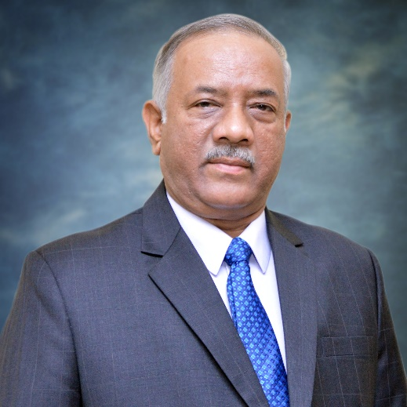
Duliajan, 30th April 2021: Shri Prasanta Borkakoty will assume the charge of Resident Chief Executive (RCE), of Oil India Limited, Field Headquarter from May 1, 2021. Shri Borkakoty joined OIL as an Executive Trainee (ET) on June 6, 1986 in the Civil Engineering Department in Duliajan. Born to Shri Prafulla Borkakoty and Smt Tunu Borkakoty, Shri Prasanta Borkakoty comes from Doomdooma, Tinsukia district, Assam. He did his schooling in Sainik School, Goalpara and has acquired his Engineering degree in Civil from Regional Engineering College, Calicut.
Shri Borkakoty served the Civil Engineering Department in various capacities and became a Senior Engineer (Civil) in 1991. Later, he served as the Senior PR Officer in the Department of Public Relations Department (1994 to 1995) until 2006 when he took over the position of Senior Manager in the same Department. In 2012 he was transferred to the Employee Relations Department as the Head - Employee Relations to look after the challenging responsibilities of employee engagement, trust & relationship building with stakeholders as well as statutory compliances and welfare measures for contract labour engaged by contractors at OIL. He was promoted to the position of Chief General Manager in the Administration Department on February 12, 2018. He was then promoted to the position of Executive Director (HR&A) on January 1, 2019 until April 30, 2021.
Shri Prasanta Borkakoty has a reputation of having worked with diverse communities at the grassroots level and has remained actively associated with various organizations and public institutions honing his leadership and social influence skills. Known for his visionary leadership with sound technical knowledge and amicable persona, Shri Borkakoty practices active learning & believes in developing learning strategies, which has helped in all the different roles he has undertaken. He relies on analytical thinking, emotional intelligence & ideation for resolution of complex problems.
*******************

