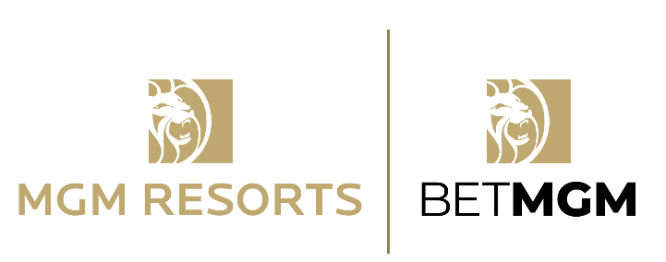
MGM RESORTS & BETMGM NAMED OFFICIAL PARTNERS OF AMERICAN GAMING ASSOCIATION’S HAVE A GAME PLAN® MISSION

Announcement coincides with Responsible Gaming Education Week

LAS VEGAS (September 23, 2021) – MGM Resorts International and BetMGM, the joint venture between MGM Resorts and Entain, are proud to join the American Gaming Association (AGA) as official partners of its Have A Game Plan® mission. Have A Game Plan aims to promote responsible sports wagering to new consumers and seasoned bettors. This announcement coincides with the AGA’s Responsible Gaming Education Week (RGEW). As the industry experiences monumental growth, RGEW 2021 is highlighting MGM Resorts and BetMGM’s unified commitment to responsible gaming.

Throughout RGEW, MGM Resorts and BetMGM are sharing important responsible gaming tips and information through its social media channels. MGM Resorts and BetMGM will continue to promote its responsible gaming education throughout the year by providing useful information, tools and resources on its apps and websites.

“We are proud to become a partner of such an important initiative for the industry,” said Richard Taylor, Responsible Gambling Program Manager, BetMGM. “Through GameSense, we are committed to doing our part in creating a fun and safe experience for customers.”

As MGM Resorts and BetMGM continue to expand and evolve its sports betting and other gaming platforms, responsible gaming education remains a key focus. GameSense is an industry-leading program, developed and licensed to MGM Resorts by the British Columbia Lottery Corporation (BCLC), focusing on positive, transparent and proactive conversations with players about how to gamble responsibly. The program comes alive through personal interactions between guests and trained staff based at each property's M life Rewards desk. In addition to speaking to trained employees – known as GameSense Advisors – guests also utilize interactive GameSense touchscreens and educational materials, and other resources found at the M life Rewards Desk.

Garrett Farnes, Responsible Gaming Compliance Manager, MGM Resorts, said, “This partnership complements our ongoing commitment to GameSense. GameSense has been an instrumental part of the MGM Resorts guest service model since 2017, helping customers understand the risks, where to get help and ultimately, how to keep gaming fun.”

For more information, follow @BetMGM and @mgmresorts on Twitter.

# # #
About BetMGM
BetMGM is a market leading sports betting and gaming entertainment company, pioneering the online gaming industry. Born out of a partnership between MGM Resorts International (NYSE: MGM) and Entain Plc (LSE: ENT), BetMGM has exclusive access to all of MGM’s U.S. land-based and online sports betting, major tournament poker, and online gaming businesses. Utilizing Entain’s US-licensed, state of the art technology, BetMGM offers sports betting and online gaming via market leading brands including BetMGM, Borgata Casino, Party Casino and Party Poker. Founded in 2018, BetMGM is headquartered in New Jersey. For more information, visit https://www.betmgm.com/.

About MGM Resorts International
MGM Resorts International (NYSE: MGM) is an S&P 500® global entertainment company with national and international locations featuring best-in-class hotels and casinos, state-of-the-art meetings and conference spaces, incredible live and theatrical entertainment experiences, and an extensive array of restaurant, nightlife and retail offerings. MGM Resorts creates immersive, iconic experiences through its suite of Las Vegas-inspired brands. The MGM Resorts portfolio encompasses 29 unique hotel and destination gaming offerings in the United States and Macau, including some of the most recognizable resort brands in the industry such as Bellagio, MGM Grand, ARIA and Park MGM. The Company's 50/50 venture, BetMGM, LLC, offers U.S. sports betting and online gaming through market-leading brands, including BetMGM and partypoker. The Company is currently pursuing targeted expansion in Asia through the integrated resort opportunity in Japan. Through its “Focused on What Matters: Embracing Humanity and Protecting the Planet” philosophy, MGM Resorts commits to creating a more sustainable future, while striving to make a bigger difference in the lives of its employees, guests, and in the communities where it operates. The global employees of MGM Resorts are proud of their company for being recognized as one of FORTUNE® Magazine's World's Most Admired Companies®. For more information, please visit us at www.mgmresorts.com. Please also connect with us @MGMResortsIntl on Twitter as well as Facebook and Instagram.
MGM Resorts' public filings with the SEC. MGM Resorts has based forward-looking statements on management's current expectations and assumptions and not on historical facts. Examples of these statements include, but are not limited to, statements regarding the future results of BetMGM. Among the important factors that could cause actual results to differ materially from those indicated in such forward-looking statements include effects of economic conditions and market conditions in the markets in which MGM Resorts operates and competition with other destination travel locations throughout the United States and the world, the design, timing and costs of expansion projects, risks relating to international operations, permits, licenses, financings, approvals and other contingencies in connection with growth in new or existing jurisdictions and additional risks and uncertainties described in MGM Resorts' Form 10-K, Form 10-Q and Form 8-K reports (including all amendments to those reports). In providing forward-looking statements, MGM Resorts is not undertaking any duty or obligation to update these statements publicly as a result of new information, future events or otherwise, except as required by law. If MGM Resorts updates one or more forward-looking statements, no inference should be drawn that it will make additional updates with respect to those other forward-looking statements.
CONTACTS
MGM Resorts
Marc Jacobson
media@mgmresorts.com

BetMGM
Elisa Richardson
media@betmgm.com

