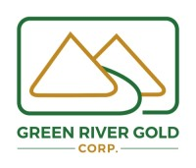Green River Gold Corp.
News Release
CSE: CCR
April 26, 2021

GREEN RIVER GOLD CORP. OPTIONS THE QUESNEL NICKEL PROJECT TO SURGE BATTERY METALS INC.
EDMONTON, ALBERTA – Green River Gold Corp. (“Green River” or the “Company”) is pleased to announce it has entered into an Option Agreement with Surge Battery Metals Inc. (“Surge”) (TSXV: NILI, OTC: NILIF, FRA: DJ5C) whereby Green River granted to Surge the right and option, subject to the terms of the Option Agreement, to acquire (the “Option”) an undivided 80% interest in a contiguous block of 8 mineral claims comprising 2,219.34 hectares (the “Property”). The optioned mineral claims represent less than 25% of Green River’s 8,937.94 hectare Fontaine project which it acquired in 2019.
The Fontaine Project is located 45 km east of the city of Quesnel in central interior British Columbia. The project is accessible year-round by Provincial Highway 26 and various well-maintained forestry roads. The project borders Osisko’s Cariboo Gold Project, with indicated resources of 3.2 Moz Au (21.4 million tonnes grading 4.64 g/t Au) and inferred resources of 2.72 Moz of Gold (21.7 million tonnes grading 3.91 g/t Au).
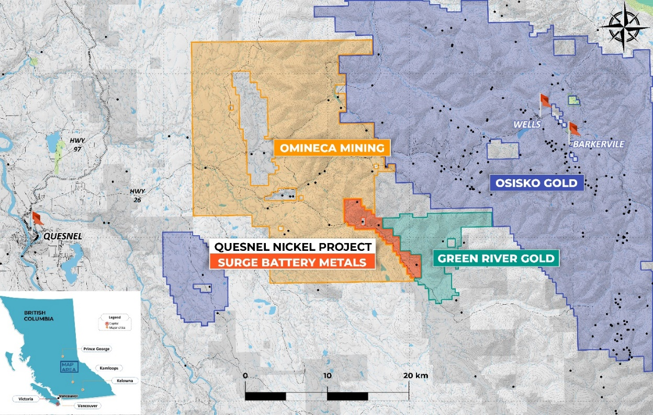
Terms of the Option Agreement

The Option shall vest upon all the requirements set out below being satisfied. To exercise the Option, Surge must issue common shares (“Shares”) to Green River, in the aggregate sums shown in the following table:

Date | Shares to be Issued
Upon signing the Option Agreement | 500,000
1st Anniversary date of the effective date | 150,000
2nd Anniversary date of the effective date | 200,000
3rd Anniversary date of the effective date | 250,000
4th Anniversary date of the effective date | 300,000

In addition to the issuance of Shares as described, Surge must incur no less than $800,000 in mining work expenditures on the Property by the end of the 4th Anniversary date of the effective date of the Option Agreement. Upon Surge exercising its option to acquire an undivided 80% interest in the Property by performance of all of the requirements set forth above, a joint venture shall be formed between Green River and Surge to contribute their share of future development and production costs. In the event that Green River does not choose to contribute their share of future costs, then its 20% interest in the Property would convert to a 2% Net Smelter Royalty.

Green River acquired the Fontaine Project with a focus on its gold potential, however, the Company was also aware of the potential for other minerals as highlighted in the following BC MINFILES:
- 093A 013 – Sovereign Creek – developed prospect containing talc and magnesite, and coincident showing containing nickel sulfides.
- 093A 130 – Sovereign – showings containing talc and nickel sulfides.
- 093A 139 – Fontaine Creek – showing containing asbestos.
- 093H 061 – R.T. – showing containing nickel, chromium and cobalt.
The four BC MINFILE occurrences are based on exploration work documented in 16 BC ARIS and 12 BC Property File reports, as well as various government agency reports and maps.
Perry Little, Green River’s President and CEO, comments; “We are pleased to see that we were not alone in recognizing the potential for other minerals at the Fontaine Project. We look forward to seeing the results of Surge’s exploration and wish them great success.”
Kyle Townsend, Green River’s Mine Manager, comments; “Our target remains precious metals. We are pleased to have been approached by and to have reached an agreement with Surge Battery Metals Inc. who has the technical expertise and background to target the possible nickel alloy mineralization on the property.”
The technical data in this new release has been reviewed and approved by Stephen Kocsis, P.Geo., a qualified person for the purpose of National Instrument 43-101 - Standards of Disclosure for Mineral Projects.
About Green River Gold Corp.
Green River Gold Corp. acquires and develops placer mining claims and mineral claims. The Company controls a 100% interest in the flagship Fontaine Gold Project. The 8,900-hectare Fontaine Gold Project is situated 12 kilometers southwest of Barkerville. The property includes both placer and hard-rock tenures. The properties straddle an 18 km length of the Barkerville and Quesnel Terranes and are contiguous to Osisko Development Corp.’s proposed mine at its Cariboo Gold Project. A portion of the Fontaine Gold Project mineral claims have been optioned to Surge Battery Metals Inc.
The Company also controls a 100% interest in the 1,214.32-hectare Kymar Silver Project, located 28 kilometers West of Invermere, British Columbia.
The Company also controls a 100% interest in placer mining projects on the Little Swift River, Sovereign Creek, Willow River, and Swift River. The Company rents placer claims to placer gold miners for cash rent, in lieu of a royalty.
Green River Gold Corp. also distributes equipment and supplies for the placer mining industry and is a Limited Partner in the Green River Gold Trading Limited Partnership which purchases raw placer gold from miners. Those operations, and the mining operations are based out of a 6,000 square foot office, retail and manufacturing facility in the heart of the Cariboo Mining District in Quesnel, British Columbia.
Additional information about Green River Gold Corp. can be found by reviewing its profile on SEDAR at www.sedar.com.

For more information contact:
Green River Gold Corp.
Mr. Perry Little
President and Chief Executive Officer
780-993-2193

Forward Looking Information: This release contains forward-looking information within the meaning of applicable Canadian securities legislation. Forward-looking information involves known and unknown risks, uncertainties and other factors that may cause actual results or events to differ materially from those expressed or implied by such forward-looking information. In addition, the forward-looking information contained in this release is based upon what management believes to be reasonable assumption. Readers are cautioned not to place undue reliance on forward-looking information as it is inherently uncertain, and no assurance can be given that the expectations reflected in such information will prove to be correct. The forward-looking information in this release is made as of the date hereof and, except as required under applicable securities legislation, the Company assumes no obligation to update or revise such information to reflect new events or circumstances.

The securities of the Company have not been registered under the United States Securities Act of 1933, as amended, and may not be offered or sold in the United States absent registration or an applicable exemption from the registration requirements. This release is issued for informational purposes only and does not constitute an offer to sell or the solicitation of an offer to buy any securities, nor shall there be any sale of any securities in any jurisdiction in which such offer, solicitation or sale would be unlawful.

The Canadian Securities Exchange (operated by CNSX Markets Inc.) has neither approved nor disapproved of the contents of this press release.

