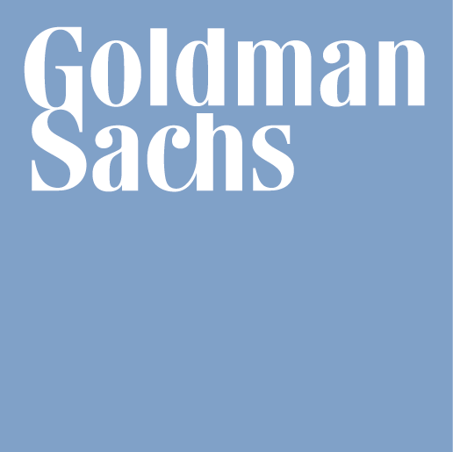
April 26, 2024

NOTICE OF WITHDRAWAL OF OFFER
GOLDMAN, SACHS & CO. WERTPAPIER GMBH
(The "Issuer")
Series P Programme for the Issuance of Warrants, Notes and Certificates
Issue of the Aggregate Nominal Amount* of Five-Year Quanto GBP 1-Delta Autocallable Notes on the Class 2538 FTSE 100 Index and S&P 500® Index linked Preference Shares issued by Goldman Sachs (Cayman) Limited, due April 26, 2029
(the "Notes" or the "Securities")
 |  | ISIN: | XS2752165857
 |  | Common Code: | 275216585
 |  | Valoren | 34130056
 |  | WKN: | GQ66LE
 |  | PIPG Tranche: | 594234

We refer to the final terms dated March 1, 2024 relating to the Securities (the "Final Terms").
We hereby notify you that the Issuer has exercised its discretion to withdraw in whole the offer of the Securities. Any applications to purchase the Securities made on or prior to the date of this notice will be cancelled.
The Issuer accepts responsibility for the information contained in this notice.
This Notice will be filed with the United Kingdom Financial Conduct Authority.

